A Systematic Review of Swine Manure Resource Utilization via Black Soldier Fly Larvae: Synergistic Degradation Mechanism, Pollutant Fate and Efficiency Regulation
Zhengrong Fu¹, Jialei Sun^{2,*}

¹ Shaoyang University, Shaoyang 422000, Hunan, China; E-mail: 441680332@qq.com (Zhengrong Fu)
² Hunan University of Technology, Zhuzhou 412007, Hunan, China
*Corresponding author: Jialei Sun, E-mail: 3024862647@qq.com

Abstract
With the advancement of intensive breeding, the efficient resource utilization of pig manure has become a key challenge in mitigating agricultural non-point source pollution. Traditional composting and anaerobic fermentation are often limited by long degradation cycles and the risk of secondary pollution. In contrast, black soldier fly larvae (BSFL) bioconversion technology provides a new pathway for the resource utilization of pig manure due to its high throughput and high value-added product characteristics. This paper systematically reviews the synergistic "physical-metabolic-microbial" mechanism of BSFL-mediated pig manure conversion, pollutant fate patterns, and process regulation strategies. Studies have shown that through mechanical disturbance and the synergistic action of intestinal functional microorganisms (e.g., Bacteroidetes, Firmicutes) and complex enzyme systems, BSFL can effectively break down the complex lignocellulose barrier in pig manure, achieving a dry matter reduction rate (DMR) of 30%–56%.
While achieving volume reduction, BSFL exhibit a significant concentration regulation mechanism against high-risk heavy metal residues in pig manure. Under high-concentration stress of copper and zinc, larvae actively excrete heavy metals by activating resistance genes such as CutC and zntB. More than 90% of Cu and Zn, as well as 86.6% of Pb, are transferred to frass, thereby reducing the risk of bioaccumulation in larval bodies. Carbon-rich additives such as biochar and tea residues can further reduce the bioavailability of heavy metals through adsorption and reduction effects—for instance, tea polyphenols reduce Cr(VI) to Cr(III).
In addition to heavy metals, nitrogen migration and transformation represent another key indicator affecting the environmental benefits of the system. Although the total nitrogen reduction rate of the system can reach 22.1%–82.1%, limited by ammonia volatilization (accounting for 19%–23% of total nitrogen loss), the actual efficiency of nitrogen conversion into insect protein is only 25%–27%. Comparative analysis indicates that the bioconversion efficiency of pig manure is lower than that of chicken manure due to its "low energy value, high fiber" substrate characteristics. Accordingly, this paper proposes strategies based on "yield compensation" and "nutrient restructuring": co-digestion with high-carbon substrates such as food waste to precisely adjust the C/N ratio to 25–30, and inoculation with functional flora such as Bacillus to break the degradation bottleneck caused by high hemicellulose content in finishing pig manure. This technology can not only produce high-value insect protein and organic fertilizer but also significantly reduce greenhouse gas emissions, representing a promising approach for the volume reduction and high-value utilization of livestock and poultry waste.
Keywords: Black soldier fly ; Swine manure valorization; Synergistic degradation; Heavy metal fate;Nitrogen transformation

1 Introduction
With the advancement of large-scale and intensive livestock farming, a large amount of livestock and poultry solid waste has accumulated,becoming a problem for agricultural non-point source pollution and ecological management.Direct discharge or field application of livestock and poultry solid waste can easily cause nitrogen and phosphorus accumulation, nitrate pollution in groundwater,and eutrophication of water bodies,endangering drinking water safety^{[1]}.Furthermore,it is prone to emitting offensive odors,breeding pests,and releasing greenhouse gases,which severely impacts the rural environment and public health, thereby driving up the costs of environmental management.
Traditional solid waste treatment methods, including composting, anaerobic digestion, and landfilling,are often plagued by resource waste and secondary pollution. In particular,when processing high-moisture and high-nitrogen manure,conventional composting and anaerobic digestion frequently hit bottlenecks,such as sluggish degradation,offensive odors,and greenhouse gas emissions^{[2]};On the other hand, landfilling poses severe risks of groundwater contamination via leachate runoff and substantial resource waste;consequently,none of these conventional practices can meet the treatment demands of large-scale intensive livestock farming^{[3]}.In addition, physical parameters such as substrate moisture content significantly shape microbial community structures and organic matter transformation.These constraints inevitably limit degradation efficiency and residue stability in traditional processes,thereby escalating the risk of secondary pollution.Consequently,there is an urgent need for more efficient and controllable treatment technologies capable of generating high-value co-products to achieve sustainable solid waste recycling^{[4]}.
Driven by the growing popularity of circular agriculture and resource recovery paradigms,waste management through insect bioconversion has garnered increasing attention.These insects subsist on various waste streams and efficiently upgrade nitrogenous compounds into high-value proteins.Compared with conventional protein crops,the insect bioconversion process requires significantly fewer precious resources, such as land and water,per unit of protein produced^{[5]}.Crucially,the larvae of the saprophagous insect,the black soldier fly (Hermetia illucens; BSFL),stand out as highly efficient organic waste converters that play a pivotal role in this sustainable paradigm^{[6]}.Characterized by a broad dietary spectrum, BSFL voraciously consume diverse organic waste streams,including livestock manure and food waste.Their low rearing costs and brief life cycle further facilitate upscaling for mass production^{[7]}.Upon consuming pig manure, Black Soldier Fly Larvae (BSFL) can accumulate a crude protein content of up to 21.98%^{[8]}.Extensive research indicates that BSFL-driven bioconversion of swine manure substantially enhances organic matter removal and optimizes the nutritional profiles of the remaining residues,while concurrently demonstrating great potential to mitigate greenhouse gas emissions^{[9]}.Although variation in substrate characteristics inevitably affects larval growth and bioconversion efficiency,BSFL exhibit remarkable adaptability and processing potential toward diverse agricultural solid wastes. This robust tolerance provides a solid experimental foundation for their widespread application across heterogeneous waste streams^{[10]}.
This review provides a systematic investigation into the bioconversion of swine and other livestock manures driven by BSFL.It dissects the regulatory mechanisms of different process conditions on degradation kinetics,and ultimately contextualizes both the techno-economic viability and safety bottlenecks of the downstream products.By elucidating the underlying mechanisms and process optimization pathways of BSFL-mediated bioconversion,this review aims to provide viable strategies for livestock manure reduction and resource recovery.Ultimately, this work seeks to alleviate environmental pollution pressures and promote sustainable, synergistic ecological development.

2 Biological characteristics of BSFL

2.1 Ontogeny and Life History
BSFL is a saprophagous dipteran insect of the Stratiomyidae family and Hermetia genus. Indigenous to South America,it adapts well to various tropical and subtropical climates, exhibiting peak metabolic and physiological performance at 25°C–30°C^{[11, 12]}.As a holometabolous insect, the black soldier fly undergoes a complete metamorphosis comprising five distinct developmental stages:egg,larva,prepupa,pupa,and adult,as schematically illustrated in Figure 1.The developmental kinetics across these stages are significantly governed by environmental and nutritional variables,most notably temperature,humidity,diet quality, and rearing density^{[13, 14]}.
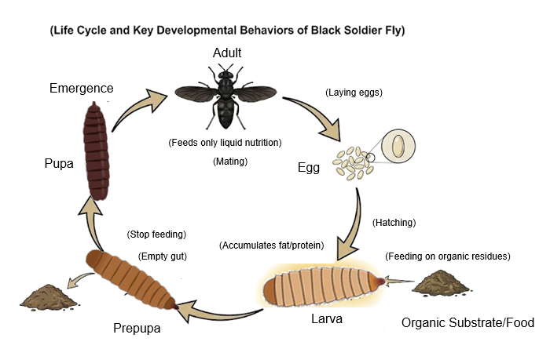
Figure 1. The typical life cycle and developmental stages of black soldier fly.
An individual black soldier fly egg weighs approximately 0.028 mg,with each egg clutch containing between 324 and 998 eggs^{[15]},Under optimal controlled conditions of 28°C and 70% relative humidity,the incubation period is typically completed within four days^{[16]}.Under favorable conditions,the larval stage exhibits the most rapid growth kinetics,reaching maturity within a few weeks.Although elevated temperatures within a specific threshold accelerate development, excessive thermal stress or over-crowded rearing densities severely impede biomass growth and escalate mortality rates^{[17]},the optimal temperature range for the larval stage is bounded between 28°C and 32°C.The morphological traits of BSF larvae are depicted in Figure 2.The larval foraging window generally persists for 2–4 weeks,heavily contingent upon fluctuating matrix temperature, ambient moisture, and feeding rations.Prior to pupation, the larvae complete six developmental instars via molting.At the twilight of the feeding phase,they progress into prepupae,at which point they cease organic substrate ingestion,evacuate their digestive tracts,and leave the waste matrix to locate dry pupation niches^{[18]}.Once hatched, BSFL exhibit intense foraging behavior on heterogeneous organic wastes,concurrently upgrading these low-value streams into premium larval biomass rich in proteins and lipids.These accumulated macronutrients serve as the primary energetic baseline required to fuel their upcoming pupal and adult lifespans.The brown-colored BSF pupae generally measure 12–14 mm in length. While the standard pupal duration spans 10–20 days prior to eclosion, extreme environmental stressors can significantly delay this phenotypic transition,extending the pre-emergence period to as long as 5 months^{[19]}.Following emergence, the adult black soldier fly exhibits a brief lifespan,typically persisting for only 5 to 8 days^{[20]}.Morphologically,the adult black soldier fly exhibits a body length ranging from 13 to 20 mm.The oviposition rate of this species is co-determined by a complex interplay of maternal nutrient reserves,the quality of the oviposition substrate, and population density metrics. Consequently,tailoring dietary nutrition and optimizing density management represent viable engineering strategies to significantly augment both egg yields and survival rates, thereby maximizing overall system productivity^{[21]}.
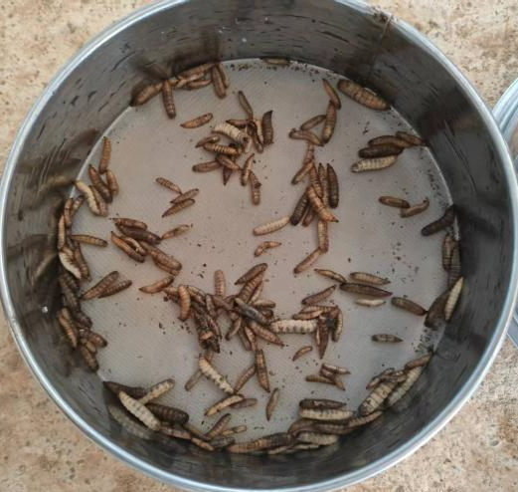
Figure 2. Typical morphology and developmental phases of BSF larvae.

2.2 Bioconversion Performance and Process Evaluation Metrics
BSFL is a typical omnivorous saprophytic insect, showing excellent adaptability and transformation potential for decaying organic matter.Its biotransformation ability stems from a unique life history strategy:adult black soldier flies have degenerated mouthparts,only consume water, and have a very short lifespan without feeding^{[10]}.Therefore,the entire energy reserve required for individual development must be accumulated during the larval stage.This characteristic drives the larvae to exhibit extremely high feeding intensity,allowing them to efficiently consume and digest various organic wastes, including livestock and poultry manure and kitchen waste. In addition,unlike houseflies,adult black soldier flies are not major carriers of pathogens,which provides a fundamental guarantee for their biosafety in waste treatment.
The main indicators for evaluating BSFL conversion efficiency include Waste Reduction Index (WRI),Feed Conversion Efficiency (FCE),and Bioconversion Rate (BCR).WRI was proposed by Diener et al.^{[18]}and is a further development based on the reduction rate of dry matter (DM). The calculation formula is:
$$\begin{aligned}WRI=\frac{W−R}{W×t}×100\#(1)\end{aligned}$$
Here,W is the total amount of initial substrate, R is the total amount of residue (residue + worm castings),and t is the number of experimental days.This index combines the degree of substrate degradation with the biological development cycle, aiming to characterize the substrate consumption rate per unit of development time.Compared to a single degradation rate indicator,WRI can more objectively evaluate the conversion efficiency of insects such as black soldier fly on organic waste.According to literature statistics,the WRI of poultry and livestock solid waste processed by BSFL ranges from 0.2 to 6.4.Among them,the study by Oonincx et al^{[22]}.achieved the lowest WRI value of 0.2,which is mainly attributed to the excessively long larval rearing period (144 days for the chicken manure and pig manure groups,and 214 days for the cow manure group),a duration far exceeding the conventional settings in similar studies.Additionally, Peng et al.investigated the effects of substrate depth on the bioconversion performance of fresh swine manure mediated by BSFL^{[23]},specifically, they found that the WRI peaked at 6.4 under a substrate depth of 15 cm,accompanied by a substantial swine manure weight reduction efficiency of 64.4%.This optimal performance is attributed not only to the favorable equilibrium achieved between oxygen diffusion and substrate temperature at this specific depth,but also to the increased specific surface area provided by a relatively thin layer,which accelerates moisture evaporation and consequently drives up the WRI values.Notably,the nutrient composition of the substrate also modulates the WRI significantly.Focusing on the daily degradation capacity,Veldkamp et al. documented that the maximum daily processing rate reached 10.6 g for food waste, followed by 5.4 g for swine manure mixtures, whereas a solitary solid swine manure matrix yielded merely 3.0 g^{[10]}.
Concurrently,FCE quantifies the efficacy of larvae in converting ingested substrates into cumulative biomass.It is worth noting that the conceptual terminology surrounding this metric varies significantly across different academic domains.For instance,a seminal study by Waldbauer^{[24]} conceptualized this parameter as the Efficiency of Conversion of Ingested Food (ECI),whereas Elsayed^{[25]} defined a similar operational boundary as the Conversion Efficiency of Digested Food (CED).To resolve these nomenclature discrepancies, the mathematical formulations for FCE,ECI,and CED within the BSFL bioconversion system are contextualized and cross-referenced as follows:
$$\begin{aligned}FCE(\%)=\frac{M}{S}×100\#(2)\end{aligned}$$
$$\begin{aligned}ECI(\%)=\frac{B}{W−R}×100\#(3)\end{aligned}$$
$$\begin{aligned}CED(\%)=\frac{M}{W−R}×100\#(4)\end{aligned}$$
M represents the net biomass weight gain of the larval cohort during the rearing cycle(g);S denotes the total mass of the organic substrate actually consumed by the larvae(g);B signifies the cumulative final biomass weight of both larvae and pupae harvested at the termination of the experimental trial(g);W constitutes the total initial mass of the raw substrate allocated into the bioconversion system(g);R is the remaining residue composed of unconsumed substrate and larval frass at harvest(g).Existing studies indicate that the FCE for swine manure bioconversion exhibits an average value of 35.2%,with the maximum recorded efficiency reaching as high as 60.8%.According to the feeding trials conducted by Veldkamp^{[10]},the ECI value for the swine manure mixture was quantified at 37%,which was significantly higher than the 14% observed for solitary plant residues.Importantly,the developmental duration exerts a profound impact on the ECI.As documented by Oonincx et al.,the larval developmental period on a solitary swine manure diet extended to an extreme of 144 days,which consequently depressed the ECI to a mere 4.5%^{[22]},From the perspective of bioenergetics,a protracted developmental duration implies that a disproportionate fraction of the ingested energy is designated for basal metabolic maintenance rather than being allocated for anabolic biomass incorporation, thereby triggering a substantial decline in the overall conversion efficiency.
BCR is a commonly used indicator. BCR refers to the ratio of the mass of insects produced to the mass of feed substrate provided^{[26]},providing a more intuitive evaluation of system output. The calculation formula is as follows.
$$\begin{aligned}BCR(\%)=\frac{B}{W}\#(5)\end{aligned}$$
B represents the mass of insects produced, and W represents the amount of feed provided.
In summary, the bioconversion of livestock and poultry manure mediated by BSFL transcends a mere process of physical mass reduction; rather,it represents a highly sophisticated biochemical reaction networks strictly regulated by the physical architecture of the substrate,the carbon-to-nitrogen (C/N) ratio,and macromolecular nutritional homeostasis.Through the co-fermentation of multi-source organic wastes, it is feasible not only to optimize critical performance metrics such as WRI and ECI, but also to modulate the directional trajectories of carbon and nitrogen flows. This synergistic approach ultimately maximizes waste valorization while simultaneously mitigating environmental ammonia volatilization.

3 Core mechanism of black soldier fly in manure treatment
3.1 Physical mechanism
The differences in evaluation indicators essentially stem from the different transformation mechanisms,and therefore it is necessary to further analyze the core mechanisms of BSFL in processing poultry and livestock solid waste.The physical properties of livestock and poultry waste, such as breeding density,temperature and humidity control,and feeding strategies,directly determine the degradation efficiency of BSFL. Suitable density can ensure larval feeding and growth,avoid competition and hypoxia, and maintain high conversion rates,while densities that are too high or too low are detrimental to system stability and degradation rate^{[27]}.Temperature and humidity conditions influence larval metabolism, enzyme activity, and gut microbiota. Within a suitable range,feeding amount and decomposition rate are enhanced,while fluctuations or extremes inhibit activity and alter degradation pathways^{[28]}.
In terms of feeding strategy,it is important to reasonably control the amount, frequency,and substrate ratio of the feed to prevent local anaerobic conditions and nutrient imbalance.Existing BSFL treatment systems typically use continuous or batch feeding, which helps match larval growth with substrate consumption and improve continuous operation capability and product consistency^{[27, 28]}.Continuous and batch processes each have their characteristics in black soldier fly treatment of poultry and livestock solid waste,as shown in Figure 3.Continuous processing improves throughput per unit of time through stable feeding and balanced conditions, making it suitable for small-scale long-term operations,but it requires strict control of feed uniformity,temperature and humidity, and pathogen management. Batch processing operates in cycles,allowing larvae to develop into prepupae more effectively when food is sufficient, and is simpler to operate, but the development period is extended by 2 to 4 days,making it suitable for experimental or large-scale scenarios^{[29]}.
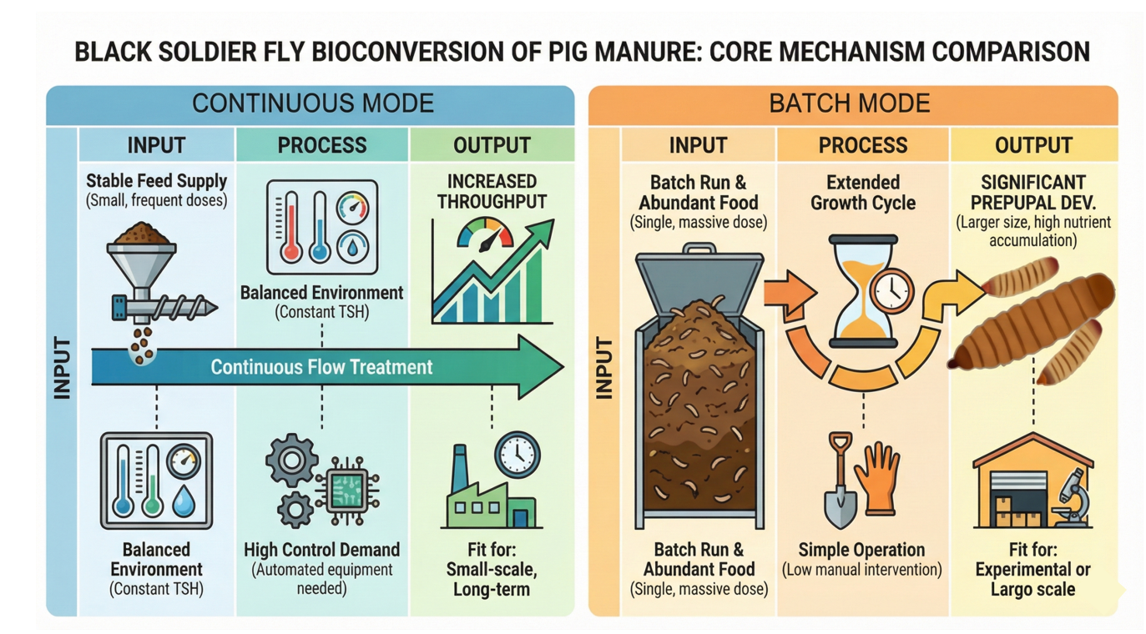
Figure 3. Comparison of continuous and batch processes mode
In addition to the physicochemical properties of livestock and poultry manure itself, the physical activities of BSFL,such as mechanical disturbance,improved aeration, and restructuring of the substrate,also play an important role.Research by Purkayastha and Sarkar shows that the swarming and chewing of BSFL can continuously stir loose or cohesive livestock and poultry waste and break it into fine particles, increasing the specific surface area and promoting moisture and gas exchange^{[14]}.This continuous physical modification not only increases the contact opportunities between the matrix and microorganisms but also facilitates enzymatic decomposition, while improving the pore structure and oxygen diffusion, reducing anaerobic zones,and lowering the risk of putrefaction and odor generation.It can be seen that the physical intervention of larvae and biochemical degradation work synergistically to drive the rapid stabilization of livestock and poultry waste.In addition, adding bulking agents such as sawdust to pig manure can optimize the composting process and improve decomposition efficiency^{[30]}.
3.2 Synergistic effect of microorganisms and intestinal enzyme systems
The efficient conversion of complex organic materials such as pig manure by BSFL is not solely due to the independent function of their digestive system,but rather the result of deep collaboration between gut microbes and gut enzyme systems.This synergy forms the core biological basis of the BSFL conversion system,mainly reflected in two aspects:the substrate adaptability, nutrient metabolism,and bottleneck breakthroughs of the microbes,and the synergistic enhancement of the host-microbe composite enzyme system.
First,the physical properties of the substrate have a strong screening and shaping effect on the microbes in the BSFL gut and conversion system,while functionally guided microbes are the key to improving conversion efficiency^{[31, 32]}.Wang et al.^{[33]},through high-throughput 16S rRNA sequencing, found that an appropriate moisture content (75%) can maximize the diversity of the gut microbiota and selectively enrich functional microbial communities closely related to the growth of the organism and the degradation of organic matter.Correlation heatmap analysis verified that the relative abundance of specific gut symbionts,such as Akkermansia and Helicobacter,scaled progressively with the optimization of the matrix moisture gradient. Crucially,these specific taxa exhibited a highly significant positive correlation(P<0.01)with both the average daily gain (ADG) and feed conversion efficiency (FCE) of the BSFL cohort.The pH profile of the substrate acts as a critical determinant,directly modulating the chemical solubility and subsequent bioavailability of the ingested nutrients^{[34]},thereby exerting a robust environmental selective pressure that profoundly shapes the compositional architecture of the BSFL gut microbiota.Consequently,these heterogeneous substrate characteristics selectively recruit specific microbial taxa endowed with the metabolic capacity to depolymerize complex polysaccharides. Beyond merely degrading recalcitrant organic matter, the resident intestinal microbiota within the BSFL gut effectively converts these macromolecules into simplified,bioavailable nutrients,thereby providing direct metabolic support to sustain rapid larval somatic growth^{[35]}.
In addition,the high conversion efficiency of BSFL is due to its powerful complex enzyme system.The host larvae autonomously secrete a comprehensive repertoire of digestive enzymes,including proteases,lipases,and phytases.These enzymes are systematically responsible for cascading the hydrolysis of proteins,the cleavage of lipids,and the liberation of bound phosphorus from phytates,thereby supplying essential nitrogen sources,metabolic energy, and bioavailable minerals to fuel larval somatic development^{[36]}.However,the efficacy of this host endogenous enzyme repertoire remains tightly constrained when encountering the structurally complex and highly heterogeneous macromolecular fractions—predominantly cellulose and hemicellulose—inherent in swine manure^{[37]}.At this juncture, the diverse repertoire of hydrolases (e.g.,cellulases and xylanases) and oxidoreductases secreted by the intestinal microbiota serves as a pivotal complement.These microbial enzymes, in tandem with the host-derived enzymatic pool,construct a functionally synergistic degradation network.This co-catalytic framework stepwise depolymerizes complex organic matrices into readily assimilable,low-molecular-weight nutrients,thereby substantially accelerating the organic degradation kinetics and overall mineralization efficiency^{[31, 38]}.This host-microbiota enzymatic complementation and synergistic cascade,as systematically illustrated in Figure 4, mutually drives the highly efficient bioconversion of complex substrates,such as swine manure, within the BSFL system^{[39]}.Notably,localized investigations have unveiled that BSFL actively synthesize short-chain antimicrobial peptides (AMPs).These bioactive agents effectively suppress the proliferation of phytopathogenic and opportunistic pathogens within the manure matrix,thereby establishing a homeostatic micro-milieu that privileges the proliferation of beneficial symbionts and stabilizes enzymatic cascades^{[40]}.This interconnected feedback loop beautifully exemplifies the multidimensional and multi-tiered systemic synergy inherent within the bioconversion framework.
Within the lumen of the BSFL gut,the synchronized depolymerization and assimilation of recalcitrant fibers and proteins are systematically orchestrated by specialized microbial consortia and enzymatic cascades.Specifically, prominent bacterial cohorts such as Bacteroides spp. partition complex fiber matrices by secreting a rich repertoire of carbohydrate-active enzymes (CAZymes,including carbohydrate esterases [CEs] and glycoside hydrolases [GHs]) to liberate bioavailable monosaccharides. Concurrently,the resident yeast Issatchenkia orientalis channels organic carbon through the thiolase pathway to generate critical metabolic precursors, thereby augmenting the de novo biosynthesis of essential amino acids.
Furthermore,cross-kingdom signaling networks are actively engaged in proteolysis;I.orientalis and Citrobacter amalonaticus deterministically upregulate host endogenous proteases (such as pepsin and total soluble proteins [TSP]) via targeted signaling cascades involving Sen34/AAT I and peptidoglycan recognition proteins (PGRPs),fundamentally accelerating protein cleavage.Concomitantly,a symbiotic cooperative axis consisting of Bacteroides ovatus, Pichia kudriavzevii,and Candida spp. exerts a profound regulatory effect on host intermediary metabolism, systematically stimulating the tricarboxylic acid (TCA) cycle, fatty acid synthesis (FAS),and core vitamin metabolic pathways,which collectively maximizes energy conservation and macro-nutritional accumulation.
The structural dependencies and key metabolic pathways governing this multi-tiered degradation process are systematically mapped out in Figure 4.The ability of BSFL to transform manure effectively overcomes the limitations of the larvae's own digestive enzymes,jointly breaking down complex organic matter into usable nutrients, thereby achieving efficient bioconversion.
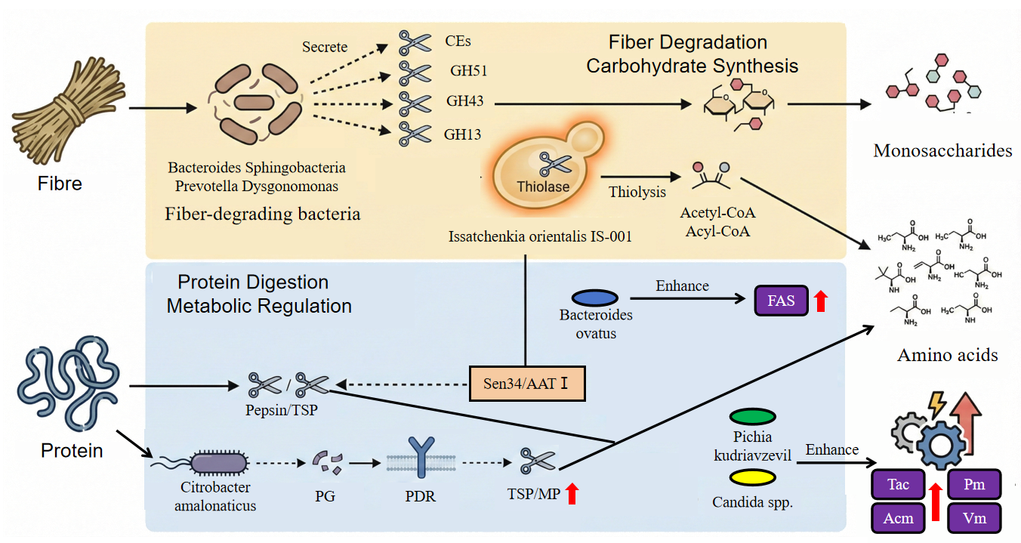
Figure 4. Synergistic mechanism of microbial-enzyme systems in BSFL conversion of pig manure.
CEs:Carbohydrate esterases GHs:Glycoside hydrolases PG:Peptidoglycan
PDR: Peptidoglycan recognition receptor TSP:Trypsin-like serine protease
FAS:Fatty acid synthas Tac:Tricarboxylic acid cycle Pm:Purine metabolism
Acm:Amino acid metabolism Vm:Vitamln metabolism
3.3 Migration and transformation of pollutants
The BSFL processing system can not only reduce the volume of feces,but its greater potential lies in the biodegradation of various persistent organic pollutants,especially antibiotic residues.In a comprehensive review, Wang et al. emphasized that BSFL exhibit exceptional tolerance alongside robust degradation efficiency toward a broad spectrum of antibiotics, prominently including tetracyclines and sulfonamides^{[41]}.Taking tetracycline(TC) as a representative paradigm,its mitigation within the BSFL intestinal bioreactor does not proceed via a singular monolithic pathway;rather,it involves a sophisticated cascading process that bridges abiotic hydrolysis and biotic enzymatic transformations^{[42]}.The following are the core reaction pathways of tetracycline degradation in the BSFL gut.
Initially,TC undergoes spontaneous abiotic hydrolysis within the specialized intestinal microenvironment,yielding key intermediate species such as 4-epitetracycline (ETC) or isotetracycline (iso-TC).This initial transformation effectively destabilizes the recalcitrant naphthacene core,thereby priming the substrate for subsequent microbially-mediated enzymatic cleavage,as depicted in Eq. (6):
$$\begin{aligned}C_{22}H_{24}N_{2}O_{8}(TC)\underset{→}{Hydrolysis}ETC/iso−TC(m/z 445.16)\#(6)\end{aligned}$$
Subsequently,the resident microbiota dispatches specialized demethylases and deaminases to orchestrate a targeted attack on the dimethylamino moiety of the tetracycline skeleton.This biological process drives the consecutive removal of methyl and amino fractions,yielding key metabolite products such as P439 and P397.Crucially,this pathway selectively dismantles the critical pharmacophore responsible for the antimicrobial efficacy of tetracyclines,effectively neutralizing its selective pressure within the matrix.
$$\begin{aligned}C_{22}H_{24}N_{2}O_{8}(TC)\underset{→}{−CH_{3}}P439(C_{20}H_{20}N_{2}O_{8})\#(7)\end{aligned}$$
$$\begin{aligned}P439\underset{→}{−NH_{2}}P397(C_{19}H_{19}NO_{7})\#(8)\end{aligned}$$
Hence,gut-associated monooxygenases and dioxygenases capitalize on ROS accumulation to execute the systematic ring-cleavage of polycyclic fractions.As exemplified by the oxygenation of P397 into P385,and TC into P489,these sequential cascades ensure the total disintegration of the foundational macrocyclic core.
$$\begin{aligned}P397+O_{2}\underset{→}{Oxygenase}P385(C_{17}H_{20}O_{10})\#(9)\end{aligned}$$
$$\begin{aligned}TC+O_{2}\underset{→}{Oxygenase}P489(C_{22}H_{24}N_{2}O_{11})\#(10)\end{aligned}$$
Hence, these metabolic intermediates face terminal mineralization to CO₂ and H₂O or direct redirection into host energetic scaling. Consequently,the zero-accumulation phenotype observed in the larvae establishes the core regulatory foundation guaranteeing the safe,high-value reclamation of the resulting insect biomass.
Beyond organic contaminants,the mobilization and speciation dynamics of heavy metals during BSFL bioconversion represent another critical determinant governing the safe valorization of downstream products. Unlike antibiotics,which predominantly rely on microbial and enzymatic biodegradation,heavy metals are chemically indestructible elements within the BSFL ecosystem;consequently,their environmental fate is strictly dictated by chemical speciation shifts and multi-media partitioning cascades.Through a systematic investigation into the chemical speciation,migration dynamics,and bioavailability of Cd,Cr,and As within the swine manure-BSFL bioconversion system, Wang et al.^{[43]} elucidated the divergent behavioral trajectories of these potentially toxic elements regarding larval ontogeny,tissue bioaccumulation, and residual matrix distribution.Results indicated that As substantially suppressed BSFL development, contrasting with the high tolerance exhibited toward Cd and Cr. Distinct mass allocation pathways occurred:Cd possessed high bioaccumulation capability,tracking into larval bodies, whereas Cr and As partition coefficients favored accumulation in the frass.Crucially,the bioreaction successfully mitigated Cr bioavailability,whereas the bio-accessible fractions of Cd and As remained largely persistent.Specifically,Wu et al.^{[44]} quantified that more than 90% of dietary Cu and Zn was routed into the frass fractions,whereas less than 10% was incorporated into larval bodies.This partition preference reflects the robust metal-excretion capability inherent to BSFL,rendering this bioprocess a strategically viable approach to produce heavy-metal-compliant insect proteins from contaminated livestock wastes.Consequently,this integrated matrix pathway establishes a core safety reference for evaluating the ecological footprints and secondary contamination indices of transformed larval products.It simultaneously signals that managing the biomagnification potential of Cd and the development arrest driven by As dictates the ultimate regulatory compliance of this biotechnology.

4 Treatment efficiency and optimization of pig manure management
4.1 Dry matter reduction
Dry matter reduction^{[45]}（DMR）is a key measure of the load reduction capacity of BSFL treatment systems and is defined as the ratio of the consumed feed substrate to the total feed substrate provided. The calculation formula is as follows:
$$\begin{aligned}DMR(\%)=(1−\frac{(W−R)}{W})×100\#(11)\end{aligned}$$
W is the initial amount of substrate,and R is the remaining amount of substrate after feeding is completed.
BSFL show significant reduction potential in the process of transforming pig manure,with volume and mass reduction rates typically ranging between 30% and 56%^{[45-47]}.However,DMR is not fixed and is greatly influenced by the composition of the substrate,especially the differences in fecal composition caused by different growth stages of pigs.As shown in Table 1, BSFL converts feces from growing pigs significantly better than from pigs in the fattening stage.The core logic underpinning this phenomenon resides in the biosorption barrier effect exerted by the cellulosic fractions of the dietary matrix on the larval intestinal micro-milieu.Research shows that as pigs transition from the nursery phase to the fattening phase,adjustments in feed formulation lead to a significant increase in the lignocellulose content in feces,which constitutes a key rate-limiting step in BSFL bioconversion.Specifically, hemicellulose was identified as the predominant negative regulatory factor strongly constraining larval ontogeny,exhibiting an exceptionally high inverse correlation（r =-0.9569）^{[48]};The barrier it constructs not only directly hinders the larvae's uptake of intracellular nutrients,but also further reshapes the intestinal microbial structure of the larvae.Within the growth-stage porcine manure cohort exhibiting the peak bioconversion efficiency,the larval intestinal tract was characterized by the absolute dominance of the phylum Firmicutes,with the relative abundances of the genera Lactobacillus and Clostridium being significantly elevated at prominent levels^{[49]}.The former plays a pivotal role in maintaining intestinal homeostasis and suppressing pathogenic colonization,whereas the latter possesses a robust capability to synthesize highly efficient cellulolytic enzymes and cleave complex carbohydrates,thereby providing critical metabolic scaffolds for host larval development.Conversely,when the structural lignocellulose content escalates within the dietary substrate—as exemplified by fattening porcine manure—the ecological niches for the aforementioned highly efficient degraders contract significantly.This population suppression is concurrently succeeded by a pronounced taxonomic shift toward the enrichment of Bacteroidetes and Proteobacteria.This cascading chain reaction,shifting from substrate-component constraints to functional microbiota succession,effectively decodes the underlying biological mechanism driving the diminished dry matter reduction (DMR) commonly observed in high-fiber fecal matrices.
Conclusively,the superior DMR observed in the nursery and growth-stage porcine manure matrices benefits from their lower abundance of recalcitrant fiber and hemicellulose fractions,which sequentially enriches the dominant Lactobacillus-Clostridium bacterial consortia.Together,these dual elements consolidate into a highly efficient microbe-host symbiotic metabolic network that maximizes bioconversion kinetics.In contrast, the high-hemicellulose profile signature of fattening swine feces acts as a primary barrier,rendering the assimilation of this recalcitrant substrate strictly locked into the microbially-sourced cellulolytic machinery within the larval gut lumen^{[50]}.Therefore,bio-supplementing high-fiber manure with specialized thermophilic Bacillus species (B. cereus and B. subtilis) to optimize in-situ cellulase yields^{[47]} constitutes an effective approach to dismantle complex fiber configurations,capturing the ultimate solution to unlock the processing constraints of fattening-stage waste.
Table 1 BSFL conversion data of pig manure at different developmental stages^{[47, 48]}
Type of pig manure | Survival rate  （%） | Individual dry weight  （mg） | Conversion rate  （%） | DMR  （%）
Before weaning | 95.34±1.24 | 0.093±0.01 | 18.91±0.03 | 39.56±1.94
After weaning | 94.52±3.25 | 0.091±0.01 | 18.90±0.02 | 40.38±1.23
Growth period | 96.75±2.53 | 0.097±0.01 | 19.96±0.01 | 43.27±2.02
Fattening period | 89.65±1.03 | 0.089±0.01 | 18.88±0.01 | 37.74±1.01
Conservation period |  | 0.065±0.0062 | 20.7 | 51.2
Growth period |  | 0.058±0.0073 | 18.0 | 40.2
Fattening period |  | 0.030±0.0061 | 8.5 | 14.2
Note：Substrate characteristics may marginally vary depending on porcine breeds and feeding management.Data extrapolated from Hao et al.^{[48]} lack explicit percentage values for survival and conversion rates,as the authors solely reported mass metrics regarding dry weight and reduction rates.Variations in individual larval dry weight formatting are driven by historical documentation preferences across independent literature.
Besides the substrate components, the pretreatment status of the substrate and the species and strain of the insects also significantly affect DMR.Regarding system processing throughput,Newton et al.^{[51]} sustained a 56% bulk mass reduction using belt-harvested solid fractions, whereas the corresponding DMR value collapsed to 37.7% under the experimental setup of Oonincx et al.^{[22]}.This kinetic disparity is primarily attributable to the aggressive drying and milling pretreatments applied to the swine manure in the experimental design of Oonincx et al. These severe thermal and mechanical processing steps systematically obliterated the indigenous microbial consortia and denatured thermally labile nutritional fractions, thereby imposing critical metabolic constraints that compromised larval bioconversion efficiency.Furthermore,a critical study by Zhou et al.^{[52]} underscored the defining influence of host genetic backgrounds on bioconversion performance; under an identical swine manure matrix,the temperate Wuhan strain exhibited a robust DMR of 53.4%,whereas its tropical Guangzhou counterpart yielded an inferior DMR of merely 28.8%.In summary,maintaining unmanipulated biotic matrices while integrating tailored cellulolytic reinforcements—such as direct hemicellulase dosing or targeted Bacillus spp. enrichment—represents the definitive technological configuration to unlock the degradation limits of fattening porcine wastes and optimize system DMR scaling.
4.2 Heavy metal
The heavy metals remaining in pig manure are the core risk factor limiting its resource utilization^{[8, 53, 54]}.In the process of using BSFL to treat pig manure,heavy metals in the substrate not only exert toxic stress on the growth and development of the larvae,but also migrate through the food chain during the feeding process.In response to heavy metal stress within the waste matrix,BSFL primarily manifest two distinct toxicokinetic pathways:systemic bioaccumulation and extracellular excretion.To accurately evaluate the ecotoxicological safety thresholds of the final outputs (larval biomass and processed frass),quantifying the heavy metal assimilation profile of BSFL remains a paramount prerequisite.Consequently,independent trials extensively introduce the bioaccumulation factor (BAF) as a foundational metric to calibrate the metallic sequestration capacity of the larvae.This factor is universally defined as the mathematical ratio of the specific heavy metal concentration fixed within the larval tissue to its baseline concentration embedded in the initial swine manure matrix^{[55]}.The definitive mathematical expression is structured as follows：
$$\begin{aligned}BAF=\frac{C_{organism}}{C_{substrate}}\#(12)\end{aligned}$$
In essence,larval metal retention cascades are highly contingent on three interdependent vectors:heavy metal taxonomy, initial mass concentration thresholds, and the structural formatting of the fecal residue^{[56]}.In scenarios with heavy metal overloads, BSFL mass transfer profiles incorporate the sequestering of As,Cd,Cu,Pb, and Zn,with the retention fluxes for Cu and Zn selectively dominating the body-burden inventory^{[54, 57]}.Although Cu and Zn are trace elements essential for the growth and development of insects,they usually exhibit bioaccumulation characteristics.^{[58]},BSFL shows a significant concentration threshold effect in the accumulation behavior of these two elements.Wu et al.^{[44]} found that when the Cu concentration in pig manure exceeded 400 mg/kg, the BAF was less than 1.Rather than resulting from limited bioavailability (with >80% of Cu/Zn remaining highly bioavailable),this phenomenon is driven by concentration-induced microbial defense networks in the larval gut.The pronounced transcriptional activation of specific resistance and transport genes (CutC,pcoD,zntB,and zurR) enables the BSFL to excrete over 90% of the heavy metal load, securing their essential homeostatic balance.Furthermore,an investigation by Lin et al.^{[8]} corroborated this paradoxical 'low accumulation under high exposure' phenomenon.Over a 25-day bioconversion cycle utilizing swine manure,they recorded an impressive 86.6% elimination rate for lead (Pb).Mechanistically, Pb is predominantly translocated and immobilized within the chitinous exoskeleton,ultimately being shed during successive ecdysis (molting) events,which successfully guarantees a minimized somatic body burden within the harvested larvae.。
In order to regulate the fate of heavy metals in the BSFL bioconversion system and reduce environmental risks,researchers explored the effect of adding carbon-rich additives to the substrate^{[59]}.These exogenous bulking agents not only dynamically alter the baseline physicochemical attributes of the baseline matrix,but also profoundly modulate heavy metal bioavailability and its subsequent partitioning within the integrated 'larva-frass' system through a tripartite synergy of physical adsorption, chemical complexation, and microbial community reshaping (Table 2).
Table 2. Changes in Bioavailable Heavy Metals in Black Soldier Fly Larvae Residues^{[53, 59]}
Exogenous bulking agents | Processing stage | Zn | As | Cu | Pb | Cd | Cr | Ni | Mn
Bamboo strip | Biotransformation | ↓12% | ↓51% | ↓6% | ↓12% | ↓30% | ↓19% | － | －
Wood chip | Biotransformation | ↑18% | ↓11% | ↑15% | － | － | ↓26% | － | －
Biochar | After composting | ↓58.9% | ↓51.7% | － |  |  | ↓6.3% | － | ↓29.9%
Humic acid | After composting | ↓19.9% | ↓42.5% | － |  |  | － | ↓12.1% | ↓14.3%
tea leaves residue | After composting | ↓60.8% | － | － |  |  | ↓21.4% | ↓10.1% | ↓6.1%
Note: “↓” and “↑” indicate significant changes, “－” indicates no significant change, and a blank space indicates missing related data.
Additives radically pivot heavy metal allocation in BSFL bioreactors by linking adsorption profiles with altered migration routes,exhibiting prominent material-specific patterns. For bamboo chips,their specific microstructure and acidic chemistry accelerate metal ion liberation,optimizing their flux through larval cellular membrane pores. Furthermore,the porous network provides critical anchoring surfaces for microbial colonies,leading to an indirect reinforcement of heavy metal biomineralization.
Concurrently,tea polyphenols heavily enriched within tea residues possess potent reducing capacity and an abundance of functional moieties, such as phenolic hydroxyl (-OH) and carboxyl (-COOH) groups.These active ligands drivingly reduce highly toxic hexavalent chromium[Cr(VI)]species into trivalent chromium [Cr(Ⅲ)] complexes characterized by minimized toxicity and superior precipitation propensity.The schematic mechanism of this redox transformation is formulated as follows:
$$\begin{aligned}3Ph−OH+{Cr}_{2}O_{7}^{2−}+8H^{+}→3Ph=O+2{Cr}^{3+}+7H_{2}O\#(13)\end{aligned}$$
This process converts highly toxic and easily soluble Cr(VI) into low-toxicity and stable Cr(III),fundamentally reducing its ecological risk in the environment.
The elevated specific surface area and abundant surface oxygen-containing functional moieties of biochar confer upon it exceptional efficiency as an adsorbent substrate. Leveraging a synergy of electrostatic attraction and ion-exchange dynamics,biochar securely immobilizes divalent cations,such as Zn²⁺ and Cu²⁺,onto its rigid carbonaceous framework. Concurrently,humic acid orchestrates the formation of highly stable,insoluble chelates with these heavy metal ions via the rich arrays of carboxyl and phenolic hydroxyl groups embedded within its macromolecular configuration.The general stoichiometric formulation governing this chelation matrix is established as follows:
$$\begin{aligned}2R−COO^{−}+M^{2+}→{(R−COO)}_{2}M↓\#(14)\end{aligned}$$
This chelation reaction causes heavy metals to change from ion forms that can be directly utilized by organisms into stable organic chelated forms,thereby greatly reducing their bioavailability.

4.3 Nitrogen transformation
Nitrogen transformation of BSFL in pig manure conversion is a complex process with significant environmental implications.Figure 5 shows the pathways of nitrogen transformation in this system.This technology effectively reduces the negative environmental impact of manure management in animal husbandry by converting organic waste into insect biomass, while also achieving resource utilization of nitrogen^{[11, 60, 61]}.BSFL treatment of pig manure is not only a process of waste reduction, but also a complex process of nitrogen form transformation and distribution. In this system,the flow of nitrogen mainly follows three pathways:larval biological assimilation,gaseous volatilization loss,and frass residue.
Larval biological assimilation is the core pathway for nitrogen resource utilization.BSFL can absorb nitrogen from pig manure and incorporate it into their bodies, mainly in the form of protein^{[62]}.In accordance with ¹⁵N isotopic dilution assessments,a definitive mass-balance linkage is established,showing that fecal-derived ammonia is directly routed through the larval metabolic network to populate the newly synthesized insect protein bulk.^{[63]}。Crucially,evaluations by Grassauer et al.^{[64]} underscored that while the gross nitrogen reduction performance within BSFL systems is substantial—ranging between 22.1% and 82.1%—the net proportion effectively valorized into larval protein remains heavily constrained by pronounced system leakages.Corroborating this imbalance,Parodi et al.^{[63]} demonstrated that against a total nitrogen mass reduction of 46%–48%,a mere 25%–27% of the elemental inventory was genuinely assimilated into larval biomass protein.This compromised conversion efficiency unmasks a critical kinetic bottleneck situated at the pre-assimilatory stage,wherein a dominant fraction of digestible nitrogen undergoes massive microbial-mediated dissipation prior to internal uptake by the foraging larvae.。
The second stage is mainly dominated by microbial mineralization and gas loss.As shown in Figure 5,a large amount of organic nitrogen is degraded and mineralized into NH₄⁺-N by microorganisms before being absorbed by larvae,and then volatilized in the form of NH₃^{[9, 65]}.This is the main pathway for nitrogen loss in the system, accounting for about 19%–23% of total nitrogen loss^{[63]}.Studies have found that after BSFL conversion, the total nitrogen, nitrate nitrogen, and ammonium nitrogen content in pig manure all decrease^{[65]}.Nevertheless, compared to traditional composting, BSFL systems generally reduce the emissions of greenhouse gases such as N₂O and CO₂ due to their rapid organic matter degradation ability.
Residues of insects and sand in the third stage are one of the final destinations of nitrogen.The nitrogen that has not been transformed is ultimately retained in the castings.Although the total nitrogen content of the castings is usually lower than that of the original pig manure,the form of nitrogen has been optimized.^{[66, 67]}.The nitrogen in manure is mainly present in the form of organic nitrogen and has good slow-release characteristics,which is beneficial for plant absorption.^{[66]}.Compared with untreated pig manure,the total nitrogen content in black soldier fly frass is usually lower, but the proportion of organic nitrogen may be higher, making it a high-quality bio-fertilizer.
In summary,although BSFL systems can achieve a 22.1%–82.1% reduction in nitrogen, the current efficiency of directing nitrogen toward insect protein still experiences significant losses.Future research should focus on inhibiting microbial ammonification to reduce ammonia volatilization.In terms of specific strategies, microbial metabolic pathways within the system can be optimized by adjusting the substrate C/N ratio,or certain environmental regulatory materials,such as biochar or acidifiers,can be introduced to improve the physicochemical properties of the matrix.These interventions can effectively intercept gaseous nitrogen losses, thereby substantially enhancing the overall utilization of nitrogen.
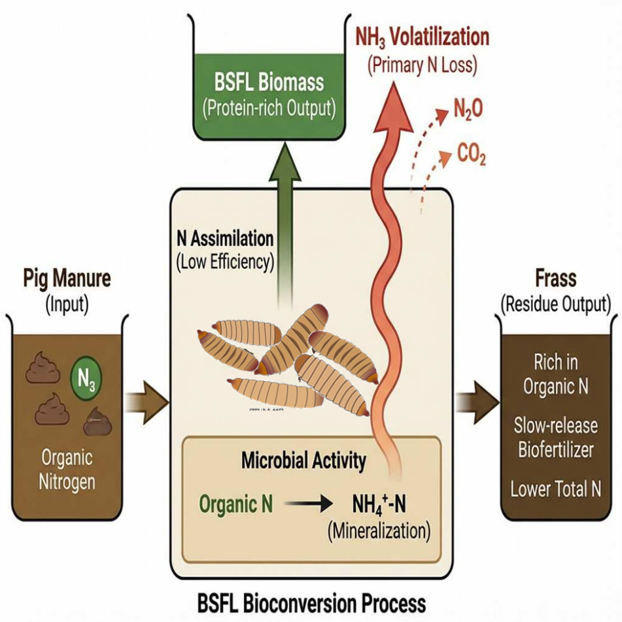
Figure 4. Nitrogen flow pathways in the black soldier fly larval conversion of pig manure system

5 Comparison of Treatment Efficiency of Pig Manure and Other Livestock and Poultry Manure and Optimization Strategies
Although BSFL has been proven to have broad adaptability to various wastes, the significant differences in the physicochemical characteristics of different livestock and poultry manures markedly restrict its biotransformation efficiency.Existing studies indicate that the biotransformation potential of pig manure is generally between that of poultry manure and ruminant manure, as shown in Table 3.
Table 3. Results of different feces transformed by black soldier fly larvae
Substrate | Transformation Time (Days) | Pre-pupal weight  (mg/pupa) | Degradation rate  （%） | References
Pig manure | 144±52.80 | 69.0±14.0 | 37.7±2.59 | ^{[22]}
chicken manure | 144±33.21 | 56.8±16.03 | 36.7±3.45 | ^{[22]}
Cow dung | 214.5±21.56 | 74.3±14.14 | 36.8±1.43 | ^{[22]}
Pig manure | 17.30±0.43 | 24.16±0.90 | 13.7 | ^{[68]}
chicken manure | 19 | 164±14 | 60±2.3 | ^{[69]}
Human feces | 19 | 245±5 | 47.7±1.1 | ^{[69]}
chicken manure | 11.3±0.3 | 113.7±8.5 | 46 | ^{[26]}
Cow dung | 15.6±0.6 | 99.0±5.4 | 48 | ^{[26]}
Pig manure | 16.7±0.6 | 82.7±0.9 | 33 | ^{[26]}
Cow dung | 22.03±0.26 | 52.77±1.50 | 43.17±0.45 | ^{[70]}
chicken manure | 18.34±0.16 | 97.54±1.70 | 55.04±0.31 | ^{[70]}
Cow dung | 24.3±0.2 | 62.8±1.2 | 25.8±2.8 | ^{[71]}
Horse dung | 25.75±17.38 | 41.00±2.00 |  | ^{[72]}
Human feces | 22.3±0.3 | 170±7.4 | 61.5±2.3 | ^{[73]}
Note:In the study by Oonincx et al.^{[22]},the feces were pretreated by drying and grinding; in the studies by Miranda and Lalander ^{[26, 69]},fresh thawed feces were used; Alyokhin, Nyakeri et al.^{[70-73]} used freshly collected feces.
To clarify the treatment positioning of pig manure, we need to systematically compare it with high-nitrogen chicken manure and high-fiber cow manure.Regarding pig manure,its degradation rate (33%–37%) is lower than that of chicken manure (46%–60%) and human feces (48%–62%),but better than some research results for cow manure (25%–48%).According to the study by Oonincx and others,in terms of nitrogen utilization efficiency,pig manure is actually superior to chicken manure and cow manure^{[22]}.Experimental data show that the larval survival rate in the pig manure group reached as high as 97.0%,significantly higher than the 82.2% in the chicken manure group,and the nitrogen conversion efficiency was highest in the pig manure group.This indicates that pig manure itself does not have serious biological toxicity and has good protein conversion potential.However,in terms of biomass conversion rate and development speed,the differences in substrates are more pronounced. Comparative experiments by Miranda et al.^{[26]} indicated that,under the same feeding frequency,larvae fed on chicken manure developed the fastest,taking about 11 days, with the highest biomass conversion rate of approximately 5.6%;in contrast, the biomass conversion rate of the pig manure group was only around 1.8%,and the development time extended to 16–20 days.
The core mechanism causing differences in BSFL conversion efficiency in different manures can be attributed to the degree of preservation of the substrate's native activity.This activity involves two aspects:the first is the bioavailability of nutrients.The shorter digestive tract of poultry results in their excreta retaining a relatively high abundance of undigested nutrients,whereas ruminant feces are rich in hard-to-degrade fibers^{[74]}.Therefore,the large amount of fiber in the feces hinders the larvae's uptake of intracellular nutrients,leading to insufficient energy acquisition and significantly prolonging the development cycle.The second point is the synergistic metabolic capability of the native microbial community.Comparing the research data of Oonincx and Miranda,the astonishing time difference (144 days vs.12–20 days) highlights the crucial role of pretreatment methods. In the study by Oonincx et al.,different feces were pretreated by drying and grinding.Drying at 60°C very likely killed beneficial microorganisms in the feces such as Bacillus spp. and destroyed heat-labile cofactors like B vitamins, leading to the collapse of an originally efficient insect-microbe synergistic metabolic network.In contrast,the freshly thawed feces used by Miranda retained microbial activity.This strongly demonstrates that the native microbial community is a necessary symbiotic condition for black soldier fly larvae to efficiently degrade pig manure and other livestock feces, essentially representing a metabolic synergy between the substrate microbes and BSFL.
For the engineering optimization of this special substrate,pig manure,the key lies in overcoming the nutritional structure limitations of 'low energy value and high fiber.'This requires systematically optimizing three aspects in engineering practice:pretreatment, feeding,and formulation.Pretreatment should avoid traditional 'over-cleaning' methods and should not use high-temperature sterilization or deep drying, so as not to destroy the indigenous microbial community.It is recommended to switch to mild solid-liquid separation to preserve the original microbial community and promote cellulose degradation.To address the low energy content of pig manure,a 'incremental compensation'dynamic feeding mechanism can be established.Miranda's experiments show that increasing the feeding amount from 18g to 27g can shorten the prepupal period by about 3–4 days^{[26]},indicating that appropriately overfeeding has a positive effect in low-energy substrates.
Given that pig manure has a lower biotransformation rate compared to other livestock and poultry manures but a higher nitrogen conversion efficiency,it can be used as a high-quality nitrogen source in the system,and co-digestion with substrates such as kitchen waste or soybean dregs can take advantage of complementary nutrition.In specific process control,Zhao et al.^{[75]} pointed out that moisture content and the carbon-to-nitrogen ratio are key variables determining microbial activity and organic matter transformation within the system, and established a C/N ratio of 25–30 as the optimal regulation range;experiments by Somaya et al.^{[76]} further confirmed that through such parameter optimization and co-digestion strategies,BSFL can not only efficiently produce high-protein biomass but also significantly reduce the organic matter content and pathogen load of the substrate,fully demonstrating the broad applicability and ecological benefits of this optimization approach in pig manure treatment.

6 Product characteristics and environmental benefits
Under the above optimization strategies,pig manure transformed by BSFL can not only achieve effective waste reduction,but also produce two core high-value products: protein-rich larval biomass and nutrient-rich frass^{[77]}.These products show extremely high economic and application value in resource utilization.On one hand, BSFL biomass contains 30%–57% protein and 21%–42% lipids^{[46, 67]},these are source of high-quality protein in animal feed^{[78]}.Black soldier fly larva oil (HIO) is rich in lauric acid and can effectively replace fish oil in aquafeed;at the same time, BSFL also shows great potential for biodiesel production,with a conversion rate of up to 94%^{[46]}.On the other hand, insect frass,which is the digestive by-product of larvae, can have an organic matter content of up to 83.5%,with total nitrogen,phosphorus, and potassium contents reaching 5.35%,0.65%,and 0.89% respectively.This process can not only reduce the load of pathogens such as Escherichia coli and Salmonella by 86%–88%,completely eliminate specific microorganisms such as Actinomycetes^{[67]},but also serve as organic fertilizer to promote plant growth^{[79]}.
Pig manure is one of the main wastes produced by animal husbandry,and if not properly managed,it can have negative impacts on the environment,health,and economy^{[80]}.Compared to traditional pig manure treatment processes such as anaerobic digestion or composting,BSFL bioconversion technology demonstrates more comprehensive and significant environmental advantages.First,in terms of waste reduction, BSFL conversion can achieve a 30%—56% reduction in pig manure dry matter within a short period of 7—14 days, with a degradation efficiency significantly higher than the 30%—40% of traditional composting processes,which usually take 20—30 days^{[81]}.Secondly,in terms of pollution control, this technology can efficiently block the environmental migration of pollutants,for example,achieving a removal rate of up to 86.6% for the heavy metal lead (Pb),and it can significantly reduce the germination rate of weed seeds such as Palmer amaranth in pig manure to control their spread^{[79]}.In addition,compared with traditional waste treatment processes,the BSFL system can effectively reduce greenhouse gas emissions such as CO₂ and N₂O,thereby genuinely alleviating the environmental burden brought by livestock farming.
In summary,BSFL bioconversion technology shows great potential and multiple benefits in handling pig manure.It not only efficiently degrades organic waste and reduces environmental pollution but also produces high-value protein, lipids,and organic fertilizers,providing an innovative approach for achieving sustainable agriculture and a circular economy.Future research should continue to focus on optimizing breeding conditions,improving conversion efficiency,ensuring product safety,and further exploring its environmental and socioeconomic benefits.

7 Conclusion
Using BSFL to process waste is an emerging technology.It can not only convert waste into commercially valuable products,but also provide an economical and ecologically sustainable management model for the circular economy.The conversion of pig manure by BSFL is a complex biochemical process involving deep cooperation between the host's enzymatic system and the gut microbial community.While the system achieves about a 50% reduction in dry matter,it can effectively mineralize typical pollutants such as antibiotics and,through its unique physiological and metabolic mechanisms,selectively excrete and control the accumulation of heavy metals.Although the nitrogen in pig manure can be efficiently assimilated into high-value insect protein and lipids,its conversion efficiency is highly dependent on the regulatory effects of the physicochemical properties of the substrate on the synergistic metabolic network of the insects and microbes.
In large-scale engineering practice,the high-fiber characteristics and low energy structure of pig manure have become the core bottlenecks restricting conversion efficiency,often leading to prolonged larval development cycles and insufficient biomass output.To address this issue,existing studies have proposed several optimization strategies:implementing co-digestion by introducing high-carbon waste to precisely anchor the C/N ratio at 25~30^{[75]},and inoculating functional microbial communities,such as Bacillus spp.,to enhance the degradation of lignocellulose ^{[47]};however,nitrogen loss caused by ammonia volatilization within the system remains the main obstacle to improving resource utilization efficiency,and the long-term accumulation risk of specific heavy metals,such as Cd,in recycling processes still requires further attention.
Future research should focus on tackling the biotechnological enhancement of lignocellulose degradation in pig manure,breaking the substrate barrier through the development of targeted exogenous enzyme preparations or functional microbial inoculation strategies,and improving system stability by combining co-digestion processes with precise control of temperature,humidity,feeding rate, and carbon-to-nitrogen ratio. At the same time,it is necessary to conduct in-depth research on new materials and processes for gaseous nitrogen collection.In the future,by thoroughly analyzing the interaction mechanisms and overcoming engineering bottlenecks,this technology is expected to become a key link connecting pollution control in animal husbandry with the development of circular agriculture, providing important support for achieving environmental protection and resource utilization goals.

[1] Mu G, Xu L, Zhang J. Study of the utilization of main crop straw resources in Southern China and its potential as a replacement for chemical fertilizers [J]. Frontiers in Plant Science, 2024, 14: 1172689.
[2] 张金金, 王占彬. 黑水虻在畜禽养殖中的应用与研究进展 [J]. 家畜生态学报, 2021, 42(04): 84-90.
[3] Escudero-Curiel S, Giráldez A, Pazos M, et al. From waste to resource: valorization of lignocellulosic agri-food residues through engineered hydrochar and biochar for environmental and clean energy applications—a comprehensive review [J]. Foods, 2023, 12(19): 3646.
[4] Lili W, Shengwen W, Rencan Y, et al. Effect of moisture content on larval gut microbiome and the conversion of pig manure by black soldier fly [J]. The Science of the total environment, 2023, 912: 169579-169579.
[5] Canton H. Food and agriculture organization of the United Nations—FAO [M]. The Europa directory of international organizations 2021. Routledge. 2021: 297-305.
[6] Lalander C, Ermolaev E, Wiklicky V, et al. Process efficiency and ventilation requirement in black soldier fly larvae composting of substrates with high water content [J]. Science of the Total Environment, 2020, 729: 138968.
[7] Lee K-S, Yun E-Y, Goo T-W. Resource Utilization of Residual Organic Sludge Generated from Bioenergy Facilities Using Hermetia illucens Larvae [J]. Insects, 2024, 15(7): 541.
[8] Lin C, Xia X, Li Y, et al. Heavy metals transport patterns and risk evaluation in the pig manure- black soldier fly-tilapia food chain [J]. Environmental Pollution, 2023, 337: 122565.
[9] Parodi A, Gerrits W J, Van Loon J J, et al. Black soldier fly reared on pig manure: Bioconversion efficiencies, nutrients in the residual material, greenhouse gas and ammonia emissions [J]. Waste Management, 2021, 126: 674-683.
[10] Veldkamp T, van Rozen K, Elissen H, et al. Bioconversion of digestate, pig manure and vegetal residue-based waste operated by black soldier fly larvae, Hermetia illucens L.(Diptera: Stratiomyidae) [J]. Animals, 2021, 11(11): 3082.
[11] Wang Y-S, Shelomi M. Review of black soldier fly (Hermetia illucens) as animal feed and human food [J]. Foods, 2017, 6(10): 91.
[12] Shumo M, Khamis F M, Tanga C M, et al. Influence of temperature on selected life-history traits of black soldier fly (Hermetia illucens) reared on two common urban organic waste streams in Kenya [J]. Animals, 2019, 9(3): 79.
[13] Seyedalmoosavi M M, Mielenz M, Veldkamp T, et al. Growth efficiency, intestinal biology, and nutrient utilization and requirements of black soldier fly (Hermetia illucens) larvae compared to monogastric livestock species: a review [J]. Journal of Animal Science and Biotechnology, 2022, 13(1): 31.
[14] Purkayastha D, Sarkar S. Sustainable waste management using black soldier fly larva: a review [J]. International Journal of Environmental Science and Technology, 2022, 19(12): 12701-12726.
[15] Chia S Y, Tanga C M, Khamis F M, et al. Threshold temperatures and thermal requirements of black soldier fly Hermetia illucens: Implications for mass production [J]. PloS one, 2018, 13(11): e0206097.
[16] Traksele L, Speiciene V, Smicius R, et al. Investigation of in vitro and in vivo digestibility of black soldier fly (Hermetia illucens L.) larvae protein [J]. Journal of Functional Foods, 2021, 79: 104402.
[17] Matos J S, de Aráujo L P, Allaman I B, et al. Evaluation of the reduction of methane emission in swine and bovine manure treated with black soldier fly larvae (Hermetia illucens L.) [J]. Environmental Monitoring and Assessment, 2021, 193(8): 480.
[18] Diener S, Zurbrügg C, Tockner K. Conversion of organic material by black soldier fly larvae: establishing optimal feeding rates [J]. Waste management & research, 2009, 27(6): 603-610.
[19] Kim W, Bae S, Park H, et al. The larval age and mouth morphology of the black soldier fly, Hermetia illucens (Diptera: Stratiomyidae) [J]. International Journal of Industrial Entomology, 2010, 21(2): 185-187.
[20] Hardouin J, Mahoux G. Zootechnie d'insectes-Elevage et utilisation au bénéfice de l'homme et de certains animaux [Z]. 2003
[21] Chineme A, Assefa G. Open and Closed Black Soldier Fly Systems Tradeoff Analysis [J]. Sustainability, 2023, 15(24): 16677.
[22] Oonincx D, Van Huis A, Van Loon J. Nutrient utilisation by black soldier flies fed with chicken, pig, or cow manure [J]. Journal of Insects as Food and Feed, 2015, 1(2): 131-140.
[23] Peng C, Zhou T, Song S, et al. Analysis and experiment of feeding material process of Hermetia illucens L. frass bucket wheel based on DEM [J]. Computers and Electronics in Agriculture, 2022, 196: 106855.
[24] Waldbauer G. The consumption and utilization of food by insects [M]. Advances in insect physiology. Elsevier. 1968: 229-288.
[25] Elsayed M, Li W, Abdalla N S, et al. Innovative approach for rapeseed straw recycling using black solider fly larvae: Towards enhanced energy recovery [J]. Renewable Energy, 2022, 188: 211-222.
[26] Miranda C D, Cammack J A, Tomberlin J K. Life-history traits of the black soldier fly, Hermetia illucens (L.)(Diptera: Stratiomyidae), reared on three manure types [J]. Animals, 2019, 9(5): 281.
[27] Visvini L, Latifah O, Ahmed O, et al. Frass production from black soldier fly larvae reared on palm oil wastes[C]// IOP conference series: Earth and environmental science, IOP Publishing,2022:012012
[28] Riolo K, Rotondo A, La Torre G L, et al. Cytoprotective and antioxidant effects of hydrolysates from black soldier fly (Hermetia illucens) [J]. Antioxidants, 2023, 12(2): 519.
[29] Banks I J, Gibson W T, Cameron M M. Growth rates of black soldier fly larvae fed on fresh human faeces and their implication for improving sanitation [J]. Tropical medicine & international health, 2014, 19(1): 14-22.
[30] Choi I H. Decomposition and Characteristics of Pig Manure–Sawdust Mixture Composted by Black Soldier Fly (Hermetia illucens L.) Larvae [J]. Entomological Research, 2025, 55(4): e70040.
[31] 李庆, 秦文杰, 曹秀芳, 等. 基于黑水虻转化的畜禽粪便资源化利用研究进展 [J]. 华中农业大学学报 (自然科学版), 2022, 41(6): 169-175.
[32] 陈燕乐, 唐昭山, 杨岸奇, 等. 黄芩防治畜禽呼吸道疾病的作用机制及产品应用综述 [J]. 湖南饲料, 2022.
[33] Wang L, Wang S, Yang R, et al. Effect of moisture content on larval gut microbiome and the conversion of pig manure by black soldier fly [J]. Science of The Total Environment, 2024, 912: 169579.
[34] Liu T, Klammsteiner T, Dregulo A M, et al. Black soldier fly larvae for organic manure recycling and its potential for a circular bioeconomy: A review [J]. Science of the Total Environment, 2022, 833: 155122.
[35] Wong C Y, Lim J W, Chong F K, et al. Valorization of exo-microbial fermented coconut endosperm waste by black soldier fly larvae for simultaneous biodiesel and protein productions [J]. Environmental Research, 2020, 185: 109458.
[36] Salahuddin M, Abdel-Wareth A A, Hiramatsu K, et al. Flight toward sustainability in poultry nutrition with black soldier fly larvae [J]. Animals, 2024, 14(3): 510.
[37] Gold M, Tomberlin J K, Diener S, et al. Decomposition of biowaste macronutrients, microbes, and chemicals in black soldier fly larval treatment: A review [J]. Waste Management, 2018, 82: 302-318.
[38] 谢洁微, 胡文锋, 李雪玲, 等. 利用黑水虻处理畜禽粪便中残留抗菌药物研究进展 [J]. 畜牧与饲料科学, 2021, 42(5): 73-78.
[39] Luo X, Fang G, Chen K, et al. A gut commensal bacterium promotes black soldier fly larval growth and development partly via modulation of intestinal protein metabolism [J]. mBio, 2023, 14(5): e0117423.
[40] Dong L, Ariëns R M, America A H, et al. Clostridium perfringens suppressing activity in black soldier fly protein preparations [J]. LWT, 2021, 149: 111806.
[41] 王会, 章启慧, 郑朝中, 等. 黑水虻生物转化降解抗生素的研究进展 [J]. 广东化工, 2023, 50(05): 123-125+106.
[42] Cai M, Ma S, Hu R, et al. Systematic characterization and proposed pathway of tetracycline degradation in solid waste treatment by Hermetia illucens with intestinal microbiota [J]. Environmental Pollution, 2018, 242: 634-642.
[43] Nan W. Changes in speciation, mobility and bioavailability of Cd, Cr and As during the transformation process of pig manure by black soldier fly larvae (Hermetia illucens) [J]. Journal of Integrative Agriculture, 2021, 20(5): 1157-1166.
[44] Wu N, Wang X, Yan Z, et al. Transformation of pig manure by passage through the gut of black soldier fly larvae (Hermetia illucens): Metal speciation, potential pathogens and metal-related functional profiling [J]. Ecotoxicology and Environmental Safety, 2021, 211: 111925.
[45] Siddiqui S A, Ristow B, Rahayu T, et al. Black soldier fly larvae (BSFL) and their affinity for organic waste processing [J]. Waste Management, 2022, 140: 1-13.
[46] Liviu Urechescu L, Arshad A, Maria Drăghici E. Composting Swine Manure Using The Biotechnology of Hermetia Illucens, The Black Soldier Fly Larvae: A Review [J]. International Journal of Advanced Multidisciplinary Research and Studies, 2024, 4(5): 24-29.
[47] Shao M, Zhao X, Rehman K U, et al. Synergistic bioconversion of organic waste by black soldier fly (Hermetia illucens) larvae and thermophilic cellulose-degrading bacteria [J]. Frontiers in Microbiology, 2024, 14: 1288227.
[48] Hao J, Liu S, Luo A, et al. Assessing nursery-finishing pig manures on growth of black soldier fly larvae [J]. Animals, 2023, 13(3): 452.
[49] 叶小梅, 尹寒, 奚永兰, 等. 黑水虻幼虫肠道微生物的功能及组学应用 [J]. 环境昆虫学报, 2024, (001): 046.
[50] ur Rehman K, Rehman R U, Somroo A A, et al. Enhanced bioconversion of dairy and chicken manure by the interaction of exogenous bacteria and black soldier fly larvae [J]. Journal of Environmental Management, 2019, 237: 75-83.
[51] Newton L, Sheppard C, Watson D W, et al. Using the black soldier fly, Hermetia illucens, as a value-added tool for the management of swine manure [J]. Animal and Poultry Waste Management Center, North Carolina State University, Raleigh, NC, 2005, 17(2005): 18.
[52] Zhou F, Tomberlin J K, Zheng L, et al. Developmental and waste reduction plasticity of three black soldier fly strains (Diptera: Stratiomyidae) raised on different livestock manures [J]. J Med Entomol, 2013, 50(6): 1224-1230.
[53] Deng B, Liu Z, Gong T, et al. Addition of plantation waste to the bioconversion of pig manure by black soldier fly larvae: Effects on heavy metal content and bioavailability [J]. Waste Management, 2024, 176: 64-73.
[54] Barboráková Z, Urminská J, Jakabová S, et al. Safety of black soldier fly larvae: Microbial and heavy metal risks [J]. Journal of microbiology, biotechnology and food sciences, 2024, 14(3): e12069-e12069.
[55] Diener S, Zurbrügg C, Tockner K. Bioaccumulation of heavy metals in the black soldier fly, Hermetia illucens and effects on its life cycle [J]. Journal of insects as food and feed, 2015, 1(4): 261-270.
[56] Grosso F, Calà E, Regalli N, et al. Canteen waste as food for black soldier fly larvae: risk of heavy metals accumulation? Variability during one year of rearing [J]. Journal of Insects as Food and Feed, 2024, 10(9): 1555-1568.
[57] Hu C, Yang L, Wang H, et al. Analysis of heavy metals in the conversion of lake sediment and restaurant waste by black soldier fly (Hermetia illucens) [J]. Frontiers in Bioengineering and Biotechnology, 2023, 11: 1163057.
[58] Proc K, Bulak P, Wiącek D, et al. Hermetia illucens exhibits bioaccumulative potential for 15 different elements – Implications for feed and food production [J]. Science of The Total Environment, 2020, 723: 138125.
[59] Wang N, He Y, Zhang X, et al. Assessment of the combined response of heavy metals and human pathogens to different additives during composting of black soldier fly manure [J]. Journal of Hazardous Materials, 2025, 493: 138347.
[60] Zhang J-b, Zhang J, Li J-h, et al. Black soldier fly: A new vista for livestock and poultry manure management [J]. Journal of Integrative Agriculture, 2021, 20(5): 1167-1179.
[61] Shelomi M. Potential of Black Soldier Fly Production for Pacific Small Island Developing States [J]. Animals, 2020, 10(6): 1038.
[62] Li Q, Zheng L, Cai H, et al. From organic waste to biodiesel: Black soldier fly, Hermetia illucens, makes it feasible [J]. Fuel, 2011, 90(4): 1545-1548.
[63] Parodi A, Yao Q, Gerrits W J J, et al. Upgrading ammonia-nitrogen from manure into body proteins in black soldier fly larvae [J]. Resources, Conservation and Recycling, 2022, 182: 106343.
[64] Grassauer F, Ferdous J, Pelletier N. Manure valorization using black soldier fly larvae: a review of current systems, production characteristics, utilized feed substrates, and bioconversion and nitrogen conversion efficiencies [J]. Sustainability, 2023, 15(16): 12177.
[65] Wu N, Ma Y, Yu X, et al. Black soldier fly larvae bioconversion and subsequent composting promote larval frass quality during pig and chicken manure transformation process [J]. Bioresource Technology, 2024, 402: 130777.
[66] Li X, Zhou Y, Su Y, et al. Microbial mechanisms enhancing humification and nitrogen retention during co-composting of black soldier fly frass and pig manure [J]. Waste Management, 2025, 208: 115146.
[67] Ngassa T G R, Agada A F, Mba O F, et al. Quality of black soldier fly (Hermetia illucens L.) larvae frass according to feeding substrates in Dschang (West Cameroon) [J]. Bioresource Technology Reports, 2025, 32: 102332.
[68] Liu Z, Minor M, Morel P C, et al. Bioconversion of three organic wastes by black soldier fly (Diptera: Stratiomyidae) larvae [J]. Environmental entomology, 2018, 47(6): 1609-1617.
[69] Lalander C, Diener S, Zurbrügg C, et al. Effects of feedstock on larval development and process efficiency in waste treatment with black soldier fly (Hermetia illucens) [J]. Journal of Cleaner Production, 2019, 208: 211-219.
[70] ur Rehman K, Cai M, Xiao X, et al. Cellulose decomposition and larval biomass production from the co-digestion of dairy manure and chicken manure by mini-livestock (Hermetia illucens L.) [J]. Journal of environmental management, 2017, 196: 458-465.
[71] ur Rehman K, Rehman A, Cai M, et al. Conversion of mixtures of dairy manure and soybean curd residue by black soldier fly larvae (Hermetia illucens L.) [J]. Journal of Cleaner Production, 2017, 154: 366-373.
[72] Alyokhin A, Buzza A, Beaulieu J. Effects of food substrates and moxidectin on development of black soldier fly, Hermetia illucens [J]. Journal of Applied Entomology, 2019, 143(1-2): 137-143.
[73] Nyakeri E, Ayieko M, Amimo F, et al. An optimal feeding strategy for black soldier fly larvae biomass production and faecal sludge reduction [J]. Journal of Insects as Food and Feed, 2019, 5(3): 201-214.
[74] Choct M, Hughes R J, Wang J, et al. Increased small intestinal fermentation is partly responsible for the anti‐nutritive activity of non‐starch polysaccharides in chickens [J]. British poultry science, 1996, 37(3): 609-621.
[75] 赵懿, 陈海斌, 杜建军, 等. 畜禽粪便肥料化及其在土壤改良中的应用综述 [J]. 湖南农业科学, 2023, (04): 109-114.
[76] Naser El Deen S, van Rozen K, Elissen H, et al. Bioconversion of different waste streams of animal and vegetal origin and manure by black soldier fly larvae Hermetia illucens L.(Diptera: Stratiomyidae) [J]. Insects, 2023, 14(2): 204.
[77] Zhang H, Zhang X, Chen M, et al. Biochar can improve absorption of nitrogen in chicken manure by black soldier fly [J]. Life, 2023, 13(4): 938.
[78] Niranjan B H, Govindaiah P M, Yandigeri M S, et al. Bioconversion and Performance of Black Soldier Fly (Hermetia illucens) in Converting Organic Poultry Waste Materials into High Value Products and Fertilizers [J]. Waste and Biomass Valorization, 2024, 15(9): 5559-5572.
[79] Diola C S, Nacilla E J, Pardillo C A, et al. Waste Reduction and Bioconversion of Quail, Chicken, and Pig Manure by Black Soldier Fly (Hermetia illucens L.) [J]. Philippine Journal of Science, 2024, 153(2).
[80] Vingerhoets R, Sigurnjak I, Spiller M, et al. Enhancing swine manure treatment: A full-scale techno-economic assessment of nitrogen recovery, pure oxygen aeration and effluent polishing [J]. Journal of Environmental Management, 2024, 356: 120646.
[81] Zhang Z, Liu D, Qiao Y, et al. Mitigation of carbon and nitrogen losses during pig manure composting: A meta-analysis [J]. Science of The Total Environment, 2021, 783: 147103.

