Summary of Best Evidence for Pelvic Floor Muscle Training During Pregnancy

Yidan Lu¹，*

¹ Shanghai Jiao Tong University School of Medicine, Shanghai 200025, China
*Corresponding author: Yidan Lu ；Email: Xxyj1123@126.com

Abstract
Background: Pelvic floor muscle training during pregnancy is a first-line, non-invasive intervention for the prevention of pelvic floor dysfunction. Although its benefits have been widely recognized, existing evidence remains fragmented across different sources, and standardized clinical recommendations are lacking. A comprehensive synthesis of the best available evidence is urgently needed to guide clinical practice.
Objectives：To provide an evidence - based approach for the clinical practice of pelvic floor muscle training, thereby promoting pregnancy health management and long - term quality of life in women.
Methods: Guided by the 6S evidence pyramid model, a top-down search was conducted from database inception to December 30, 2025. Two reviewers independently screened, extracted, and synthesized evidence following the Joanna Briggs Institute methodology, and graded the evidence level and recommendation strength.
Results: A total of 33 publications were included (8 guidelines, 3 clinical decisions, 1 expert consensus, 4 evidence summaries, and 17 systematic reviews). Following a comprehensive analysis, 26 evidence-based recommendations were developed, which were categorised into 7 aspects: overall suggestion, cost-effectiveness, efficacy, safety, timing, protocol, and adherence.
Conclusions: This study summarised the best evidence of pelvic floor muscle training in pregnant women. By adhering to the best available evidence, healthcare providers and pregnant women can work cooperatively to promote delivery outcomes, enhance the pelvic floor muscle, and reduce the incidence of pelvic floor dysfunction.

Keywords: pelvic floor muscle training, best evidence, intervention, pregnancy

Brief Summary: This study systematically summarizes the best evidence for pelvic floor muscle training during pregnancy for clinical application.

Introduction
Over the past few decades, significant progress has been made globally in reducing maternal mortality rates. However, this achievement has been accompanied by a relative neglect of postpartum morbidity arising from pregnancy and childbirth (e.g., pelvic floor dysfunction and depression). These conditions can impose substantial social, economic, and health burdens.
As stated in the Yellow Emperor’s Inner Classic, “The superior physician treats disease before it arises.” Pregnancy and childbirth are independent risk factors for pelvic floor dysfunction (PFD) [1]. Pelvic floor muscle training (PFMT) is the first-line method for preventing PFD, which is effective at all stages of tertiary prevention. This indicates that it is extremely necessary to take proactive intervention measures during pregnancy [2-5].
Currently, there is no clear clinical guidance on how to perform PFMT during pregnancy, nor is there a standardised operating procedure. This directly results in significant heterogeneity in actual clinical practice and relevant research. Key challenges to PFMT include the following: (a) Unclear start timing; (b) Suboptimal adherence; (c) Inconsistent training efficacy; (d) Insufficient health education efforts by medical staff [2,6-10]. This heterogeneity potentially increases women's susceptibility to additional health risks and associated complications. To address this critical evidence-practice gap, relevant domestic and international clinical decisions, guidelines, systematic reviews, and other studies were retrieved to form the best evidence, facilitating the translation of evidence into clinical practice for PFMT during pregnancy to promote women’s health.
Method
Problem establishment
The PIPOST (P [population], pregnant women; I [intervention], PFMT; P [professional], medical staff; O [outcome], PFMT-relevant outcomes; S [setting], hospitals, communities, and families; and T [type of evidence], guideline, systematic review, expert consensus, evidence summary, best practice, and clinical decision) method was applied to define the key research questions for this study [11] .
Search strategy
Evidence retrieval is searched from the top-down according to the ‘6S’ evidence resource model [12].The following databases were searched: UpToDate; BMJ Best Practice; National Institute of Health and Clinical Excellence (NICE); Scottish Intercollegiate Guidelines Network; New Zealand Guidelines Group; Guideline International Network; JBI Database; Cochrane Database; Society of Obstetricians and Gynaecologists of Canada (SOGC); Polish Society of Gynecologists and Obstetricians (PSGO); American Urological Association (AUA); European Association Of Urology (EAU); Canadian Urological Association (CUA); Department of Health and Aged Care (DHAC); International Consultation on Incontinence (ICI); International Continence Society (ICS); Registered Nurses’ Association of Ontario (RNAO); Chinese Nursing Association; Embase; PubMed; Web of Science; SinoMed; CINAHL; Yiigle; China National Knowledge Infrastructure (CNKI); Weipu; and Wanfang. The development of search queries involved a hybrid approach, utilising both MeSH terms and free words. Keywords were captured using terms like “pelvic floor muscle training / pelvic floor muscle exercise / conservation management / non-surgical treatment / physical therapy / Kegel exercise” and “pregnancy / gestation / gravidity / pregnant women / delivery / labour / antenatal / perinatal”. The search deadline is December 30,2025.
Literature inclusion and exclusion criteria
The selection criteria were as follows: (i) pregnant women; (ii) relevant to PFMT; (iii) guidelines, clinical decisions, evidence summaries, best practices, systematic reviews, or expert consensus; (iv) Published in Chinese or English. Grounds for exclusion were: (i) literature presented as guideline interpretations, republished, or updated versions and (ii) incomplete information, unavailable full text, or low quality.
Study selection and data extraction
The screening phase involved two independent reviewers assessing all retrieved records based on the inclusion and exclusion criteria. Any disagreements that arose were settled either by consensus following discussion or through decision by a third party. Following screening, the same reviewers proceeded to data extraction. This extraction was conducted independently using a standardised template, with reviewers blinded to each other’s work to minimise bias. Specific data collected encompassed study characteristics such as the first author, publication year, country, source, evidence type, and the title.
Literature quality evaluation criteria
We assessed the quality of the literature using a tiered strategy, where each document type was evaluated with its specific, corresponding critical appraisal instrument. (1) Guidelines were assessed with the AGREE II tool [13]. (2) Systematic reviews were appraised with AMSTAR 2 [14]. (3) The evidence summary and best practice were evaluated using the Critical Appraisal for Summaries of Evidence (CASE) tool [15]. (4) For expert consensus, the standardised criteria from the JBI Centre were applied [16]. (5) Evidence from authoritative databases (UpToDate and BMJ Best Practice) was regarded as high-quality evidence and adopted.
Literature quality evaluation process
To ensure methodological rigour, two independently working reviewers, both grounded in evidence-based nursing, performed the quality evaluations. Disagreements were adjudicated by a third party with expertise in evidence-based research. The guiding principle for inclusion was to resolve conflicts among the extracted evidence by prioritising those derived from explicit evidence-based processes, possessing higher quality assessments, and representing the most recent and authoritative sources.
Criteria for determining evidence and recommendation levels
The evaluation of the incorporated evidence was guided by the JBI grading system [17]. This framework operates on a two-component principle: first, evidence is assigned to one of five levels (1-5) according to its research design; second, its recommendation strength is classified through the FAME structure (assessing Feasibility, Appropriateness, Meaningfulness, and Effectiveness) as either Grade A (strong) or Grade B (weak).
Ethics Approval
Not applicable. This review synthesizes published, publicly available literature; no participants or identifiable data were involved.
Results
General characteristics of the included literature
From an initial retrieval of 16,831 citations, a rigorous screening process involving deduplication and sequential review of titles, abstracts, and full texts yielded 33 articles for final inclusion. The composition of the evidence base included 8 guidelines [6,18-24],3 clinical decisions [25-27], 1 expert consensus [28],2 best practices [7,8], 2 evidence summaries [29,30] and 17 systematic reviews [2,9,31-45]. The study selection flow is depicted in Figure 1, with the general information of the included studies provided in Table 1.
Quality evaluation results of the included literature
- Guidelines: The guideline appraisal encompassed eight documents [6,18-24]. Three received a Grade A recommendation for scoring ≥60% on all six domains [18,19,22],while the rest were graded B [6,20,21,23,24]. The standardised domain scores and overall evaluations are available in Table 2. (2) Clinical decision: This study included three clinical decisions, all of which were from UpToDate, of high quality, and approved for inclusion [25-27]. (3) Expert Consensus: One expert consensus met all appraisal criteria ("yes" on all items) and was included [28]. (4) Best Practices & Evidence Summaries: This paper included four best practice articles and evidence summaries, including 2 from JBI [7,8] and 2 from Yiigle [29,30]. The quality assessment results are shown in Table 3. (5) Systematic reviews: The final set contained 17 systematic reviews, among which 6 were from PubMed [2,9,31,40-42], 4 from Embase [39,43-45], 1 from Cochrane Library [38], 2 from Yiigle [32,37], and 4 from CNKI [33-36]. Their quality evaluation results are shown in Table 4.
Summary and description of evidence
Data extraction was performed on the final included literature, and the body of evidence was subsequently assessed using the JBI evidence grading and recommendation system. Through a process of synthesis and integration, the evidence was organised into seven key categories, leading to the formulation of 26 best-practice recommendations (Table 5). The recommendations addressed 7 key categories: overall suggestion, cost-effectiveness, efficacy, safety, timing, protocol, and adherence.
Discussion
Overall suggestion
Preventing and managing PFD are essential for improving the quality of life among pregnant and elderly women while reducing the medical care burden on families and society. Numerous studies [6,18-24] indicated that pregnant women without contraindications should be encouraged to perform PFMT during pregnancy to prevent PFD and induce labour. Despite increasing attention to PFD and the rising popularity of PFMT during pregnancy, current management approaches remain unscientific and unstandardised [18,28,30]. It is recommended that a multidisciplinary team be formed to provide guidance on the assessment and treatment of PFD, including referral pathways to relevant specialists.
Cost-effectiveness
Globally, urinary incontinence (UI) is acknowledged as a widespread and costly condition affecting women. PFMT during pregnancy has been shown to be a cost-effective strategy for managing UI [18,31,45]. Brennen’s team identified group-based PFMT as the most economically viable approach, with its value being sensitive to both attendance numbers and direct costs to participants [31]. However, the current body of evidence supporting this has limitations, including relatively small studies and methodological constraints, resulting in evidence of mostly low-to-moderate quality. It is thus recommended that subsequent trials include comprehensive economic analyses or report sufficient intervention details to enable cost projections by other researchers and healthcare providers.
Efficacy
The integrated lifespan model proposed by De Lancey et al. provides a conceptual framework for understanding the impact of biological and lifestyle factors on pelvic floor integrity and performance [46]. From a clinical perspective, the pelvic floor musculature possesses significant plasticity, allowing for targeted neuromuscular re-education. Such training can optimise its contribution to urethral closure mechanisms and substantially augment its functional reserve capacity [47]. Handa et al. concluded that continent women who initiate PFMT during pregnancy are 30% less likely to develop UI up to 6 months following birth than women who do not engage in PFMT [26]. There is insufficient high-quality evidence to show that PFMT before the birth reduces the risk into the late postnatal period (i.e., > 6 months postpartum) [6,19,22,29]; it is reasonable to assume that to experience long-term benefits, any training must be continued long-term. Faecal incontinence (FI) is also painful and more common in parous women [48]. Longitudinal research demonstrates a persistent pattern of FI following childbirth, affecting approximately 35% of women during pregnancy and 25% at one year postpartum, with a gradual decline to 12-14% over the subsequent 6-12 years. This long-term trajectory contrasts with findings from antenatal intervention [49]. A systematic review by Woodley et al., which incorporated eight trials, did not identify a statistically significant reduction in FI prevalence during late pregnancy from antenatal PFMT (RR, 0.64; 95% CI, 0.36-1.14; moderate-quality evidence) [38]. This conclusion aligns with the work of Zhang et al., who attribute the finding to the scarcity of FI-focused studies and a lack of large-sample data in the current evidence base [35].
Pelvic organ prolapse (POP) is related to ageing, pregnancy, and childbirth. For elderly women, surgical treatment is usually required. Professors Hagen and Stark did a systematic review [50], to compare how well conservative treatment works versus no treatment or other therapies for preventing and treating POP. Their findings showed that PFMT helps improve symptoms of POP. At this point, most guidelines [18] suggest that pregnant women without exercise contraindications should do PFMT. Similarly, lumbopelvic pain [51] is a frequently reported complaint during pregnancy, and for many women, this discomfort extends into the postpartum period. Vesentini’s team conducted a meta-analysis of PFMT’s effect on lumbopelvic pain [41]. They pointed out that even though the results are statistically significant, the real efficacy is weak, and the trials exhibit high heterogeneity. But the impact of pain on women’s daily lives and work is real [52,53], so its effectiveness still needs to be further explored.
In many countries, sexual dysfunction is wrapped in silence and stigma-due to cultural taboos, biological factors, and a history of sexual abuse. The topic has turned increasingly enigmatic. This societal silence has built an invisible wall, causing a lot of patients to struggle in the maze. Sexual dysfunction is relatively common among postpartum women. A prospective observational study noted that approximately 41%-83% of women experience sexual dysfunction within two or three months postpartum[54], with around 64% still having it six months later. Dr Jorge’s meta-analysis of 4 studies noted that the PFMT group saw a 7.67-point increase in sexual function scores [39], such as sexual arousal, orgasm, and satisfaction. As well as Dr Jorge’s research, Zahra and other scholars conducted a systematic review to explore the impact of PFMT on sexual function and quality of life [43]. The results indicated that PFMT can enhance sexual function in both primiparous and multiparous women. Beyond its benefits for sexual health, considerable research also points to a significant ancillary advantage: PFMT contributes to a reduction in the duration of the first and second stages of labour [8,9,32,33]. This finding suggests that continuous PFMT during pregnancy can help pregnant women improve the contraction and relaxation of pelvic floor muscle fibres. However, there is heterogeneity in the reduction of episiotomy and perineal tear rates. Accordingly, further high-quality research on episiotomy and perineal tears is needed in the future.
Safety
The meta-analysis by Woodley et al., which encompassed a substantial cohort of 10,832 women across 21 countries from 46 trials, affirmed the favourable safety of PFMT. Reports of adverse events were exceptionally rare, with only two participants withdrawing from a prevention study due to pelvic floor discomfort among 43 enrolled [38]. No other trial documented any further adverse effects attributable to the intervention. The EAU guideline also pointed out that PFMT rarely causes adverse events, with no serious adverse events reported (1 level of evidence) [19]. In addition, both studies indicate that pelvic floor training is unlikely to be harmful in most situations. Most adverse reactions are reversible and can be resolved by reducing the training dose [27,43]. Thus, medical staff should address concerns among pregnant women about PFMT during pregnancy in advance when providing health education.
Timing
It’s generally accepted that pregnancy is a physical sensitivity phase, but there remains no definitive consensus on the best timing to start PFMT. NICE guidance emphasises that promoting pregnant women’s awareness and training of PFMT during this period is crucial [18]. Based on 3 considerations: the perinatal period serves as a unique intervention window, not only a critical time when potential symptoms first emerge and individual risk factors can be easily identified, but also the golden timing to initiate primary prevention strategies. Although reported starting points in trials vary widely from the 11th to the 28th week of pregnancy [28], Olander et al. reframe the entire pregnancy and postpartum journey as a series of discrete, opportune moments. Contacts such as the first prenatal visit and the postnatal check-up are thus seen as behavioural tipping points that can either facilitate or inhibit adherence to preventive training [55]. Consequently, the optimal timing for pregnant women to begin training requires further high-quality randomised controlled trials to determine and further promote clinical practice.
Protocols
There is currently no standard PFMT protocol internationally, and there are many uncertainties regarding the specific implementation of PFMT in clinical practice, such as the intensity, frequency, duration, position, and whether auxiliary tools are needed. There is a lack of sufficient clinical data and expert consensus to support the efficacy of PFMT. Sun et al. emphasise that effective pelvic floor muscle training protocols should adhere to the FITT principle (Frequency, Intensity, Time, and Type) [28]. Elaborating on this, Professor Kari Bø has outlined a minimal protocol for beginners: performing 2-3 sets daily (on at least 3 days per week) over 8-12 weeks, with each set comprising 8-10 near-maximal contractions held for 6-8 seconds [56]. Practice guidelines further specify that a home-based regimen should incorporate basic voluntary contractions (1-2 second holds with equal rest) and sustained voluntary contractions (initially 6-10 seconds with equal rest). The duration of sustained contractions should be progressively increased up to 10 seconds once a baseline is established [6].
Acknowledging the preference for easily remembered regimens, Woodley et al. advocate for a cognitively streamlined prescription. They propose an evidence-based minimum standard for pelvic floor muscle strengthening: a sequence of 8 contractions, each sustained for 8 seconds followed by an 8-second rest, performed 3 times daily on 3 days per week over a 3-month period [57]. Another guideline from China recommends contracting the pelvic floor muscle for at least 3 s, relaxing for 2-6 s, and repeating this for 15-30 min, 3 times a day, or performing 150-200 contractions a day for > 3 months [21]. The use of different PFMT protocols can affect the efficacy of PFMT for pregnant women and subsequent treatment, so it is necessary to implement a standardised PFMT protocol. Future research should strive to describe protocol details in a detailed and standardised manner to provide high-quality evidence for the collection of future pelvic floor rehabilitation big data.
Adherence
Viewed through the lens of behavioural science, PFMT adherence during pregnancy is a complex process that proves difficult to maintain long-term, even though it is essential for achieving therapeutic benefits [7,8,20,30]. Utilising the COM-B (Capability, Opportunity, Motivation, and Behaviour) framework, Olander et al. categorised the determinants of this behaviour [55]. The model defines its initial component, ‘Capability’, as the individual’s psychological and physical capacity to execute the behaviour, which implies both adequate knowledge and practical skill. In a study of 633 pregnant women, Hill et al. reported that 41% believed UI during pregnancy is a normal phenomenon [58]. A survey by Wang et al. of 1243 pregnant women showed that although 52% of women experienced UI symptoms during pregnancy, only 14.8% of pregnant women reported seeking help for UI [59]. Therefore, the purpose of health education is not only to impart knowledge but more importantly to emphasise health awareness from the source of thought.
The ‘Opportunity’ dimension is constituted by a range of exogenous variables, encompassing both the social context and the physical environment that the woman encounters. The primary reason women who had previously engaged in PFMT ceased training during pregnancy was a concern that PFMT would increase the risk of miscarriage [60]. Salmon et al. showed that pregnant women prefer to obtain pelvic floor rehabilitation information through consultations with physicians or nurses, but healthcare providers face highly competitive pressures and heavy workloads, which contribute to insufficient attention to this issue [61]. Although Mason et al. introduced early evening classes to address the scheduling conflicts of working women, this accommodation did not translate into the anticipated participant turnout, with class attendance remaining lower than expected [62]. Therefore, we can reasonably assume that pregnant women generally lack training time. If pregnant women can schedule classes on weekends, perhaps pregnant women will have more time to focus on PFMT.
The concept of ‘Motivation’ describes the degree of willingness an individual possesses to modify their actions. A study conducted in Nepal demonstrated that pregnant women who received more support from their families were more willing to exercise and more likely to be compliant [63]. Temtanakitpaisan et al. also found that the attitude of pregnant women toward PFMT is a key factor in the decision to engage in PFMT [64].
In sum, synthesis of available data reveals that adherence to PFMT can be supported through digital tools, diary-keeping, communal exercise, health literacy programmes, and ongoing support [18,23,33,38,43]. Nevertheless, strategies for ensuring the long-term persistence of both clinical benefits and patient compliance constitute priority areas for further scientific inquiry.
Strength and limitations
This study conducted a comprehensive systematic search on PFMT during pregnancy, making the clinical practice recommendations developed in this study feature relatively high methodological quality and a solid evidence base, which can provide reliable support for the clinical promotion of PFMT during pregnancy. However, when using these recommendations, we need to consider their limitations. In existing trials, PFMT intervention protocols lack uniform standards for intensity,frequency, and duration, which leads to significant heterogeneity among studies and further affects the integration of results and the derivation of unified conclusions. While the literature included in this review covers different countries, the applicability of its findings in practice still requires further verification. At the same time, the impact of some supporting evidence is controversial, which also means that the interpretation of overall study results must be approached with caution.
Conclusions
As stated above, this paper has summarised the best evidence for PFMT during pregnancy from the following seven aspects: overall suggestion, cost-effectiveness, efficacy, safety, timing, protocol, and adherence. It therefore serves as a foundational reference for clinicians and community healthcare providers to guide clinical decision-making and deliver evidence-based care for pregnant women. Some of the evidence integrated in this review is derived from international studies. Therefore, when translating evidence into local clinical practice, it is advisable to make necessary adjustments to the relevant recommendations. Clinicians should take into account local healthcare resource availability, characteristics of the target population, and patient preferences to flexibly select and use the most relevant evidence. PFMT is a key measure to improve women’s pelvic floor health across their entire lifespan and has a clear role in preventing pregnancy-related UI, promoting birth outcomes, and decreasing the risk of PFD. Consequently, it is essential to promote in-depth collaboration between obstetrics and rehabilitation medicine, jointly establish evidence-based standardised PFMT implementation path, and build a sustainable long-term intervention mechanisms. Such measures will systematically enhance the quality of perinatal care and women’s well-being.

Declarations
Funding: The authors did not receive a specific grant for this research from any funding agency in the public, commercial or not-for-profit sectors.
Conflict of Interest: The authors declare that they have no Conflict of Interest.

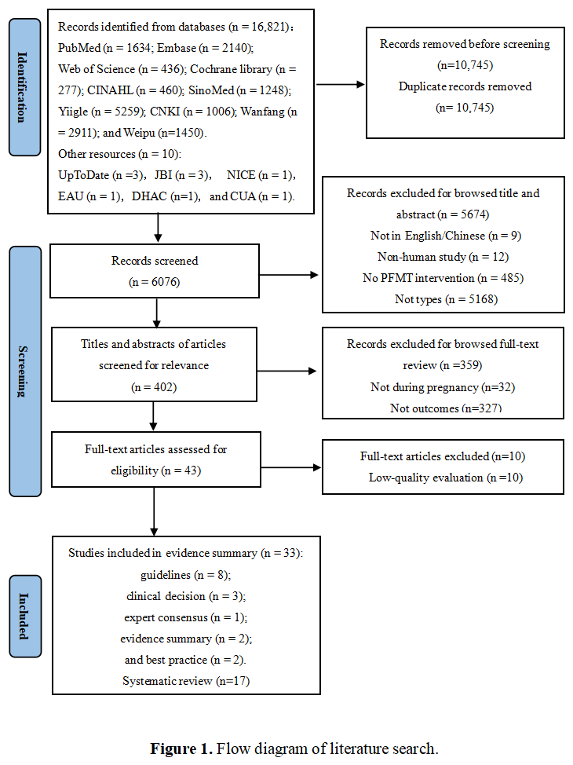

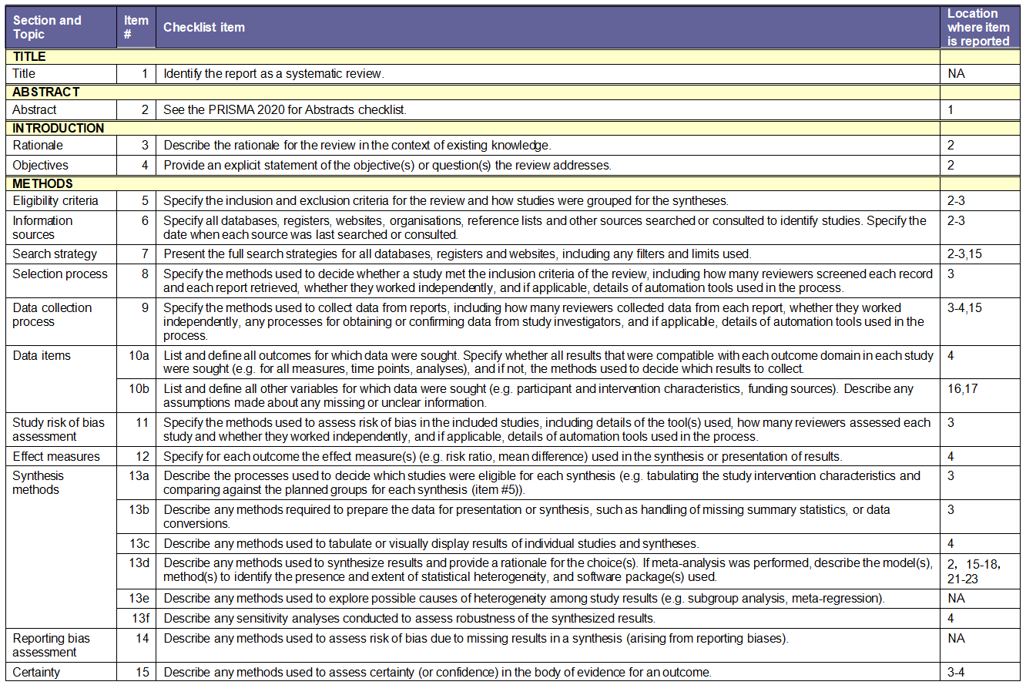
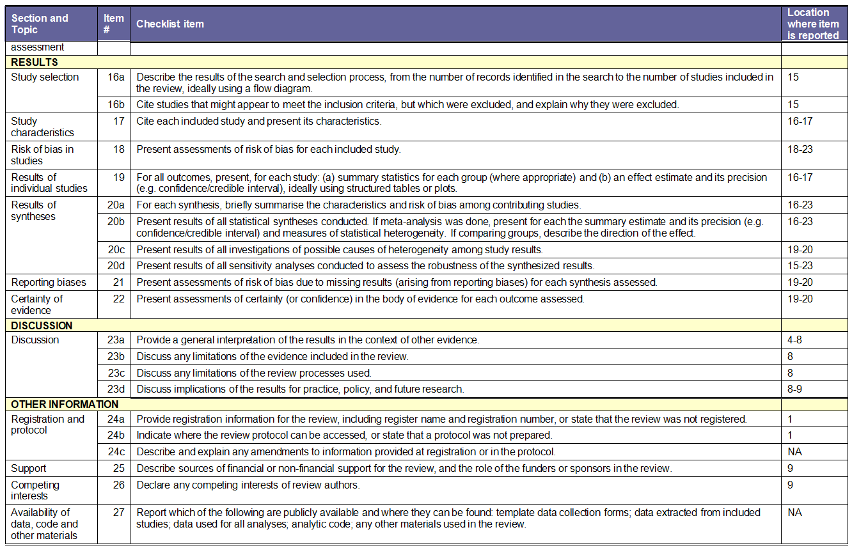
From: Page MJ, McKenzie JE, Bossuyt PM, Boutron I, Hoffmann TC, Mulrow CD, et al. The PRISMA 2020 statement: an updated guideline for reporting systematic reviews. BMJ 2021;372:n71. doi: 10.1136/bmj.n71

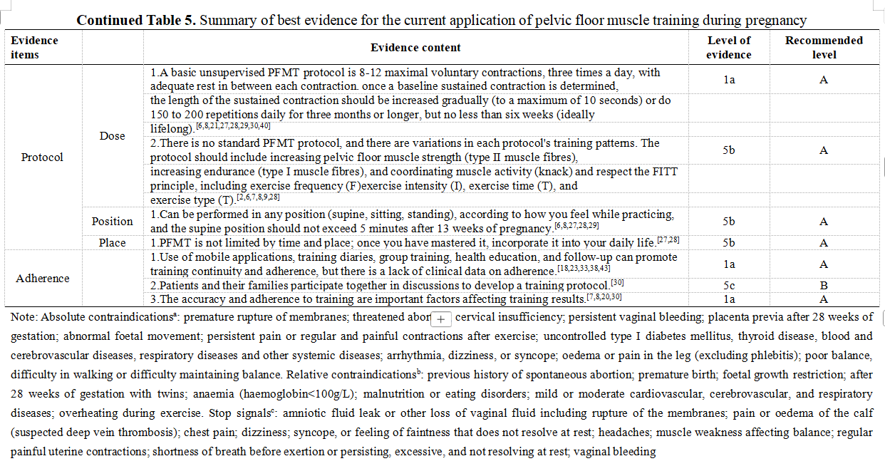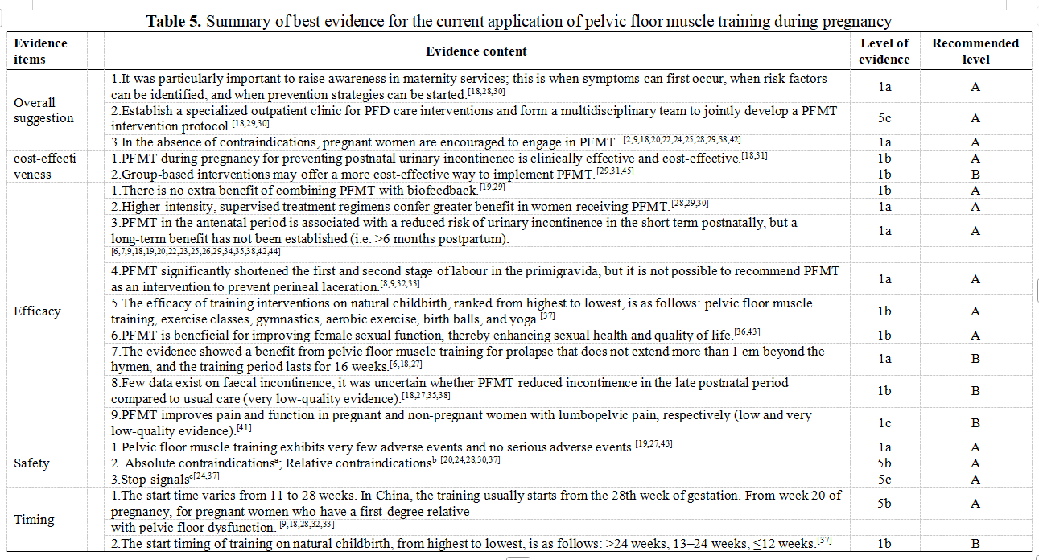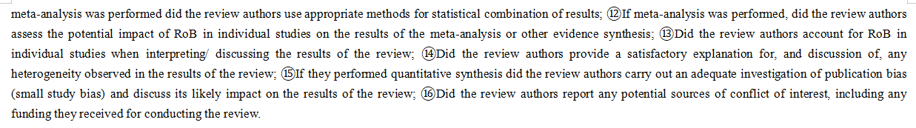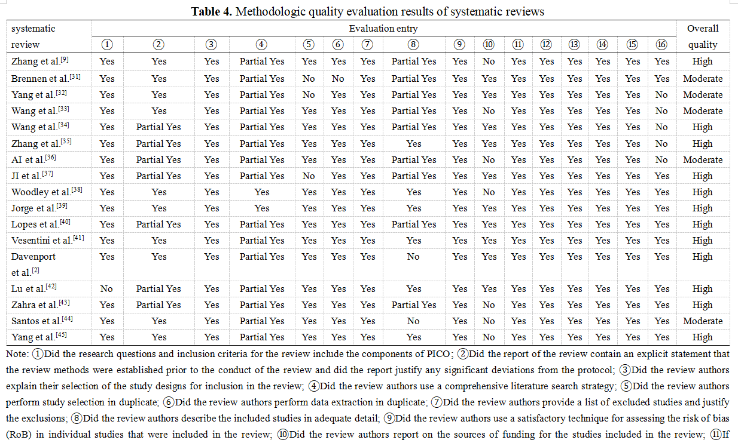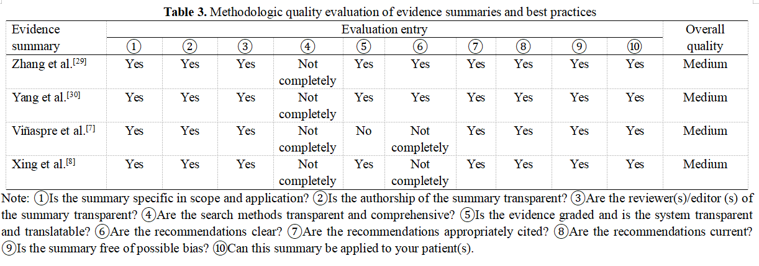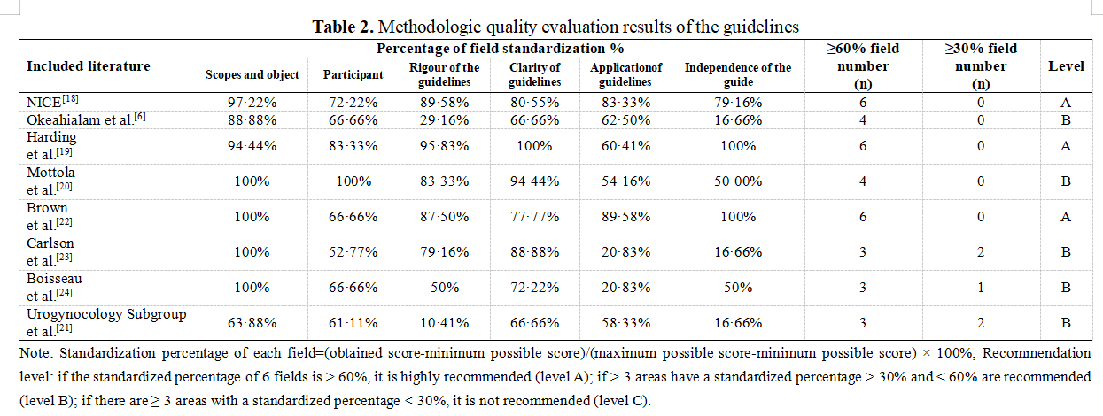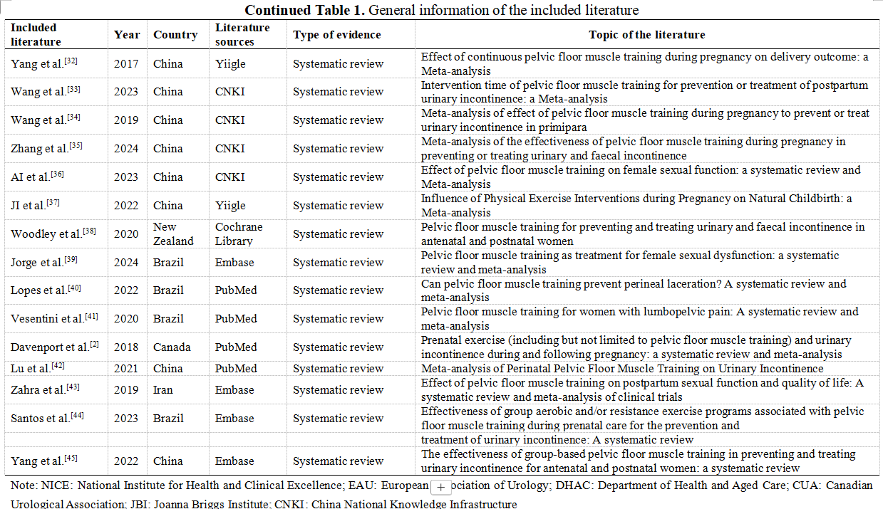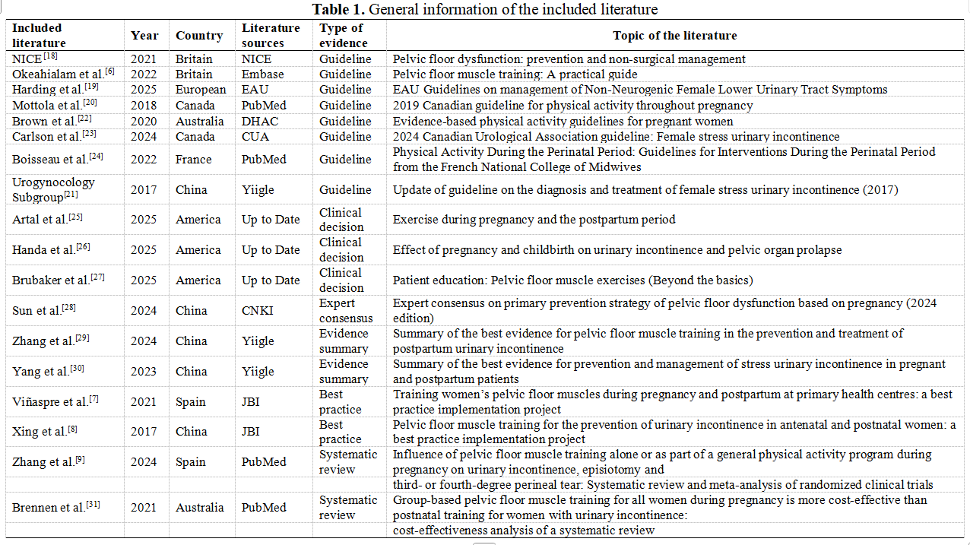
References
- López-López AI, Sanz-Valero J, Gómez-Pérez L, Pastor-Valero M. Pelvic floor: vaginal or caesarean delivery? A review of systematic reviews. International Urogynecology Journal 2021; 32: 1663-73.
- Davenport MH, Nagpal TS, Mottola MF, et al. Prenatal exercise (including but not limited to pelvic floor muscle training) and urinary incontinence during and following pregnancy: a systematic review and meta-analysis. British Journal of Sports Medicine 2018; 52: 1397-404.
- Zachovajeviene B, Siupsinskas L, Zachovajevas P, Venclovas Z, Milonas D. Effect of diaphragm and abdominal muscle training on pelvic floor strength and endurance: results of a prospective randomized trial. Scientific Reports 2019; 9: 19192.
- Sheng Y, Carpenter JS, Ashton-Miller JA, Miller JM. Mechanisms of pelvic floor muscle training for managing urinary incontinence in women: a scoping review. BMC Women's Health 2022; 22: 161.
- Szumilewicz A, Kuchta A, Kranich M, Dornowski M, Jastrzębski Z. Prenatal high-low impact exercise program supported by pelvic floor muscle education and training decreases the life impact of postnatal urinary incontinence: A quasiexperimental trial. Medicine 2020; 99: e18874.
- Nicola Adanna Okeahialam, Maria Oldfield, Ellie Stewart, Carol Bonfield, Carboni C. Pelvic floor muscle training: A practical guide. The BMJ 2022: 1-7.
- de Viñaspre, Regina Ruiz Garrido, Ana Elena Alvarez, Angeles M. Training women's pelvic floor muscles during pregnancy and postpartum at primary health centers: a best practice implementation project. JBI Evidence Implementation 2021; 19: 245-56.
- Xing W, Zhang Y, Gu C, Lizarondo L. Pelvic floor muscle training for the prevention of urinary incontinence in antenatal and postnatal women: a best practice implementation project. JBI Database System Rev Implement Rep 2017; 15: 567-83.
- Zhang D, Bo K, Montejo R, et al. Influence of pelvic floor muscle training alone or as part of a general physical activity program during pregnancy on urinary incontinence, episiotomy and third‐ or fourth‐degree perineal tear: Systematic review and meta‐analysis of randomized clinical tr. Acta Obstetricia et Gynecologica Scandinavica 2024; 103: 1015-27.
- Tong W, Yuna P, Lu G. Summary of the best evidence for pelvic floor muscle training in preventing and treating urinary incontinence in maternal. Chongqing Medical Journal 2023; 52: 3159-65.
- Zheng Z, Yan H, Weijei X, Yingfeng Z, Ying G. The composition of different types of evidence based problems. Journal of Nurses Training 2017; 32: 1991-4.
- Dicenso A, Bayley L, Haynes RB. Accessing pre-appraised evidence: fine-tuning the 5S model into a 6S model. Evidence Based Nursing 2009; 12: 99.2-101.
- Brouwers MC, Kho ME, Browman GP, et al. AGREE II: advancing guideline development, reporting, and evaluation in health care. Prev Med 2010; 51: 421-4.
- Shea BJ, Reeves BC, Wells G, et al. AMSTAR 2: a critical appraisal tool for systematic reviews that include randomised or non-randomised studies of healthcare interventions, or both. BMJ 2017: j4008.
- Foster MJ, Shurtz S. Making the Critical Appraisal for Summaries of Evidence (CASE) for evidence-based medicine (EBM): critical appraisal of summaries of evidence. J Med Libr Assoc 2013; 101: 192-8.
- JBI. Systematic reviews of text and opinion. 2020. https://jbi.global (accessed March 20,2026).
- JBI. Supporting Document for the Joanna Briggs Institute Levels of Evidence and Grades of Recommendation. 2014. https://jbi.global (accessed March 20,2026).
- NICE. Pelvic floor dysfunction：prevention and non-surgical management. 2021. https://www.nice.org.uk/guidance/ng210 (accessed March 20,2026).
- Harding CK. EAU Guidelines on management of Non-Neurogenic Female Lower Urinary Tract Symptoms. 2024. https://uroweb.org/guidelines/non-neurogenic-female-luts (accessed March 20,2026).
- Mottola MF, Davenport MH, Ruchat S-M, et al. 2019 Canadian guideline for physical activity throughout pregnancy. British Journal of Sports Medicine 2018; 52: 1339-46.
- Subgroup U. [Update of guideline on the diagnosis and treatment of female stress urinary incontinence (2017)]. Zhonghua Fu Chan Ke Za Zhi 2017; 52: 289-93.
- Brown WJ. Evidence-based physical activity guidelines for pregnant women.2020. https://www.health.gov.au/resources/publications/evidence-based-physical-activity-guidelines-for-pregnant-women?language=en (accessed March 20,2026).
- Carlson K, Andrews M, Bascom A, et al. 2024 Canadian Urological Association guideline: Female stress urinary incontinence. Can Urol Assoc J 2024; 18: 83-102.
- Boisseau N. Physical Activity During the Perinatal Period: Guidelines for Interventions During the Perinatal Period from the French National College of Midwives. Journal of Midwifery &amp; Women's Health 2022; 67: S158-S71.
- Raul Artal F, FACSM. Exercise during pregnancy and the postpartum period. 2025. http://www-uptodate-com-443.bjmu.ilibs.cn/contents/zh-Hans/exercise-during-pregnancy-and-the-postpartum-period?search=%E5%A6%8A%E5%A8%A0%E6%9C%9F%E5%92%8C%E4%BA%A7%E5%90%8E%E9%94%BB%E7%82%BC&source=search_result&selectedTitle=1~150&usage_type=default&display_rank=1 (accessed March 20,2026).
- Handa VL. Effect of pregnancy and childbirth on urinary incontinence andpelvic organ prolapse. 2025. http://www-uptodate-com-443.bjmu.ilibs.cn/contents/effect-of-pregnancy-and-childbirth-on-urinary-incontinence-and-pelvic-organ-prolapse?search=%E5%A6%8A%E5%A8%A0%E5%92%8C%E5%88%86%E5%A8%A9%E5%AF%B9%E5%B0%BF%E5%A4%B1%E7%A6%81%E5%92%8C%E7%9B%86%E8%85%94%E5%99%A8%E5%AE%98%E8%84%B1%E5%9E%82%E7%9A%84%E5%BD%B1%E5%93%8D&source=Out%20of%20date%20-%20zh-Hans&selectedTitle=1~150 (accessed March 20,2026).
- Brubaker L. Patient education：pelvic floor muscle exercises (Beyond the Basics). 2025. http://www-uptodate-com-443.bjmu.ilibs.cn/contents/pelvic-floor-muscle-exercises-beyond-the-basics?search=%E6%82%A3%E8%80%85%E6%95%99%E8%82%B2%EF%BC%9A%E7%9B%86%E8%85%94%E8%82%8C%E8%82%89%E9%94%BB%E7%82%BC&source=search_result&selectedTitle=2~88&usage_type=default&display_rank=2 (accessed March 20,2026).
- Chinese SaHSo, Prevention Medicine Association OaGsoCMWsA, Eugenics BMaCHIo. Expert consensus on primary prevention strategy of pelvic floor dysfunction based on pregnancy ( 2024 edition ). Chinese Journal of Practical Gynecology and Obstetrics 2024; 40: 737-42.
- Jiayu Z, Xin Y, Haoran D, et al. Summary of the best evidence for pelvic floor muscle training in the prevention and treatment of postpartum urinary incontinence. Chinese Journal of Modern Nursing 2024: 1604-11.
- Zhuoxin Y, Guirong L, Yunhong R, Lin Y, Xianhua W. Summary of the best evidence for prevention and management of stress urinary incontinence in pregnant and postpartum patients. Chinese Journal of Modern Nursing 2023: 3416-22.
- Brennen R, Frawley HC, Martin J, Haines TP. Group-based pelvic floor muscle training for all women during pregnancy is more cost-effective than postnatal training for women with urinary incontinence: cost-effectiveness analysis of a systematic review. J Physiother 2021; 67: 105-14.
- Yaning Y, Bizhen L, Ziqi Z, Ling L. Effect ofcontinuous pelvic floor muscle training during pregnancy on delivery outcome: a Meta-analysis. Chinese Journal of Practical Nursing 2017: 316-20.
- Jianning W, Liping W, Ran S, Weitao L, Yaxin J. Intervention time of pelvic floor muscle training for prevention or treatment of postpartum urinary. Chinese Evidence-Based Nursing 2023; 9: 2129-35.
- Xiao W, Peibei D, Shizheng D, Qiankun Z, Lu G. Meta-analysis of effect of pelvic floor muscle training during pregnancy to prevent or treat urinary incontinence in primipara Chinese Nursing Research 2019; 33: 29-36.
- Shiwen Z, Meiling H, Jincao Z, Fei P, Yan W. Meta-analysis of the effect of pelvic floor muscle training during pregnancy in preventing or treating urinary and fecal incontinence. Chinese Journal of Rehabilitation Medicine 2024; 39: 1019-26.
- Beifang A, Shening Z, Renting X, Fengfeng H, Chongjia R. Effect of pelvic floor muscle training on female sexual function:a systematic review and Meta-analysis. Chinese Evidence-Based Nursing 2023; 9: 4209-15.
- Moufang J, Ruobing L, Kejing W, Fanhua Z. Influence of Physical Exercise Interventions during Pregnancy on Natural Childbirth: a Meta-analysis. Chinese General Practice 2022: 1897-905.
- Woodley SJ, Lawrenson P, Boyle R, et al. Pelvic floor muscle training for preventing and treating urinary and faecal incontinence in antenatal and postnatal women. Cochrane Database Syst Rev 2020; 5: Cd007471.
- Jorge CH, Bø K, Chiazuto Catai C, Oliveira Brito LG, Driusso P, Kolberg Tennfjord M. Pelvic floor muscle training as treatment for female sexual dysfunction: a systematic review and meta-analysis. Am J Obstet Gynecol 2024; 231: 51-66.e1.
- Gomes Lopes L, Maia Dutra Balsells M, Teixeira Moreira Vasconcelos C, Leite De Araújo T, Teixeira Lima FE, De Souza Aquino P. Can pelvic floor muscle training prevent perineal laceration? A systematic review and meta‐analysis. International Journal of Gynecology &amp; Obstetrics 2022; 157: 248-54.
- Vesentini G, Prior J, Ferreira PH, Hodges PW, Rudge M, Ferreira ML. Pelvic floor muscle training for women with lumbopelvic pain: A systematic review and meta‐analysis. European Journal of Pain 2020; 24: 1865-79.
- Lu J, Zhang H, Liu L, et al. Meta-analysis of Perinatal Pelvic Floor Muscle Training on Urinary Incontinence. West J Nurs Res 2021; 43: 597-605.
- Hadizadeh-Talasaz Z, Sadeghi R, Khadivzadeh T. Effect of pelvic floor muscle training on postpartum sexual function and quality of life: A systematic review and meta-analysis of clinical trials. Taiwan J Obstet Gynecol 2019; 58: 737-47.
- Santos AC, Dias SN, Delgado A, Lemos A. Effectiveness of group aerobic and/or resistance exercise programs associated with pelvic floor muscle training during prenatal care for the prevention and treatment of urinary incontinence: A systematic review. Neurourology and Urodynamics 2024; 43: 205-18.
- Yang X, Zhang A, Sayer L, Bassett S, Woodward S. The effectiveness of group-based pelvic floor muscle training in preventing and treating urinary incontinence for antenatal and postnatal women: a systematic review. International Urogynecology Journal 2022; 33: 1407-20.
- Delancey JOL, Kane Low L, Miller JM, Patel DA, Tumbarello JA. Graphic integration of causal factors of pelvic floor disorders: an integrated life span model. American Journal of Obstetrics and Gynecology 2008; 199: 610.e1-.e5.
- Bø K. Pelvic floor muscle training is effective in treatment of female stress urinary incontinence, but how does it work? International Urogynecology Journal and Pelvic Floor Dysfunction 2004; 15: 76-84.
- Guise JM, Morris C, Osterweil P, Li H, Rosenberg D, Greenlick M. Incidence of fecal incontinence after childbirth. Obstet Gynecol 2007; 109: 281-8.
- Macarthur C, Wilson D, Herbison P, et al. Faecal incontinence persisting after childbirth: a 12 year longitudinal study. BJOG: An International Journal of Obstetrics &amp; Gynaecology 2013; 120: 169-79.
- Hagen S, Stark D. Conservative prevention and management of pelvic organ prolapse in women. Cochrane Database Syst Rev 2011: Cd003882.
- Vermani E, Mittal R, Weeks A. Pelvic Girdle Pain and Low Back Pain in Pregnancy: A Review. Pain Practice 2010; 10: 60-71.
- Liddle SD, Pennick V. Interventions for preventing and treating low-back and pelvic pain during pregnancy. Cochrane Database of Systematic Reviews 2015; 2015: CD001139.
- Ogollah R, Bishop A, Lewis M, Grotle M, Foster NE. Responsiveness and Minimal Important Change for Pain and Disability Outcome Measures in Pregnancy-Related Low Back and Pelvic Girdle Pain. Phys Ther 2019; 99: 1551-61.
- García‐Mejido JA, Idoia‐Valero I, Aguilar‐Gálvez IM, Borrero González C, Fernández‐Palacín A, Sainz JA. Association between sexual dysfunction and avulsion of the levator ani muscle after instrumental vaginal delivery. Acta Obstetricia et Gynecologica Scandinavica 2020; 99: 1246-52.
- Olander EK, Darwin ZJ, Atkinson L, Smith DM, Gardner B. Beyond the ‘teachable moment’-A conceptual analysis of women's perinatal behaviour change. Women and Birth 2016; 29: e67-e71.
- Mørkved S, Bø K. Effect of pelvic floor muscle training during pregnancy and after childbirth on prevention and treatment of urinary incontinence: a systematic review. British Journal of Sports Medicine 2014; 48: 299-310.
- Woodley SJ, Hay-Smith EJC. Narrative review of pelvic floor muscle training for childbearing women—why, when, what, and how. International Urogynecology Journal 2021; 32: 1977-88.
- Hill A-M, McPhail SM, Wilson JM, Berlach RG. Pregnant women’s awareness, knowledge and beliefs about pelvic floor muscles: a cross-sectional survey. International Urogynecology Journal 2017; 28: 1557-65.
- Wang X, Jin Y, Xu P, Feng S. Urinary incontinence in pregnant women and its impact on health-related quality of life. Health and Quality of Life Outcomes 2022; 20: 13.
- Bayat M, Eshraghi N, Naeiji Z, Fathi M. Evaluation of Awareness, Adherence, and Barriers of Pelvic Floor Muscle Training in Pregnant Women: A Cross-sectional Study. Female Pelvic Med Reconstr Surg 2021; 27: e122-e6.
- Salmon VE, Hay‐Smith EJC, Jarvie R, et al. Implementing pelvic floor muscle training in women's childbearing years: A critical interpretive synthesis of individual, professional, and service issues. Neurourology and Urodynamics 2020; 39: 863-70.
- Mason L, Roe B, Wong H, Davies J, Bamber J. The role of antenatal pelvic floor muscle exercises in prevention of postpartum stress incontinence: a randomised controlled trial. Journal of Clinical Nursing 2010; 19: 2777-86.
- Stensdotter A-K, Håland A, Ytterhus B, Shrestha S, Stuge B. Pregnant women’s experiences with a pelvic floor muscle training program in Nepal. Global Health Action 2021; 14: 1940762.
- Temtanakitpaisan T, Bunyavejchevin S, Buppasiri P, Chongsomchai C. Knowledge, Attitude, and Practices (KAP) Survey Towards Pelvic Floor Muscle Training (PFMT) Among Pregnant Women. International Journal of Women's Health 2020; 12: 295-9.

