Diagnostic Performance of miR-4796 and Its Correlation with CDH1 Gene Expression in FFPE Tissues of Breast Cancer Patients
Sheeman H. Mohammed ^{1,2*}, Hazha J. Hidayat¹, Kazhal M. Sulaiman¹
⁎ Corresponding Author: Sheeman H. Mohammed; sheeman.mohammed@su.edu.krd
- Department of Biology, College of Education, Salahaddin University, Erbil, Kurdistan
2. Department of Midwifery, College of Nursing, Hawler Medical University.
Region, Iraq; hazha.hidayat@su.edu.krd and kazhal.sulaiman@su.edu.Krd

Citation: Mohammed, Sh. H., Hidayat, H. J., Sulaiman, K. M. (2026) Diagnostic Performance of miR-4796 and Its Correlation with CDH1 Gene Expression in FFPE Tissues of Breast Cancer Patients, NET, Vol. 26 (1).

Academic Editor: Jihyun Park

Received: 30/January/2026
Accepted: 25/May/2026
Published: 29/May/2026

Copyright: © 2026 Sheeman H. Mohammed. This is an open access article distributed under the terms of the Creative Commons attribution License, which permits.

Abstract
MicroRNAs are endogenous, non-coding small RNAs that play an important part in regulating organismal and pathological processes. This study examined miR-4796 and CDH1 expression in breast cancer (BC) to determine its effects on clinicopathological features and prognosis. qRT-PCR was used to detect miR-4796 and CDH1 expression levels in 30 pairs of FFPE tissues and normal adjacent tissues. Additionally, the study examined the correlation between miR-4796, CDH1 expression, pathological characteristics, prognosis, and fold change analysis using 2^{-ΔΔCT}, and GraphPad Prism and MedCalc for all statistical analyses were applied. MiR-4796 levels in FFPE tissues were found to be significantly different from control tissues (p-value = 0.037) and did not correlate with clinicopathological parameters among patients, except for Her-2, which showed a significant association with (p-value = 0.0187), indicating that Her-2 subjects had lower miR-4796 expression. In addition, CDH1 gene expression in FFPE tissue is not significant (p-value=0.681) and does not correlate with clinicopathological characteristics, while tumor grade is (p-value=0.043). Moreover, the p-value, AUC, and Std. Error, sensitivity, and specificity are (0.060, 0.506, 50.0, and 36.7), and (0.633, 0.537, 53.3, and 66.7) for miR-4796 and CDH1, respectively. Additionally, the results of fold change analysis showed a (0.243)-fold decrease of miR-4796 and a (1.193)-fold increase of CDH1 in tumors compared to controls, suggesting that these markers may help comprehend BC tumor morphologies and biological processes.
In conclusion, dysregulation of miR-4796 and CDH1 may be useful, as a biomarker, for understanding BC tumor morphologies and biological processes.
Keywords: miR-4796, CDH1, Breast Cancer, Diagnostic Biomarker

Introduction
Breast cancer (BC) is the predominant cause of morbidity in women diagnosed with cancer (1). Despite considerable progress in the early diagnosis of BC and the growing availability of treatments, including surgical resection (2), radiotherapy (3), endocrine therapy (4), and immunotherapy (5). The patient's prognosis remains unfavorable due to the elevated incidence of distant metastases associated with BC. In BC, various biomarkers, such as tissue (6) and plasma proteins (7), as well as nucleic acids, including miRNAs (8), have been investigated for the early detection of BC, but only a few have been used in clinical practice.
MicroRNAs (miRNAs) are a class of endogenous elements that are widely distributed throughout the genomes of higher eukaryotes (9), with a length of about 20~25 nucleotides (10). They participate in gene expression and repression, and can modulate various pathways (11). Given that multiple miRNAs can target a specific gene, they collectively form a complex regulatory network, thereby coordinating the intricate system of eukaryotic cellular function (12). Investigations in BC have underscored significant aspects of miRNA participation, including distinct signatures in particular subtypes, their role in the stemness of tumor-initiating cells, and their influence on therapy-resistant BC (13). Consequently, among these,miR-4796 has been reported in previous studies to act as a tumor suppressor (14); however, its biological role and clinical relevance in breast cancer remain poorly understood.
Gene cadherin-1 (CDH1) encodes E-cadherin and is involved in cell-cell adhesion and epithelial integrity preservation (15). Breast cancer is one of several malignancies linked to tumor invasiveness, metastasis, and poor prognosis by loss or modification of CDH1 expression (16). Noteworthy, in recent years, few studies showed a positive correlation between CDH1 expression and metastasis, though the mechanisms explored appeared to involve the reserve process of EMT - MET (mesenchymal to epithelial transition) . The discrepancies between these findings and those on CDH1 as a tumor suppressor have not been resolved(17). More and more evidence points to the possibility that microRNAs control CDH1 expression, which in turn affects tumor behavior and clinicopathological features.
While there has been no experimental confirmation of a direct regulatory link between miR-4796 and CDH1 in breast cancer or other malignancies, new data from other cancer types indicate that such a relationship is biologically possible. Evidence suggests that miR-4796 regulates pathways involving DNA damage response, cell survival, and tumor sensitivity to therapy (14). These pathways include the regulation of genes, including ATM, BRCA1, RAD51, and PARP, and have a role in tumor suppression in many malignancies (14). Although CDH1 (E-cadherin) is essential for EMT, dysregulation of these pathways is known to impact EMT (18).
Overall, this study seeks to assess the role of the miR-4796/CDH1 pathway in the proliferation, migration, and invasion of BC. We evaluated the expression levels of miR-4796 and CDH1 in BC patients and their association with clinical characteristics. Additionally, the correlation between miR-4796 and CDH1 in BC cells and its prognostic significance were measured. This initiative may explore a novel biomarker for BC that can enhance cancer management.
2. Materials and methods
2.1. Patients and specimens’ collection
Expressions of the CDH1 gene and miR-4796 were quantified in 30 formalin-fixed paraffin-embedded (FFPE) tissue pairs of non-tumorous tissues next to tumoral samples. Tissues were obtained from the Rzgary Hospital-Erbil, Kurdistan Region, Iraq, during the period from January 2024 to June 2024. Every sample was obtained in compliance with the rules of Rzgary Hospital’s protocol, encompassing patient consent and specimen acquisition. The diagnosis and categorization of BC patients were according to the TNM system of the American Joint Committee on Cancer (AJCC). Stages I, II, and III of BC were identified in all instances based on clinical and histological confirmation, are shown in (Tables 1 and 2).
Table 1. miR-4796 expression level and its relation to Clinicopathological parameters among 30 cases, categorized as either low or high expression.
miR-4796 Expression Level
Parameters | Subclasses | Cases | Low | High | P-value
Age (years) | ≥50 | 4 | 3 | 1 | 0.454
Age (years) | <50 | 26 | 23 | 3 | 0.454
Tumor grade | I | 3 | 3 | 0 | 0.702
Tumor grade | II | 22 | 19 | 3 | 0.702
Tumor grade | III | 5 | 4 | 1 | 0.702
ER status | Negative | 9 | 14 | 3 | 0.282
ER status | Positive | 21 | 12 | 1 | 0.282
PR status | Negative | 10 | 18 | 3 | 0.087
PR status | Positive | 20 | 8 | 1 | 0.087
Her2 status | Negative | 9 | 21 | 3 | 0.018
Her2 status | Positive | 21 | 5 | 1 | 0.018
TNM Stage | 0-1 | 18 | 11 | 2 | 0.771
TNM Stage | 2-3 | 12 | 15 | 2 | 0.771

Table 2. CDH1 expression level and its relation to Clinicopathological parameters among 30 cases, categorized as either low or high expression.
CDH1 GENE Expression Level
Parameters | Subclasses | Cases | Low | High | P-value
Age (years) | ≥50 | 4 | 3 | 1 | 0.282
Age (years) | <50 | 26 | 24 | 2 | 0.282
Tumor grade | I | 3 | 3 | 0 | 0.043
Tumor grade | II | 22 | 21 | 1 | 0.043
Tumor grade | III | 5 | 3 | 2 | 0.043
ER status | Negative | 9 | 19 | 2 | 0.781
ER status | Positive | 21 | 8 | 1 | 0.781
PR status | Negative | 10 | 18 | 2 | 0.899
PR status | Positive | 20 | 9 | 1 | 0.899
Her2 status | Negative | 9 | 21 | 2 | 0.66
Her2 status | Positive | 21 | 6 | 1 | 0.66
TNM Stage | 0-1 | 18 | 17 | 1 | 0.76
TNM Stage | 2-3 | 12 | 10 | 2 | 0.76

2.2. RNA extraction and reverse transcription
The expression levels of miR-4796 and the CDH1 gene were quantitatively evaluated in 30 pairs of FFPE tissue samples. Total RNA, including miRNAs, was extracted by a combination of Trizol and silica membrane-based purification for total RNA and miRNAs. The concentration and purity were measured using a Nanodrop ND-2000 spectrophotometer, and all RNA samples exhibited an integrity value of less than 2.3.
2.3. Real-time quantitative PCR
The cDNA synthesis was carried out using the RT kit from the Tinzyme company, China. The expression level for RNA and selected miR-4796 was determined using Luna SYBR Green Kit (Biolabs). Briefly, 10 µL of Luna master mix was mixed with 0.5 µL of forward and reverse primers, and 2 µL of cDNA, and the volume was completed to 20 µL with DNase-RNase-free water. The specific nucleotide sequences for the primers used in this study are listed in (Table 3). All qRT-PCR reactions were set up using the Applied Biosystem 7500 at 95 C for 3 min for 40 cycles, for 15 s and 60 °C for 45 s. Melting curve analysis was used to control for the specificity of qRT-PCR products.
Table 3. Nucleotide sequences of primers miR-4796 and CDH1 gene
miR-4796
Targets | Primer Sequence | Length (nt)
miR-4796 - F | AACACGTGTGTCTATACTCTGTCAC | F: 25 nt
miR-4796 - R | GTGCAGGGTCGGAGGT | R: 16 nt
U6 -F | GTGCTGCTTGGGCAGCA | F: 17 nt
U6 -R | GAAATATGGAACGGTTC | R: 17 nt
CDH1 gene
CDH1- F | GGTCGACAAAGGACAGCCTA | F: 25 nt
CDH1- R | GCGTGACTTTGGTGGAAAAC | R: 25 nt
U6 -F | GTGCTGCTTGGGCAGCA | F: 17 nt
U6 -R | GAAATATGGAACGGTTC | R: 17 nt

2.4. Statistical analyses
Every statistical analysis was conducted using GraphPad Prism version 8.4.3 (GraphPad Software, San Diego, CA) and MedCalc version 23.1.7. The Mann-Whitney U test compared miRNA expression levels and the CDH1 gene in BC patient and control FFPE tissue. Clinicopathological characteristics, CDH1 gene expression, and miR-4796 expression were examined using the Chi-square test. MiR-4796, CDH1, and HKGs connection. The diagnostic performance of miR-4796 expression was assessed using ROC curve analysis and AUC computation. P values under 0.05 were significant.
3. Results
3.1. Association of miR-4796 expression with clinicopathological features
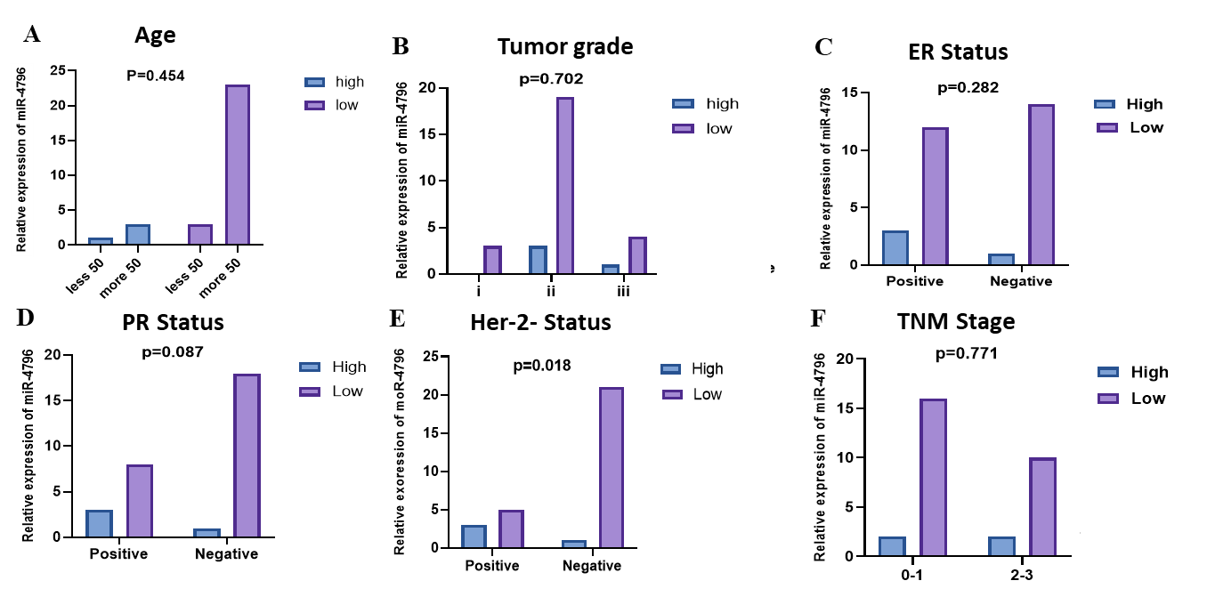
To investigate the relationship between the overexpression of miR-4796 and the clinical development of BC, the relationship between miR-4796 expression levels and the clinicopathological features of BC patients. As shown in (Table 1), (Figure 1), no discernible difference was detected in age, tumor grade, ER status, PR status, and TNM status between patients with miR-4796 overexpression. However, the Her-2 status indicated statistically significant (P = 0.0187), suggesting that miR-4796 expression was more prevalent in Her-2 positive cases. Overall, the analyzed clinical parameters showed a statistically nonsignificant correlation with the expression of miR-4796; only the association with Her-2 status lower than (p < 0.05).

Figure 1. Shows the association between miR-4796 expression and BC clinical parameters. (A) No discernible difference was detected in age. (B) In tumor grade there is no relation between tumor grade and miR-4796 expression. (C) There is no association between ER status and miR-4796 expression. (D) There is no relation between PR status and miR-4796 expression. (E) Statistically there is a significant difference between Her-2 status and miR-4796 suggesting that miR-4796 expression was more prevalent in Her-2 positive cases. (F) There is no relation between TNM status and miR-4796.
3.2. Association of CDH1 gene expression with clinicopathological features
To investigate the relationship between the expression level of the CDH1 gene and the clinical development of BC, the relationship between CDH1 expression levels and the clinicopathological features of BC patients were evaluated. As shown in (Table 2), (Figure 2), no discernible difference was detected in age, ER status, PR status, Her-2, and TNM status between patients with CDH1 gene expression. However, the tumor grade indicated statistically significant (P = 0.043), suggesting that CDH1 gene expression was more prevalent in tumor grade cases. Overall, none of the analyzed clinical parameters showed a statistically significant correlation with the CDH1 gene expression; only the association with tumor grade lower than (p < 0.05).

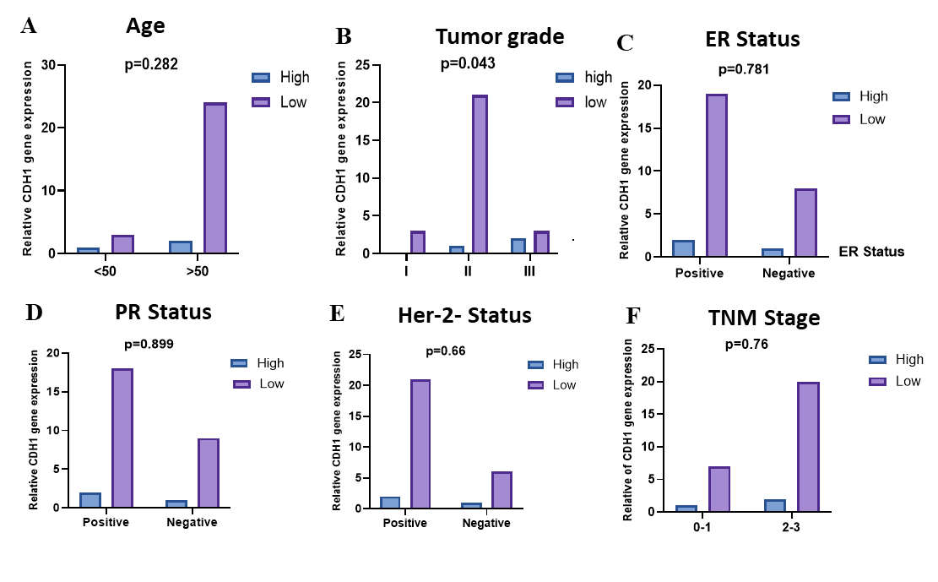

Figure 2. Shows the association between CDH1 gene expression and BC clinical parameters. (A) No discernible difference was detected in age with CDH1 gene. (B) Statistically, there is a significant difference between Tumor grade and CDH1 gene suggesting that CDH1 gene expression was more prevalent in Tumor grade cases. (C) There is no relation between ER status and CDH1 gene expression. (D) There is no association between PR status and CDH1 gene expression. (E) There is no relation between Her-2 status and CDH1 gene expression. (F) Statistically, there is no significant difference between TNM stage and CDH1 gene.
3.3. Association and expression of miR-4796, CDH1 gene, and HKGs in FFPE tissues of BC
In this study, the level of miR-4796 expression in BC FFPE tissue and contrasted it with the corresponding expression in nearby normal tissues were analyzed. To look into how miR-4796 affects the development of BC, a qRT-PCR assay was carried out to find the expression of miR-4796 in 30 pairs of breast tumor tissues and corresponding non-tumor tissues. As shown in (Figure 3A), The result showed that there is a significant difference in expression levels of miR-4796 in breast tumor tissues and those in matched noncancerous tissues (p < 0.037), which is statistically significant (p < 0.05), and this suggests that the matching non-tumor tissues and breast tumor tissues are statistically significant.
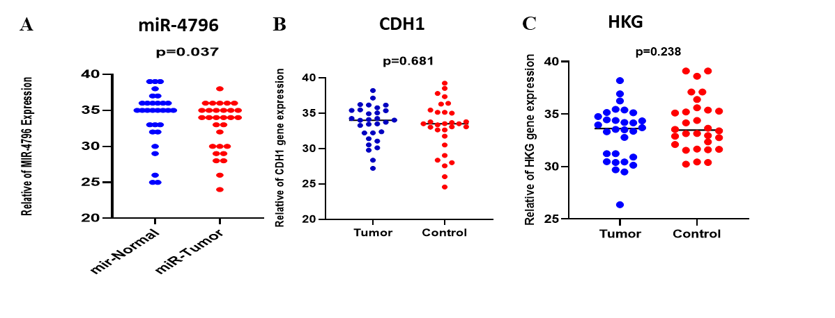
The degree of CDH1 gene expression in BC FFPE tissue and contrasted it with the comparable expression of nearby normal tissues. To look into how the CDH1 gene affects the development of BC, a qRT-PCR assay was carried out to find the CDH1 gene's expression in 30 pairs of breast tumor tissues and corresponding non-tumor tissues. As shown in (Figure 3B), The expression levels of the CDH1 gene in breast tumor tissues were significantly lower than those in matched noncancerous tissues (p < 0.681), which is statistically significant (p < 0.05), and this indicates that there is no significant difference between breast tumor tissues and corresponding non-tumor tissues. Moreover,the expression level of HKGs as a reference gene in our experiment to normalize gene expression data and ensure reliable comparison between the two groups were studied. As shown in (Figure 3 C), The p-value was (0.238), which is not statistically significant (p < 0.05), meaning that there is no significant difference between the HKGs of tumor tissue and the HKGs of corresponding non-tumor tissue groups.
Figure 3 A. Level of relative expression of miR-4796 in 30 FFPE tissue pairings of tumor samples and their corresponding neighboring non-tumor tissues. B. Relative expression level of the CDH1 gene in 30 FFPE tissue pairings of tumor samples and their corresponding neighboring non-tumor tissues. C. Relative expression level of HKGs in 30 FFPE tissue pairs of tumoral samples and their adjacent non-tumoral tissues.
3.5. Folding change of miR-4796 and CDH1 gene analysis
The results of the qRT-PCR show that the miR-4796 expression is decreased in BC patients compared to the control. As shown in (Table 4), the average CT value for miR-4796 in tumor tissue was (35.427), and in the control was (33.171), as well as with the (U6) CT values of (34.344) and (34.116) in both patients and control samples, respectively. Moreover, the ΔCT calculations showed that the BC tumor group and control group had a ΔCT of (1.083) and (-1.0945), respectively. This suggests that the tumor samples have a greater CT value than the control. Additionally, the ΔΔCT value, which compares the expression level of miR-4796 between the groups with tumors and those without, was calculated as (2.028), further confirming a downregulation in tumors. The fold change analysis using the 2- ΔΔCT method revealed a (0.243) fold decrease in the miR-4796 expression level in tumors compared to controls. This suggests that miR-4796 may have a tumor suppressor function in tumorigenesis, potentially suppressing BC progression.
According to the qRT-PCR data, BC patients' CDH1 gene expression is significantly higher than that of the control group. As shown in (Table 4), the average CT value for the CDH1 gene in tumor tissue was (32.812), and in the control was (33.055), as well as with the (U6) CT values of (33.447) and (33.436) in both patients and control samples, respectively. Moreover, the ΔCT calculations showed that the BC tumor group and control group had a ΔCT of (-0.635) and (-0.381), respectively. This indicates that the CT value is lower in the tumor samples compared to the control. Additionally, the ΔΔCT value, which compares the expression level of the CDH1 gene between the tumor group and the control group, was calculated as (-0.245), confirming a higher expression in tumors. The fold change analysis using the 2- ΔΔCT method revealed a (1.193) fold increase in the CDH1 gene expression level in tumors compared to controls. This suggests that the CDH1 gene may have oncogenic function in tumorigenesis, potentially stimulate BC progression, because when the tumor suppressor microRNA decrease led to an increase in oncogene expression.
Additionally, the diagnostic capability of miR-4796 in distinguishing between BC tissues and adjacent tissues were evaluated (Figure 5). The AUC is (0.506), with the Std. Error of (0.075), sensitivity (0.50), and specificity (0.36), this signifies a moderate capacity of the test to differentiate between patients with tumors and controls. The 95% confidence interval spans from (0.357 to 0.654), indicating fluctuation in the estimate while remaining above (0.5), signifying that the test outperforms random chance. The p-value of (0.060) signifies statistical significance, indicating that the test possesses discriminatory power. Also, the CDH1 gene expression level's diagnostic utility in differentiating BC tissues from surrounding tissues were evaluated (Figure 6). The AUC is (0.537), with the Std. Error of (0.0760), sensitivity (0.53), and specificity (66.7), this signifies a moderate capacity of the test to differentiate between patients with tumors and controls. The 95% confidence interval spans from (0.387 to 0.685), indicating fluctuation in the estimate while remaining above (0.5), signifying that the test outperforms random chance. The p-value of (0.633) signifies statistical significance, indicating that the test possesses discriminatory power.

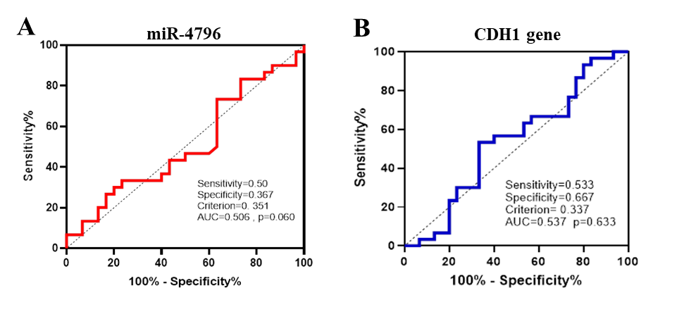

Figure 5. A) The ROC curve of miR-4796 expression for the differentiation of BC tissues from surrounding normal tissues. AUC indicates area under the ROC curve. B) The ROC curve of CDH1 gene expression for the differentiation of BC tissues from surrounding normal tissues. AUC indicates area under the ROC curve.

Table 4. Average CT value for miR-4796 and the CDH1 gene

Equations
ΔCT target miR-4796 | ΔCT = CT (a target miR-4796) – CT (a reference gene)  ΔCT (target) = 35.427 – 34.344 = 1.083
ΔCT control | ΔCT = CT (Control) – CT (control- reference gene)  ΔCT (Control) = 33.171 – 34.116 = -0.945
ΔΔCT | ΔΔCT = ΔCT (a target miR-4796) – ΔCT (Control)  ΔΔCT= 1.083 – (-1.0945) =2.028
Folding change | Folding change = 2- ΔΔCT=2−2.028=0.243
ΔCT target CDH1 gene | ΔCT = CT (a target CDH1 gene) – CT (a reference gene)  ΔCT=32.812-33.447= -0.635
ΔCT control | ΔCT = CT (Control) – CT (control- reference gene)  ΔCT (Control) = 33.055-33.436= -0.381
ΔΔCT | ΔΔCT = ΔCT (a target CDH1 gene) – ΔCT (Control)  ΔΔCT=-0.635-(-0.381)= -0.245
Folding change | Folding change = 2- ΔΔCT=2−(−0.245)= 1.193

Discussion
Recent studies indicate that miRNAs have significant roles in human disorders, as well as the initiation, development, and metastasis of cancer, which are expressed abnormally. Dysregulation of miRNAs is discovered to have a significant role in the occurrence and progression of numerous cancers, and abnormal expression of miRNAs has been found in a variety of tumor tissues (19). The aberrant expression levels of several miRNAs and their roles in breast cancer have been extensively studied. For example, some miRNAs have carcinogenic properties and are more commonly expressed in breast cancer. These miRNAs lower the expression of anti-oncogenes that are involved in apoptosis, invasion, metastasis, and cell proliferation. MiR-10, miR-15, miR-16, miR-17~92 cluster, miR-18, miR-19, miR-20, miR-21 family, miR-92, miR-155, and miR-569 and associated families are among the carcinogenic miRNAs (20).
This work measured and statistically analyzed miR-4796 and CDH1 gene expression in 30 BC FFPE tissues. Our miR-4796 analysis showed that BC patients' expression levels was statistically significant compared to controls. (p=0.037), that is, tumor tissue has lower miR-4796 expression than normal tissue due to decreased tumor-suppressor miRNAs, which reduces target oncogene repression and overexpression, promoting cancer development. Gene expression accelerates uncontrolled without miRNAs, which operate as "brakes". Reduced miRNAs overactivate Wnt-path, a signal transduction pathway essential for cell growth, development, tissue regeneration, and stem cell maintenance. Cancer is connected to Wnt signaling overactivation. Sireke et al revealed that downregulation of miR-2115 and miR-497 appeared to be responsible for the overexpression of the WNT pathway (21). Nevertheless, the cell adhesion system malfunctions in the absence of E-cadherin, which results in a decrease in cell-cell adhesion, the release of cytoplasmic β-catenin, an increase in Wnt signaling, and an increase in tumor invasiveness. As a result, the CDH1 gene is expressed at a lower level. Numerous malignancies, including breast, ovarian, lung, and stomach cancers, have been found to have decreased CDH1 expression (22).
In addition, the average CT value for miR-4796 in tumor tissue was lower than in the control group. Thus, the ΔCT calculations showed a lower CT value in the tumor samples compared to the control samples. As a result, the fold change analysis using the 2- ΔΔCT method revealed a (0.243)-fold downregulate in the expression level of miR-4796 in tumors compared to controls. This suggests that miR-4796 may have a tumor suppressor function in BC tumorigenesis, but the average CT value for the CDH1 gene in tumor tissue was greater than that of the control samples. Thus, the ΔCT calculations showed a lower CT value in the tumor samples compared to the control samples. As a result, the fold change analysis using the 2^{- ΔΔCT} method revealed a (1.193) - fold upregulated in the expression level of the CDH1 gene in tumors compared to controls. However, our study has limitations. Initial sample sizes for FFPE tissues are minimal. It is difficult to determine miR-4796's BC detection accuracy from different sample sources. Thus, miR-4796's efficacy as a BC biomarker should be tested from different samples. Second, miR-4796's clinical application was limited by the lack of ethnic group-specific diagnostic efficacy investigations. More research is needed to assess miR-4796's diagnostic accuracy across ethnicities.
We also tested miR-4796's capacity to differentiate BC tissues from neighboring tissues. The AUC is (0.506), Std. Error (0.075), sensitivity (50.0), and specificity (36.7). Overall, miR-4796 appears to discriminate controls and breast cancer patients moderately. However, its low specificity and sensitivity are limitations. These findings suggest that miR-4796 may be a biomarker, although its diagnostic efficacy is insufficient for practical usage. The 95% confidence interval ranges from (0.357 to 0.654), demonstrating estimate volatility while remaining above (0.5), indicating the test surpasses random chance. Additionally, the CDH1 gene test has a moderate capacity to distinguish between controls and breast cancer patients, with an AUC of (0.537), Std. Error of (0.0760), sensitivity (53.3), and specificity (66.7). Due to its lower 95% confidence interval (0.387 to 0.685), the genuine effect magnitude is less.
In conclusion
The downregulation of miR-4796 in FFPE tissues was found to be acted as a biomarker for BC patient diagnosis, constituting an important resource for BC validation and biomarker identification. Significant results will stimulate more research with strict criteria and large study populations to address any unresolved questions regarding the diagnostic utility of miR-4796 in BC patients.
Ethics Approval and Consent to Participate: The study received ethics approval, and it was carried out according to the standards of Salahaddin University’s Ethics Committee (approved no. 45/320; 8.9.2024), and the study was conducted according to the principles of the Declaration of Helsinki. All enrolled patients signed informed consent forms. Specimens were collected directly from the hospital.

Declaration: Written informed consent was obtained from all adult participants before their inclusion in the study. For minors and fetal samples, informed consent was obtained from parents or legal guardians. Participation was voluntary, and confidentiality of participant data was strictly maintained.
Potential conflicts of interest: The authors declare that they have no conflict of interest.

Reference
1. Afifi AM, Saad AM, Al‐Husseini MJ, Elmehrath AO, Northfelt DW, Sonbol MB. Causes of death after breast cancer diagnosis: A US population‐based analysis. Cancer. 2020;126(7):1559-67.
2. Moore-Palhares D, Chen H, Khan BM, McCann C, Bosnic S, Hahn E, et al. Locoregional ablative radiation therapy for patients with breast cancer unsuitable for surgical resection. Practical Radiation Oncology. 2024;14(4):316-27.
3. Kaidar-Person O, Meattini I, Boersma LJ, Becherini C, Cortes J, Curigliano G, et al. Essential requirements for reporting radiation therapy in breast cancer clinical trials: An international multi-disciplinary consensus endorsed by the European Society for Radiotherapy and Oncology (ESTRO). Radiotherapy and Oncology. 2024;195:110060.
4. Ma Y, Lu Z, Qiu J, Luo H, Tang L, Li Y, et al. Symptom experience in endocrine therapy for breast cancer patients: A qualitative systematic review and meta-synthesis. Asia-Pacific Journal of Oncology Nursing. 2024;11(2):100364.
5. Michaels E, Chen N, Nanda R. The Role of Immunotherapy in Triple-Negative Breast Cancer (TNBC). Clinical Breast Cancer. 2024.
6. Zakic T, Kalezic A, Drvendzija Z, Udicki M, Ivkovic Kapicl T, Srdic Galic B, et al. Breast cancer: mitochondria-centered metabolic alterations in tumor and associated adipose tissue. Cells. 2024;13(2):155.
7. Iweala EEJ, Amuji DN, Nnaji FC. Protein biomarkers for diagnosis of breast cancer. Scientific African. 2024:e02308.
8. Baylie T, Kasaw M, Getie G, Jemal M, Ahmed H, Nigatu A, et al. The role of miRNAs as biomarkers in breast cancer. Frontiers in Oncology. 2024;14:1374821.
9. Yadav P, Tamilselvan R, Harita M, Singh KK. MicroRNA-mediated regulation of nonsense-mediated mRNA decay factors: Insights into microRNA prediction tools and profiling techniques. Biochimica et Biophysica Acta (BBA)-Gene Regulatory Mechanisms. 2024:195022.
10. Hou Z, Deng W, Li A, Zhang Y, Chang J, Guan X, et al. A sensitive one-pot ROA assay for rapid miRNA detection. aBIOTECH. 2024:1-11.
11. Kumar S, Ranga A. Role of miRNAs in breast cancer development and progression: Current research. BioFactors. 2025;51(1):e2146.
12. Zhang S, Cheng Z, Wang Y, Han T. The risks of miRNA therapeutics: in a drug target perspective. Drug design, development and therapy. 2021:721-33.
13. Abolhasanzadeh N, Sarabandi S, Dehghan B, Karamad V, Avci CB, Shademan B, et al. Exploring the intricate relationship between miRNA dysregulation and breast cancer development: insights into the impact of environmental chemicals. Frontiers in Immunology. 2024;15:1333563.
14. Jiang T, Chen J, Wang Z, Wang X, Ma J, Zhao F, et al. miR-4796 enhances the sensitivity of breast cancer cells to ionising radiation by impairing the DNA repair pathway. Breast Cancer. 2023;30(5):691-702.
15. Del Valle Estopinal M, Middleton LP, Esmaeli B, Patel KP, Nowroozizadeh S, Williams MD. Primary Signet Ring Cell/Histiocytoid Carcinoma of the Eyelid: Clinicopathologic Analysis with Evaluation of the E‐Cadherin/β‐Catenin Complex and Associated Genetic Alterations. Case Reports in Pathology. 2021;2021(1):6628150.
16. Mitchell G, Mitchell MG, Preciosa A. The Role of the CDH1 Gene in the Pathogenesis and Progression of Lobular Breast Cancer. Cureus. 2025;17(8).
17. Ye T, Li J, Sun Z, Liu D, Zeng B, Zhao Q, et al. CDH1 functions as an oncogene by inducing self-renewal of lung cancer stem-like cells via oncogenic pathways. International Journal of Biological Sciences. 2020;16(3):447.
18. Aban CE, Lombardi A, Neiman G, Biani MC, La Greca A, Waisman A, et al. Downregulation of E-cadherin in pluripotent stem cells triggers partial EMT. Scientific reports. 2021;11(1):2048.
19. Palanichamy JK, Rao DS. miRNA dysregulation in cancer: towards a mechanistic understanding. Frontiers in genetics. 2014;5:54.
20. Juneja T, Shah S. MicroRNAs and noncoding RNAs as gene regulators and potential therapeutic agents. Breast cancer: from bench to personalized medicine: Springer; 2022. p. 213-34.
21. Sirek T, Sirek A, Zmarzły N, Opławski M, Król-Jatręga K, Boroń D, et al. Impact of MiRNAs on Wnt-related gene activity in breast cancer. Scientific Reports. 2025;15(1):16211.
22. Huang R, Ding P, Yang F. Clinicopathological significance and potential drug target of CDH1 in breast cancer: A meta-analysis and literature review. Drug design, development and therapy. 2015:5277-85.

