MicroRNA-1301-5p Targets PTEN Protein to Promote Cell Growth and Metastasis in Breast Cancer

Sevan Omer Majed¹, Srwa Yousif Anwer¹, Shayan Rasheed Abubakir¹, Shang Ziyad Abdulqadur², Harmand A. Hama³, Abdulakrim Yaseen Karim²

- Biology Department, College of Education, Salahaddin University-Erbil, Erbil, 44001, Kurdistan Region, Iraq.
- Biology Department, College of Science, Slahaddin University-Erbil, Erbil, 44001, Kurdistan Region, Iraq.
- Biology Education Department, Tishk International University, Erbil, Iraq

Corresponding Author: Sevan Omer Majed
Email: sevan.majed@su.edu.krd

Abstract
MicroRNAs, a class of non-coding RNA transcripts, control target genes by causing translational inhibition or mRNA degradation. MicroRNA (miR) expression dysregulation is found to be correlated with various types of malignancy. Here, miR-1301-5p expression level in breast cancer (BC) was examined to determine if it influences this cancer. In this experiment, bioinformatics analysis revealed that PTEN was a predicted target of miR-1301-5p. Real-time quantitative PCR results revealed that miR-1301-5p was significantly overexpressed (P value=0.001) and PTEN was significantly downexpressed (P value=0.0001) in 50 BC cases and 50 healthy controls. Moreover, the 3'UTR luciferase reporter confirmed that miR-1301-5p expression level in BC cell lines and tissues was increased. When miR-1301-5p mimics are overexpressed, the cell proliferation and invasion in BC are stimulated by directly inhibiting PTEN in breast cancer cell lines and tissues. To conclude, the findings suggest that miR-1301-5p functions as an oncogene, promoting the proliferation, migration and invasion of breast cancer cells. PTEN is a target gene for miR-1301-5p in breast cancer cells, and overexpression of PTEN may reverse the invasive phenotype induced by miR-1301-5p.

Keywords: Breast cancer, miR-1301-5p, PTEN, cell proliferation, cell migration, cell invasion.

Introduction
Breast cancer (BC) is identified as the most aggressive malignancy among women worldwide [1]. It is a complicated illness that is impacted by a number of environmental variables and is identified by a variety of genetic changes. Oncogene dysregulation or amplification often happens later in the tumor's course and is highly correlated with the tumor's aggressiveness [2]. As a result, tumor cells may migrate from the original tumor to other locations [3]. Numerous proteins are involved in growth factor, angiogenesis, adhesion molecules, proteases, and proliferation and metastasis [4]. Therefore, early detection and treatment intervention may benefit from a knowledge of the changes in gene and protein expression that occur throughout the course of breast cancer.
MicroRNAs (miRNAs 22nt ) are a type of non-coding single-stranded RNAs that bind specifically to the corresponding sequence in the coding or noncoding region of mRNA transcripts to control gene expression by transcript degradation, translational repression, and/or transcript cleavage [5-7]. Cell growth, invasion, migration, metastasis, apoptosis, differentiation, and metabolism are only a few of the biological activities in which miRNAs have been characterized to be involved. Certain malignancies have been observed to develop and emerge in relation to dysregulated miRNA expression [8-12]. Additionally, researchers have discovered that miRNA profiles can differentiate cancers of the breast[13], pancreas[14], colon[15], lung[16], kidney[17], and liver [18] from their counterparts based on next-generation sequence analysis of global miRNA expression patterns in cancer tissues.
miRNA can have a carcinogenic or anti-cancer effect in various cancers by targeting distinct downstream genes. While miR-1301 is down-regulated in 9 malignances, it is up-regulated in breast cancer [19, 20] and lung cancer [21, 22].
MiR-1301 was expressed more in four lung cancer cell lines than in human normal lung epithelial cells (BEAS-2B). Lung cancer and idiopathic pulmonary fibrosis are tightly associated with the cell surface glycoprotein Thy-1. It has been demonstrated that down-regulation of polymerase I and transcript release factor (PTRF), also referred to as cavin-1, accelerates the development of glioblastoma, breast cancer, and prostate cancer. By blocking the Thy-1 and PTRF genes, miR-1301 functions as an oncogene in lung cancer[23-25].
A number of breast cancer cell lines and tissues have markedly elevated expression of miR-1301, which directly targets and inhibits the production of ICAT to enhance the growth of cancer cells [26]. EZH2 and miR-1301 are involved in a negative feedback loop in triple-negative breast cancer (TNBC). In particular, EZH2 can suppress the expression of EZH2 itself by promoting the expression of miR-1301. Additionally, the formation of xenograft tumors in mice and the proliferation of TNBC cells may be inhibited by overexpressing miR-1301 [27]. The previous research suggests that miR-1301's dual function may be dependent on how upstream factors are regulated in certain diseased tissues. Nine breast cancer cell lines exhibit elevated expression of miR-1301 when compared to two major normal breast epithelial cell lines. ICAT, an inhibitor of β-catenin and TCF4, can inhibit Wnt/β-catenin activity and have a tumor suppressor impact in a range of malignancies [28, 29]. ICAT expression can be inhibited by miR-1301, which raises the risk of breast cancer [29]. Furthermore, TCGA data analysis revealed that TNBC had significant expression of miR-1301. Experiments conducted both in vitro and in vivo have demonstrated that overexpression of miR-1301 can prevent the formation of breast cancer tumors [27]. The known oncogene EZH2 may be the source of miR-1301's capacity to prevent tumor growth. Many human cancers have overexpression of EZH2 [30]. Human cancer's advanced stage and poor prognosis are frequently linked to EZH2 overexpression. It is noteworthy that there is a positive correlation between the expression of miR-1301 and EZH2 in TNBC, and that high expression of both is associated with poor overall survival and metastasis-free survival in TNBC patients [27, 31].
The current investigation discovered that breast cancer cell lines and tissues have elevated levels of miR-1301-5p. Cell proliferation, invasion, and migration are enhanced when miR-1301-5p mimics are expressed ectopically. Our results using bioinformatic analysis showed that a potential binding site for miR-1301-5P is present in the 3'UTR of PTEN. The 3'UTR luciferase reporter experiment was subsequently used to establish that miR-1301-5p directly targets PTEN. The endogenous expression of PTEN is suppressed by forced expression of miR-1301-5p. Additionally, the results showed that PTEN was down-regulated in tissues and cell lines of breast cancer. The rescue experiment showed that overexpression of RASSF6 attenuates miR-1301-promoted cell growth, whereas overexpression of PTEN attenuates miR-1301-promoted cell invasion and migration. When considered collectively, this research shows that miR-1301-5p acts as an oncogene to encourage the invasion, migration, and proliferation of breast cancer, which might be a crucial therapeutic target for the treatment of breast cancer.
Material and Method
Case samples
In this experiment, all procedures while performing the research were done in accordance with local Human Research Ethics Committee (HREC) at Science College in Salahuddin University-Erbil (Reference no. SU2026HREC/57) and the 1964 Helsinki Declaration. All cases participated provided written informed consent and permission for this research. Fresh specimens were collected from 50 participants with breast cancer (BC) at the theater of PAR and CMC hospitals. Based on histopathological investigation, the specimens were classified into two groups: breast cancer Low-Grade (BC-LG, n = 20) and Breast cancer High-Grade (BC-HG, n = 30). All the participants who engaged did not receive chemotherapy or radiotherapy or any other medicine prior to the operation. From the same participant, two fresh samples (one BC tissue and Peritumoral Tissue (PTT)) were harvested and preserved at -80℃. The non-cancerous tissue surrounding a tumor was taken nearly 3cm distal to the cancerous margin. Prior to total RNA extraction performance, the cancerous and normal tissues were diagnosed at the histopathological laboratory. Clinical demographic characterization of the 50 participants was gained through a questionnaire. Table 1 showed the participant characterization.
Variable |  | HG (n=30)  Percentage (%) | LG (n=20)  Percentage (%) | p- value
Age-Median, *IQR |  | 53 (21–65) | 34 (18–45) | 0.07
*BMI-Median, IQR |  | 30 (24–40) | 28 (25–39) | 0.04
Menopausal status |  |  |  | 0.01
Pre |  | 18 (60%) | 11 (55%)
Post |  | 12 (40%) | 9 (45%)
Hypertension status |  |  |  | 0.06
Yes |  | 17 (56.7%) | 2 (20%)
No |  | 13 (43.3%) | 18 (790%)
Diabetes |  |  |  | 0.06
Yes |  | 12 (40%) | 4 (20%)
No |  | 18 (60%) | 16 (80%)
Smoking status |  |  |  | 0.07
Never smoker |  | 25 (83.33%) | 20 (100%)
Earlier smoker |  | 4 (13.33%) | -
Current smoker |  | 1(3.33%) | -
Ethnicity |  |  |  | 0.06
Kurdish |  | 28 (93.3%) | 16 (80%)
Non-Kurdish |  | 2 (6.7%) | 4 (20%)
Stage |  |  |  | 0.07
I (LG) |  | - | 3 (15%)
II (LG) |  | - | 17 (85%)
III (HG) |  | 20 (66.7%) | -
IV (HG) |  | 10 (33.3%) | -
Histological subtype |  |  |  | 0.03
*ILC |  | 18(60%) | 1 (45%)
*IDC |  | 12(40%) | 11 (55%)
Metastasis state |  |  |  | 0.02
Yes |  | 28 (93.3%) | -
No |  | 2 (6.7%) | 20(100%)
 | *BMI= body mass index, *IQR= interquartile range, *IDC=Invasive lobular carcinoma, *IDC=Invasive ductal carcinoma.

Table 1: The clinical characterization of participant.

Cell Culture and Transfection
In this experiment, the breast cancer cell lines (MCF-7, and MDA-MB-468), and non-malignant breast epithelial cell (MCF-10A) were obtained from IraqiLab in Baghdad-Iraq. They were cultured in Dulbecco’s Modified Eagle Medium (DMEM) with ten percentage of fetal bovine serum (FBS). All cell lines were incubated at 37°C in 5% CO2. Transfection of the cells with miR-1301-5p mimics (MCH01252), miR-1301 inhibitors (MIH01250), pcDNA3-PTEN (Invitrogen, China) was carried out applying Lipofectamine 2000 (Invitrogen), as explained in the manufacturer’s protocol.

Finding the phenotypes of cells
The MTT solution and colony formation assays were used to assess the impact of miR-1301-5p on breast cancer cell proliferation. MCF-7 and MDA-MB-468 cells were grown on 96-well culture plates (3×103 per well). The cells were incubated for 24 h. Then, these cells were transfected with miR-1301-5p mimics, miR-1301 inhibitor. For 12, 24, 36 and 48 h, they were controlled. Then the MTT (0.5 mg/ml; Sigma-Aldrich, USA) was added to each well, including twenty μl/well. Following a further four hours of incubation, the plates were gently shaken, 200 ml of DMSO (Sigma, USA) was added, and the MTT solution was removed. An ELISA reader with a wavelength of 570 nm was used to calculate the absorbance. Cells were counted and planted in 12-well plates (in duplicate) at a density of 100 cells per well for the colony formation experiment. Every three days, new culture media was added. After 14 days, the number of alive cell colonies was counted, photographed, dyed with crystal violet, and maintained with methanol. Every experiment was carried out three times.
Cell proliferation assay
MCF-7 and MDA-MB-468 were seeded into 96-well plates at a density 1 × 10⁴ cells/well. Next day, they were transfected and then cultured for around 48 h. Cell proliferation was analysed using the assay of Cell Counting Kit-8 (CCK8) (Beyotime, China) according to the manufacturer’s protocols. For each well, 10µl CCK8 solution was used and incubated at 37℃ for 3 h. The microplate reader was used to read the absorbance of 450 nm.
Migration and invasion assay
The examination of cell migration and invasion was performed utilizing a 24-well transwell plate with eight mm pore polycarbonate membrane inserts. This examination was done according to the manufacturer’s instructions (Beyotime, China). For the invasion assay, the matrigel (14.8 μg/ml) used to the upper surface of the membranes. At 48 h after transfection, 5 × 104 cells/well were placed on the top chamber in serum-free media and this was changed with complete growth media for twelve hours. Cells that migrated or invaded through surface of the membrane were fixed with methanol and stained with hematoxylin. For cell counting, migrating or invasive cells from five random microscope at ×200 magnification of fields/filter were determined. Each experiment was performed in triplicate.
Western blotting
In this experiment, the total cellular proteins were extracted according to the manufacturers protocol RIPA (sc-24948). Western blotting was performed to determine protein expression of PTEN. Cells were washed twice with Phosphate Buffered Saline (PBS, sc-24946). Bradford protein dye reagent (Bio-Rad, Hercules, CA) was used to measure the protein concentration in the supernatants. Then, the molecule of protein lysates was separated on SDS-PAGE (SDS-polyacrylamide gel electrophoresis). Next, they were transferred using Towbin, with SDS, 10X(sc-24954) to a polyvinylidene difluoride membranes (Bio-Rad, Hercules, CA, USA). The membranes were blocked with 5% non-fat milk using blocking peptide (sc-516214), followed by incubation with antibodies against PTEN (1:1000, Millipore, sc-7974). Horseradish peroxidase (HRP) conjugated secondary antibody (sc-516102) was utilized, then visualized with enhanced chemiluminescence (ECL) reagents according to the manufacturer’s instructions. GAPDH (1:1000, Santa Cruz, CA) was utilized as an internal control.
Detection and expression of mRNAs and miRNAs
Extraction of total RNA transcripts from human tissues and cells were conducted as described in RNA/DNA Purification Plus kit (Cat. No. 54300, NORGEN BIOTEK CORP, Canada). To synthesize complementary (c)DNA, 2.5 μg of each total RNA sample was aliquoted using the miRNA All-In-One cDNA Synthesis Kit (Cat. No. G898, abmgood company, US).
For quantification of mRNA expression value, PTEN and GAPDH were measured by qRT-PCR. All qRT-PCR products were amplified using a SYBR green PCR Master Mix kit (Qiagen)
according to the manufacturer"s instructions on the Bio-Rad CFX96 Real Time PCR Machine, 96 wells. For quantification of PTEN mRNA in transfected cells and fresh tissues, GAPDH was used as the internal control. The mRNA expression level were measured based on the ratio of PTEN mRNA/GAPDH mRNA applying the equation of 2-ΔΔCt method where ΔΔCt = ΔCtBC – ΔCtNAT = (CtBC-target - CtBC-GAPDH) - (CtNAT-target - CtNAT-GAPDH), in which “BC” represents the BC tissue, “NAT” the negative control group, and “target” the desired gene.
For quantification of miR expression value, the total volume for each solution well was twenty μl which included two μl of cDNA template, 1μl for each reverse and forward primers (Cat. No. MPH02163), ten μl of BrightGreen miRNA qPCR MasterMix-ROX (Cat. No. MasterMix-mR), and 6μl of nuclease-free water. The U6-2 primers (Cat. No. MPH0001) was used as a control to measure the miR expression level. The miR-1301-5p level in human tissue samples were measured and normalized using the 2-ΔΔCt method formula as mentioned above. The qRT-PCR reaction was conducted as the following 3-step cycling program. Enzyme activation was at 95℃ for ten min, 35 cycles were arranged for denaturing at 95℃ for 10 s, annealing at 60℃ for 15 s and extension at 72℃ for 25 s.
Bioinformatics prediction and statistics analysis
In the present study, five computational predicted sites, MirTarBase, MirTar2, Mirbase, DIANA, MirPath, PicTar, were used to determine the targets of miR-1301-5p. Statistical analysis was executed for miR-1301-5p expression value applying the software GraphPad Prism (V. 8.0.1) to compare the distribution of expression values across sample tissues and cells. A Bonferroni adjustment was applied to the p values for the pair-wise comparisons. All test consequences were two-sided and the significance level was set at P<0.05. The results are revealed as the mean ± standard error (SE).
Results
Differential expression level of miR-1301-5p
To understand the role of miR-1301-5p in breast cancer development, the differential expression value of this miRNA was measured using Quantitative Real-Time Polymerase Chain Reaction (qRT-PCR) in 50 patient fresh tissues and 50 normal adjacent tissues (NATs). Every NAT was taken from the same patient and was 3cm away from the cancer margin. The breast cancer (BC) tissues were grouped into breast cancer-low grade (BC-LG, including grade I and II) and breast cancer high grade (BC-HG, including grade III and IV). Quantitative Real-Time Polymerase Chain Reaction (qRT-PCR) result showed that the miR-1301-5p level was significantly overexpressed in both BC-LG (P<0.01) and BC-HG (P<0.001), as compared with their NATs (Figure 1A and B). The expression level of miR-1301-5p in MDA-MB-468 cell line was significantly increased (P<0.003), compared with that in MCF-7 cell line (Figure 1C); Additionally, the miR-1301-5p value of was significantly overexpressed (P<0.024) in metastasis tissues, as compared with non-metastasis tissues (Figure 1D).
The role of miR-1301-5p during breast cancer progression was confirmed using the cell lines of MCF-7 and MDA-MB-468. The qRT-PCR was used to measure the differential expression levels of miR-1301-5p to determine the role of miR-1301-5p. The cell line of MCF-7 and MDA-MB-468 was only used due to money constraints.
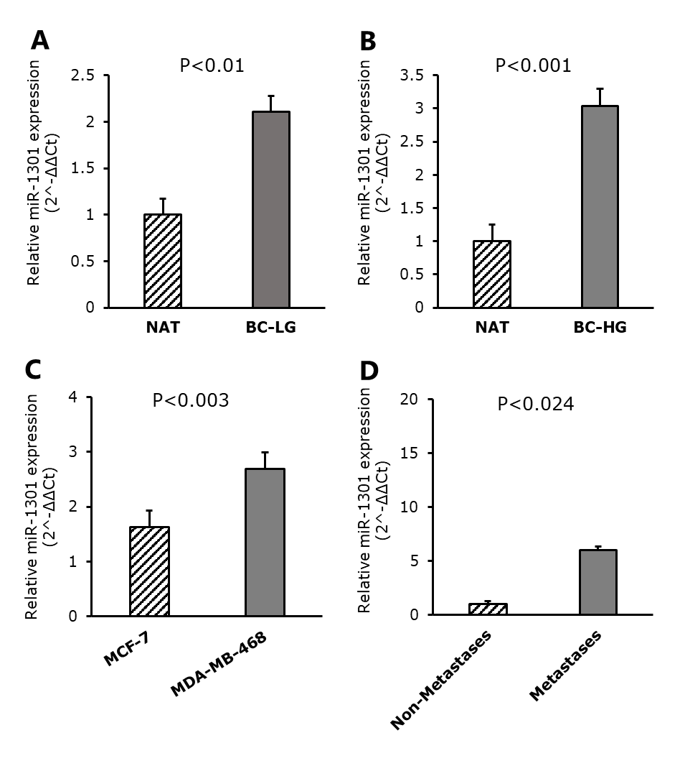
Figure1: Differential expression value of miR-1301-p5 in fresh tissues and cell lines. A. Relative expression of miR-1301-p5 in breast cancer low-grade (BC-LG) and normal to adjacent tissues (NATs). B. Relative expression of miR-1301-p5 in breast cancer high-grade (BC-HG) and normal to adjacent tissues (NATs). C. Relative expression of miR-1301-p5 in the cells of MCF-7 and MDA-MB-468. D. Relative expression of miR-1301-p5 in breast cancer metastasis tissues and non-metastasis tissues.

miR-1301-5p enhances breast cancer cell growth
A miR-1301-5p mimic or ant-miR-1301-5p (inhibitor) was transfected into MCF-7 or MDA-MB-468 cells, respectively, to investigate the function of miR-1301-5p in controlling cell growth. The transfection of miR-1301-p5 mimic considerably raised the level of miR-1301-5p in MCF-7 cells compared to the control group (Figure 2A). However, the level of miR-1301-5p was significantly lower in MDA-MB-468 cells (Figure 2B). The influence of miR-1301-5P mimic or miR-1301-5P inhibitor on cell development were then examined. The findings of the MTT and colony formation tests shown that the introduction of miR-1301-5p can enhance the growth of MCF-7 cells (Figures 2C and 2D), but the proliferation of MDA-MB-468 cells was reduced when anti-miR-1301-5p blocked the expression of miR-1301-5p (Figures 2E and 2F). Moreover, the Annexin V experiment revealed that, in comparison to the control group, miR-1301-5p mimics significantly reduced cell apoptosis (Figure 2G), but anti-miR-1301-5p clearly increased MDA-MB-468 cell apoptosis (Figure 2H). In addition, validation was obtained using the RASSF6 gene (Ras association domain family member 6), which codes for a tumor suppressor protein that is essential for regulating cell development and apoptosis. The western blot outcome demonstrated that miR-1301-5p mimics inhibited RASSF6 expression (Figure 2I).
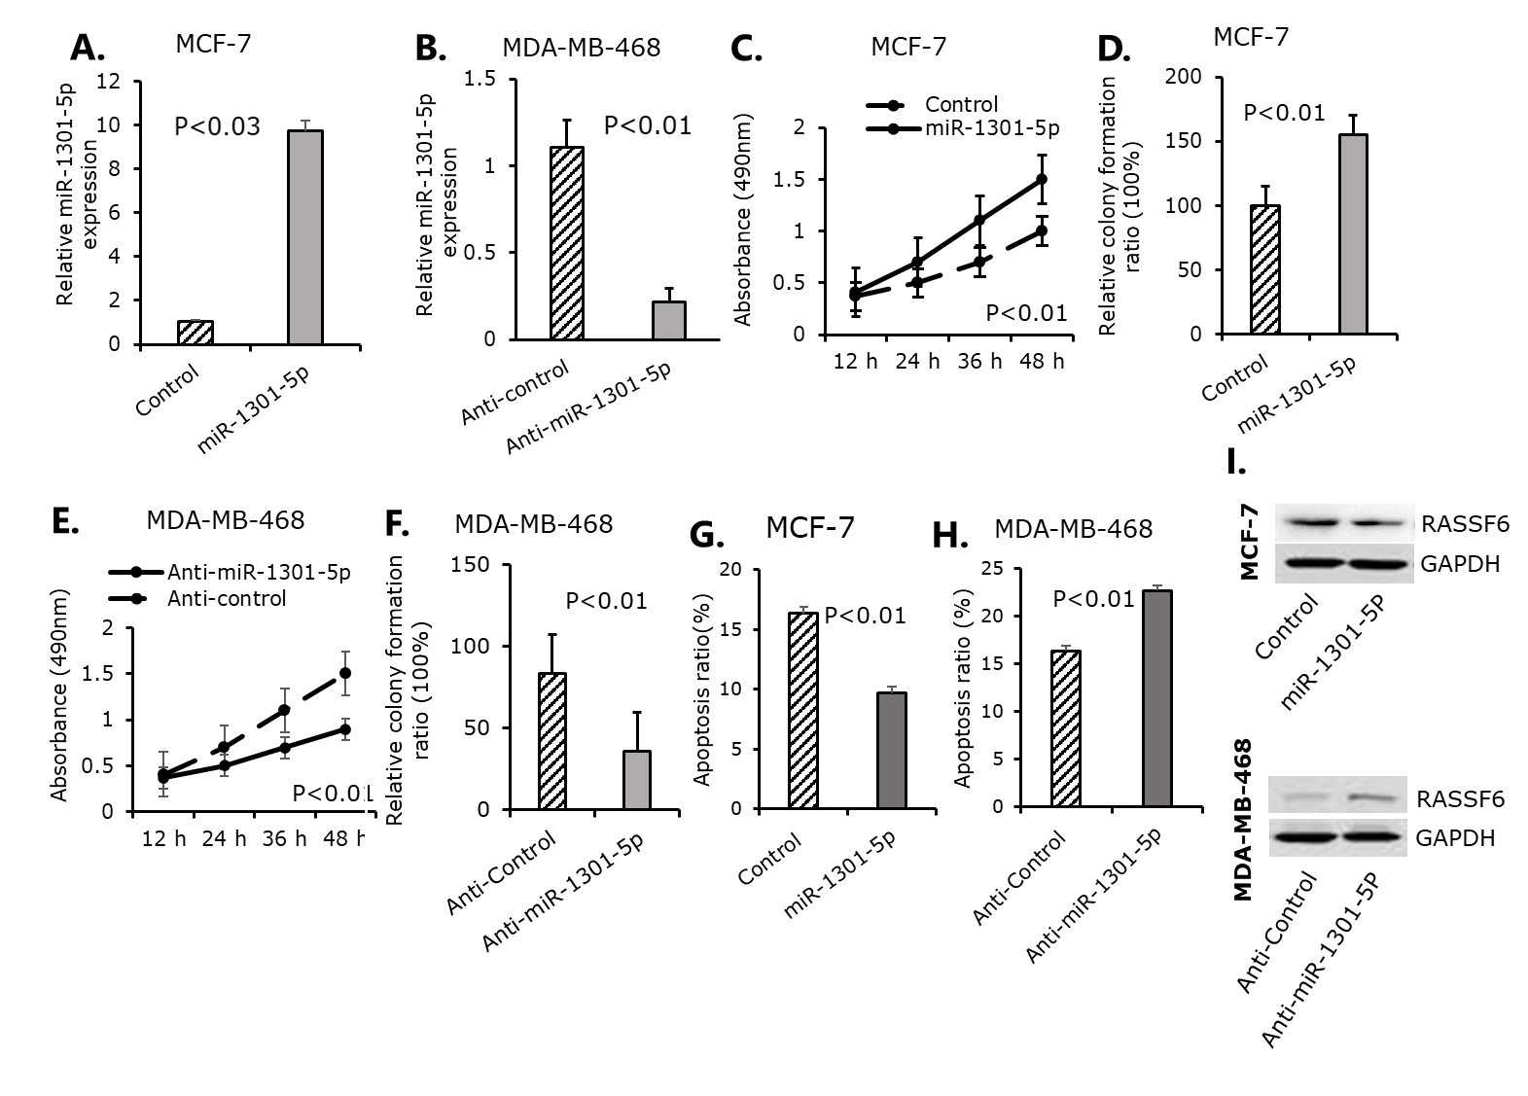
Figure 2: miR-1301-5p decreased cellular apoptosis and increased the growth of breast cancer cells (A and B) RT-qPCR was used to measure the effectiveness of miR-1301-5p and anti-miR-1301-5P in MCF-7 and MDA-MB-468 cells, respectively. (C and E) Using MCF-7 cells transfected with miR-1301-5p or MDA-MB-468 transfected with anti-miR-1301-5p, cell viability was assessed for 12, 24, 36, and 48 hours using the MTT test. (D and F) MCF-7 cells transfected with miR-1301-5p or MDA-MB-468 cells transfected with anti-miR-1301-5p were used in the colony formation experiment to measure the cells' long-term proliferation potential. (G and H) Using MCF-7 cells transfected with miR-1301-5p or MDA-MB-468 cells transfected with anti-miR-1301-5p , the Annexin V test was used to identify cell apoptosis. (I) The impact of miR-1301-5p and anti-miR-1301-5p on RASSF6 expression in MCF-7 and MDA-MB-468 cells, respectively, was assessed by Western blot.

miR-1301-5p encourages breast cancer cell lines to invade and migrate
The assays of transwell invasion and wound healing were used to further examine whether miR-1301-5p influences cell metastasis. MCF-7 cell invasion was enhanced by miR-1301-5p mimics in comparison to the control group (Figure 3A), but MDA-MB-468 cell invasion was suppressed by miR-1301-5p inhibitor (Figure 3B). Additionally, the wound healing assay was utilised to determine the role of miR-1301-5p in cell migration. The migratory capacity of MCF-7 cells was enhanced by miR-1301-5p mimics, but the migration potential of MDA-MB-468 cells was decreased by miR-1301-5p inhibitor, as seen in Figures 3C and 3D. These findings demonstrated that miR-1301-5p may encourage the invasion and migration of breast cancer cells.
PTEN is identified as miR-1301-5p 's direct target.
Next, the possible mechanism of how miR-1301-5p affects cell migration and invasion was determined. PTEN (suppressor of cancer cell invasion), a previously discovered protein that controls invasive cell migration, was suggested as a possible target of miR-1301-5p based on bioinformatic data utilizing five computational algorithms: MirTarBase, MirTar2, Mirbase, DIANA, MirPath, and PicTar.
There is evidence that miRNAs cause mRNA degradation or translational inhibition by forming mismatched base pairing with the 3'UTR of target genes (Figure 3E). Her, the 3'UTR luciferase reporter assay was applied to confirm whether miR-1301-5p directly targets PTEN. As seen in Figure 3F, miR-1301-5p mimics significantly reduced the luciferase activity of the wild-type PTEN 3'-UTR in MCF-7 cells, but the significant inhibition was eliminated when the seed sequences of the miR-1301-5p target sequences were mutated in the PTEN 3'UTR.
To validate whether miR-1301-5p directly targets PTEN, the cells in MCF-7 and MDA-MB-468 were transfected with miR-1301-5p mimics or inhibitors to assessed the impact of miR-1301-5p on the expression of PTEN protein. The Western blot results showed that transfection with miR-1301-5p mimics significantly decreased PTEN expression in MCF-7 cells when compared to the control group, whereas miR-1301-5p inhibitor significantly increased PTEN protein expression (Figure 3G). These findings revealed that miR-1301-5p directly targets the 3'UTR of PTEN mRNA to suppress PTEN protein production.
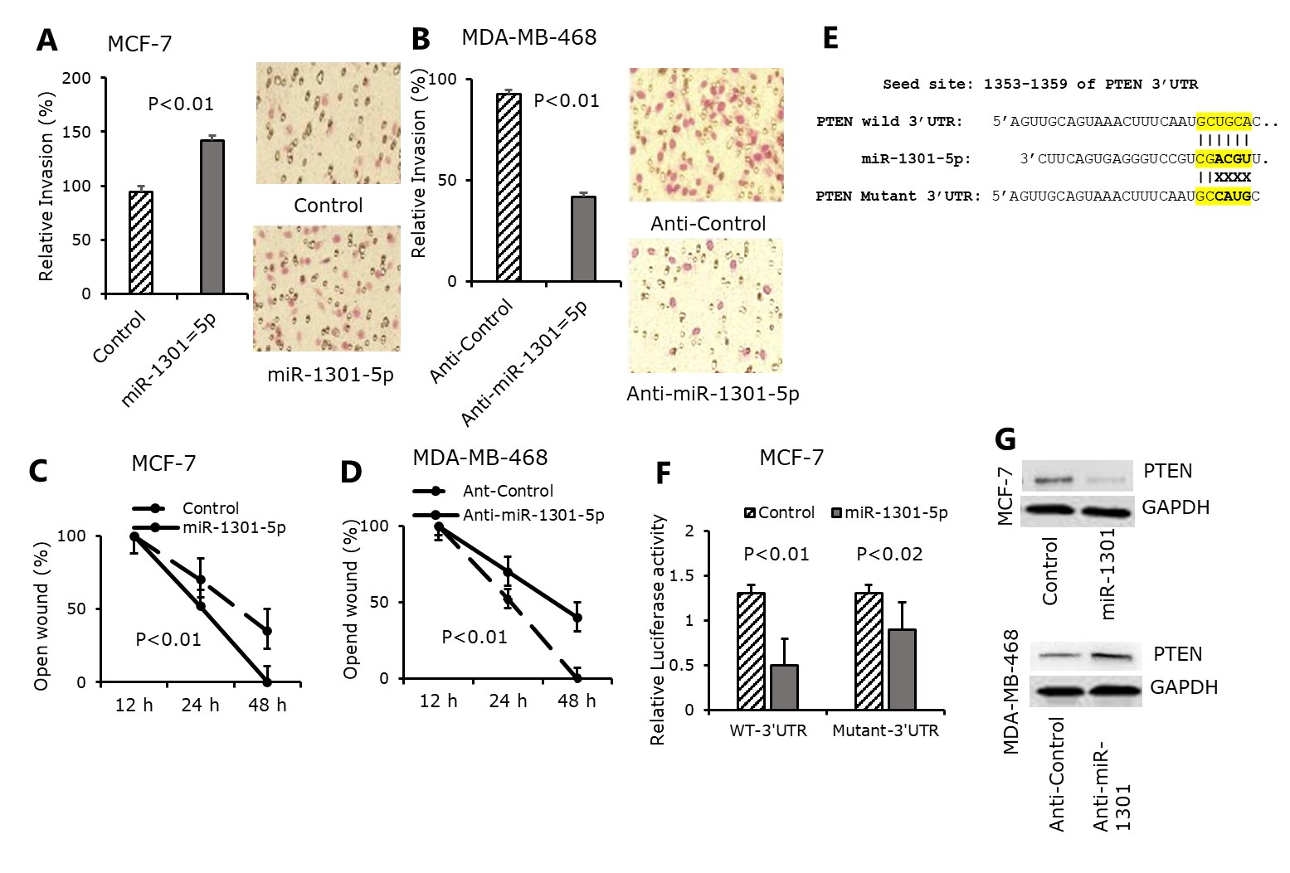
Figure 3: miR-1301-5p hits PTEN and enhances cell spread. (A and B) MCF-7 cells transfected with miR-1301-5p or MDA-MB-468 cells transfected with anti-miR-1301-5p were used for the transwell invasion experiment. (C and D) MCF-7 cells transfected with miR-1301-5p or MDA-MB-468 cells transfected with anti-miR-1301-5p were used for the wound healing experiment. (E) The complementary binding site of the miR-1301-5p seed sequence in PTEN 3'UTR (position: 1353-1359 bps) is underlined (yellow site). (F) MCF-7 cells co-transfected with either miR-1301-5p plus WT-3'UTR or miR-1301-5p plus mutant-3'UTR were used for the 3'UTR luciferase reporter experiment. (G) Using MCF-7 cells transfected with miR-1301-5p or MDA-MB-468 cells transfected with anti-miR-1301-5p, a western blot was used to measure the protein expression of PTEN. GAPDH was used as an expression control.
Overexpression of RASSF6 and PTEN considerably reduces the promotion of cell growth and metastasis by miR-1301-5p .
PTEN expression in breast cancer cell lines and tissues was validated as a direct target of miR-1301-5p. PTEN mRNA expression levels in breast cancer cell lines were measured using qRT-PCR, which revealed that miR-1301-5p had less expression from MCF-7 and MDA-MB-468 cells (Figure 4A). Additionally, PTEN mRNA and protein expression was significantly lower in breast cancer (BC) tissue when compared to normal to adjacent tissues (NATs) (Figure 4B and 4C).
A rescue experiment was then carried out to determine if the effects of miR-1301-5p on cellular invasion, proliferation, and migration are certainly caused by the inhibition of RASSF6 and PTEN. The transfection of pcDNA3-RASSF6 prevented miR-1301-5 from promoting the growth of MCF-7 cells, as revealed in Figure 4D. Additionally, transfection of pcDNA3-PTEN in MCF-7 cells was validated to eliminate the invasion and migration of cells generated by miR-1301-5p mimics (Figure 4E and 4F). These findings revealed that RASSF6 and PTEN facilitated the proliferation, invasion, and migration of breast cancer cells caused by miR-1301-5p , as revealed in Figure 4G.
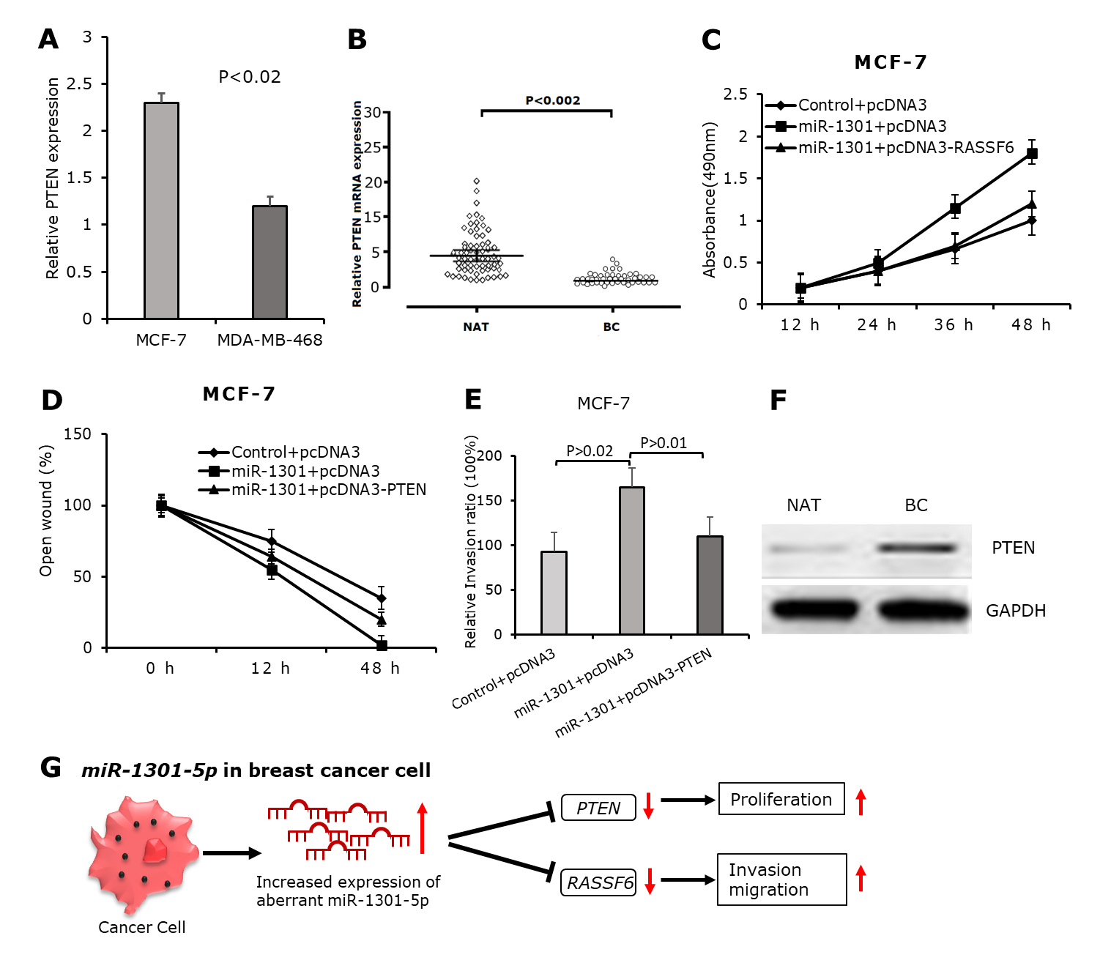
Figure 4: Cell invasion, migration, and proliferation caused by miR-1301-5p may be reversed by RASSF6 and PTEN. (A) PTEN expression levels in MCF-7 and MDA-MB-468 cells. (B) PTEN's relative mRNA expression in breast cancer (BC) and normal to adjacent tissues (NATs). (C) PTEN protein expression in surrounding NATs and BC tissues. (D) The impact of RASSF6 overexpression on MTT-detected cell viability caused by miR-1301-5p. (E and F) Transwell and wound healing assays were used to measure the impact of PTEN overexpression on miR-1301-5p -induced cell invasion and migration. (G) An example of how miR-1301-5p affects the invasion, migration, and proliferation of breast cancer cells.

Discussion
MicroRNAs are known as small non-coding regulatory RNAs that have been investigated in a number of cancer types[1, 32]. Numerous miRNAs have been shown to regulate both pro-metastatic and anti-metastatic processes, as well as the epithelial-to-mesenchymal transition (EMT). Numerous biological processes can be modulated by microRNAs. MiRNAs have been shown to have distinct functions in the proliferation, differentiation, migration, and metastasis of cancer cells [33-35]. Differential expression of many miRNAs in breast cancer cells and tissues has been shown, indicating their role in the development and progression of breast cancer. Although miR-1301-5p has been previously shown to regulate genes in several other cancer types, its functions in breast cancer remain unidentified [20, 36]. This study provides the first evidence that miR-1301-5p contributes to the growth, invasion, and metastasis of breast cancer cells. The potential efficacy of miR-13015p was examined in relation to breast cancer. In highly metastatic MDA-MB-468 cells, miR-1301-5p expression was significantly elevated, but in non-cancerous breast epithelial cells (MCF-7), miR-1301-5p expression was markedly reduced. MiR-1301-p5 was expressed at the greatest levels in breast cancer tissues with the highest malignancy stage, and its expression was greater in metastases than in non-metastases. Thus, miR-1301-5p may have a role in the pathogenesis of breast cancer by boosting proliferation and metastasis. In vitro investigation using MTT, Transwell, and wound healing tests on breast cancer cells further supported the hypothesis of this study. In HeLa cells, it has been reported that miR-1301-5p targets the protein RASSF6 (Ras association domain family member 6) to suppress cellular apoptotic signaling [37]. Here, the outcome shows that miR-1301-5p may prevent the apoptosis of MCF-7 and MDA-MB-468. Additionally, it was confirmed that miR-1301-5p suppresses RASSF6 expression in breast cancer cells. Several computational techniques were employed to investigate other potential targets of miR-1301-5p, and the PTEN (Phosphatase and Tensin homolog) gene was identified as a prospective target. The direct target of miR-1301-5p was shown to be PTEN using the 3'UTR luciferase reporter experiment. PTEN expression is down-regulated in tandem with an increase in miR-1301-5p expression. This observation that PTEN was down-regulated in breast cancer tissues and that the non-malignant breast epithelial cell MCF-7 expressed the highest level of PTEN while highly metastatic cells (MDA-MB-468) expressed relatively lower PTEN expression may help to explain the down-regulation of PTEN during the pathogenesis of breast cancer. There is evidence that PTEN is an important tumor suppressor gene that prevents uncontrolled proliferation that causes cancer [38, 39]. The tumor suppressor PTEN gene and microRNAs (miRNAs) have a crucial regulatory relationship, where oncomiRs (like miR-21, miR-106b, miR-221, miR-183) often downregulate PTEN, activating the pro-growth PI3K/AKT pathway, leading to increased cell proliferation and invasion, while tumor-suppressing miRNAs can upregulate PTEN, inhibiting cancer [40]. This intricate axis impacts cancer progression, metastasis, and treatment response, making both PTEN and specific miRNAs important diagnostic/prognostic markers and potential therapeutic targets, as shown by studies involving miRNA-20a/PTENP1 interactions or miR-424-5p's suppressive role[41]. The ability of invasive cell migration is dramatically increased when PTEN is knocked down by RNA-mediated interference [42]. These were consistent with the promotion of invasion and migration induction ability in breast cancer cells and further supported findings that miR-1301-5p can target PTEN.

Conclusion
This research demonstrated that miR-1301-5p directly targeted PTEN. PTEN expression can be decreased by inducing miR-1301-5p expression. Furthermore, RASSF6 and PTEN mediated the promotion of breast cancer invasion, migration, and proliferation by miR-1301-5p. As a result, these findings may offer fresh perspectives on the treatment and pathogenesis of breast cancer.

Acknowledgements
This work was supported and funded by Salahaddin University-Erbil.
Disclosure of conflict of interest
None.

Reference
1. Majed, S.O. and S.A. Mustafa, MACE-Seq-based coding RNA and TrueQuant-based small RNA profile in breast cancer: tumor-suppressive miRNA-1275 identified as a novel marker. BMC Cancer, 2021. 21(1): p. 473.
2. Khodabandeh, Z., et al., The potential role of nicotine in breast cancer initiation, development, angiogenesis, invasion, metastasis, and resistance to therapy. Breast Cancer, 2022. 29(5): p. 778-789.
3. Vidra, R., et al., Spectrum of BRCA1/2 Mutations in Romanian Breast and Ovarian Cancer Patients. International Journal of Environmental Research and Public Health, 2022. 19(7): p. 4314.
4. Wei, J.-L., Y.-Z. Jiang, and Z.-M. Shao, Survival and chemotherapy-related risk of second primary malignancy in breast cancer patients: a SEER-based study. International journal of clinical oncology, 2019. 24(8): p. 934-940.
5. Zhang, Z.G., et al., MiR-132 prohibits proliferation, invasion, migration, and metastasis in breast cancer by targeting HN1. Biochem Biophys Res Commun, 2014. 454(1): p. 109-14.
6. Sun, Y.-S., et al., Risk factors and preventions of breast cancer. International journal of biological sciences, 2017. 13(11): p. 1387.
7. Abbasi-Dokht, T., et al., Assessing Angiogenesis Factors as Prognostic Biomarkers in Breast Cancer Patients and Their Association with Clinicopathological Factors. Biomarkers, 2024(just-accepted): p. 1-20.
8. Donati, S., et al., Serums miR-24-3p and miR-1301-3p as Potential Biomarkers in MEN1 Syndrome. International Journal of Molecular Sciences, 2025. 26(11): p. 5076.
9. Singh, R. and Y.-Y. Mo, Role of microRNAs in breast cancer. Cancer biology & therapy, 2013. 14(3): p. 201-212.
10. Takahashi, R.-u., H. Miyazaki, and T. Ochiya, The roles of microRNAs in breast cancer. Cancers, 2015. 7(2): p. 598-616.
11. Liu, H., et al., Ligation-recognition triggered RPA-Cas12a cis-cleavage fluorogenic RNA aptamer for one-pot and label-free detection of MicroRNA in breast cancer. Biosensors and Bioelectronics, 2025. 272: p. 117106.
12. Muñoz, J.P., et al., The role of MicroRNAs in breast cancer and the challenges of their clinical application. Diagnostics, 2023. 13(19): p. 3072.
13. Mohammadi, M., et al., Correlation of PTEN signaling pathway and miRNA in breast cancer. Molecular Biology Reports, 2024. 51(1): p. 221.
14. Smolarz, B., et al., The role of microRNA in pancreatic cancer. Biomedicines, 2021. 9(10): p. 1322.
15. Tâlvan, C.-D., et al., Exploring miRNA Profiles in Colon Cancer: A Focus on miR101-3p, miR106a-5p, and miR326. Cancers, 2024. 16(12): p. 2285.
16. Lobera, E.S., et al., miRNA as biomarker in lung cancer. Molecular biology reports, 2023. 50(11): p. 9521-9527.
17. He, L., et al., MicroRNA‐501‐3p inhibits the proliferation of kidney cancer cells by targeting WTAP. Cancer medicine, 2021. 10(20): p. 7222-7232.
18. Huang, P.-S., et al., Functional and clinical significance of dysregulated microRNAs in liver cancer. Cancers, 2021. 13(21): p. 5361.
19. Lorusso, G. and C. Rüegg, The tumor microenvironment and its contribution to tumor evolution toward metastasis. Histochemistry and cell biology, 2008. 130(6): p. 1091-1103.
20. Ladeiro, Y., et al., MicroRNA profiling in hepatocellular tumors is associated with clinical features and oncogene/tumor suppressor gene mutations. Hepatology, 2008. 47(6): p. 1955-1963.
21. Robertson, N.M. and M.V. Yigit, The role of microRNA in resistance to breast cancer therapy. Wiley Interdisciplinary Reviews: RNA, 2014. 5(6): p. 823-833.
22. Martínez-Espinosa, I., J.A. Serrato, and B. Ortiz-Quintero, MicroRNAs in Lung Cancer Brain Metastasis. International Journal of Molecular Sciences, 2024. 25(19): p. 10325.
23. Adams, B.D., et al., Targeting noncoding RNAs in disease. J Clin Invest, 2017. 127(3): p. 761-771.
24. Wu, K.-L., et al., The roles of MicroRNA in lung cancer. International journal of molecular sciences, 2019. 20(7): p. 1611.
25. Zhong, C., et al., Aberrant expression of miR-1301 in Human Cancer. Frontiers in Oncology, 2022. 11: p. 789626.
26. Lin, W.-h., et al., MicroRNA-1301 induces cell proliferation by downregulating ICAT expression in breast cancer. Biomedicine & Pharmacotherapy, 2016. 83: p. 177-185.
27. Wu, Q., et al., EZH2 induces the expression of miR-1301 as a negative feedback control mechanism in triple negative breast cancer. Acta Biochimica et Biophysica Sinica, 2018. 50(7): p. 693-700.
28. Zhang, K., et al., ICAT inhibits glioblastoma cell proliferation by suppressing Wnt/β-catenin activity. Cancer letters, 2015. 357(1): p. 404-411.
29. Wu, Z., et al., E2F1 suppresses Wnt/β-catenin activity through transactivation of β-catenin interacting protein ICAT. Oncogene, 2011. 30(37): p. 3979-3984.
30. Chang, C. and M. Hung, The role of EZH2 in tumour progression. British journal of cancer, 2012. 106(2): p. 243-247.
31. Jang, S.-H., et al., High EZH2 protein expression is associated with poor overall survival in patients with luminal a breast cancer. Journal of breast cancer, 2016. 19(1): p. 53.
32. Majed, S.O., RNA Sequencing-Based Total RNA Profiling; The Oncogenic MiR-191 Identification as a Novel Biomarker for Breast Cancer. Cellular and Molecular Biology, 2022. 68(1): p. 177-191.
33. Majed, S.O., MACE-Seq-Based Transcripts Profilings in Breast Cancer: Tumor Suppressive miR-1185-p5 Promotes Cell Migration and Invasion by Targeting BCAS1, CASC3, GATA2, and VOPP1. Law and Medicine, 2025. 12(1): p. 1-26.
34. Majed, S.O. and S.A. Mustafa, The profiles of miR-4510 expression level in breast cancer. Scientific Reports, 2023. 13(1): p. 2262.
35. Majed, S.O., MACE-Seq-Based Transcripts Profilings in Breast Cancer: Tumor Suppressive miR-1185-p5 Promotes Cell Migration and Invasion by Targeting BCAS1, CASC3, GATA2, and VOPP1. Law and Medicine, 2025. 12(1): p. 1-24.
36. Lin, L., et al., MiR-1228 promotes breast cancer cell growth and metastasis through targeting SCAI protein. International journal of clinical and experimental pathology, 2015. 8(6): p. 6646.
37. Yan, B. and J.-l. Zhao, miR-1228 prevents cellular apoptosis through targeting of MOAP1 protein. Apoptosis, 2012. 17(7): p. 717-724.
38. Ferrari, P., et al., Molecular Mechanisms and Therapeutic Strategies to Overcome Resistance to Endocrine Therapy and CDK4/6 Inhibitors in Advanced ER+/HER2− Breast Cancer. International Journal of Molecular Sciences, 2025. 26(7): p. 3438.
39. Fusco, N., et al., Immunohistochemistry for PTEN testing in HR+/HER2˗ metastatic breast cancer. Virchows Archiv, 2025. 487(4): p. 727-732.
40. Mohammadi, M., et al., Correlation of PTEN signaling pathway and miRNA in breast cancer. Mol Biol Rep, 2024. 51(1): p. 221.
41. Gao, X., et al., PTENP1/miR-20a/PTEN axis contributes to breast cancer progression by regulating PTEN via PI3K/AKT pathway. J Exp Clin Cancer Res, 2019. 38(1): p. 256.
42. Ma, J., et al., PTEN Gene Induces Cell Invasion and Migration via Regulating AKT/GSK-3β/β-Catenin Signaling Pathway in Human Gastric Cancer. Digestive Diseases and Sciences, 2017. 62(12): p. 3415-3425.

