Comparative Efficacy of Synthetic and Natural Pesticides in Turfgrass Management

Hong Liu¹
¹Chemical Engineering Department, Fushun Vocational Technology Institute, Fushun 113122, China
Email: 1840726129@qq.com

Abstract
To scientifically compare the control efficacy and ecological adaptability of synthetic versus natural pesticides in turfgrass management, a comprehensive evaluation model based on multidimensional weighted indicators was constructed. This model uses turf coverage, plant height, disease spot change rate, pest density change rate, weed coverage reduction rate, and ecological safety indicators as core parameters. A weighting system was established by combining the Analytic Hierarchy Process (AHP) with expert weighting methods, and it was optimized based on previous turf plant protection effect evaluation models. Experimental designs encompassed two typical turfgrass species—perennial ryegrass and Bermuda grass—subjected to control trials under five pesticide treatments: chlorantraniliprole, glyphosate, chlorothalonil, garlic oil, and nicotine. Results indicate synthetic pesticides excel in disease suppression and pest density control, with chlorothalonil and chlorantraniliprole achieving 80.7% and 81.5% disease reduction rates, respectively. Glyphosate demonstrated over 80% reduction in weed coverage. Although natural agents showed weaker short-term efficacy, they demonstrated advantages in enhancing coverage and ecological friendliness. The garlic oil group increased coverage in American ryegrass by 16.4% without significant ecological negative effects. This model validated the sustainable potential of natural agents, providing scientific basis for green turf maintenance strategies.
Keywords: turfgrass management; synthetic pesticides; natural pesticides; efficacy evaluation; ecological adaptability

1 Introduction
Turfgrass plants play vital roles in urban greening, aesthetic landscapes, and ecological regulation, with their management directly impacting the stability and sustainability of horticultural ecosystems. With accelerated urbanization and increased turf utilization intensity, frequent pest and weed outbreaks have become primary factors limiting turf quality. For a long time, synthetic chemical pesticides have been central tools in turfgrass maintenance due to their rapid action and precise targeting. However, accompanying issues such as environmental residues, resistance evolution, and non-target organism hazards have gradually become prominent, compelling the industry to seek more ecologically safe alternatives. In recent years, natural pesticides have been progressively integrated into turfgrass management practices due to their strong biodegradability, low environmental impact, and excellent ecological compatibility, forming a dual-system approach alongside traditional synthetic agents.
Against this backdrop, systematically comparing the control efficacy, growth promotion effects, and ecological responses of synthetic versus natural pesticides in turfgrass management not only helps delineate the appropriate boundaries for different pesticide types but also provides empirical evidence for establishing green, sustainable maintenance models. Through experimental design and a multidimensional evaluation system, this study comprehensively analyzes the performance differences between synthetic and natural pesticides in terms of turf coverage, plant height, pest and disease control, and ecological factor adaptability. It aims to provide scientific references for optimizing turf management models and transforming pesticide usage concepts, while exploring feasible pathways to balance control efficiency and environmental safety under an ecology-first approach.
2. Evolution of Pesticide Use in Turfgrass Management
The application of pesticides in turfgrass management initially relied primarily on highly effective synthetic chemical agents, focusing on controlling high-frequency pests such as aphids, spider mites, and broadleaf weeds. These agents offered rapid efficacy and broad-spectrum control. Beginning in the 1970s, as turfgrass areas expanded and landscape standards rose, pesticide usage increased significantly. Consequently, environmental pollution and resistance issues gradually emerged. Entering the 21st century, natural pesticides gained widespread attention due to their high biodegradability and lower toxicity. In recent years, natural formulations derived from plant extracts (e.g., pyrethrins), microbial metabolites (e.g., Bacillus thuringiensis toxins), and mineral sources (e.g., diatomaceous earth) have progressively entered turfgrass management systems. These substances demonstrate eco-friendly alternative potential in low-input pest and disease management, signaling a shift in turfgrass pesticide philosophy from "high-efficiency control" to "green sustainability"[1] .
3 Experimental Design for Pesticide Efficacy Evaluation
3.1 Selection of Experimental Materials
Following principles of typicality and representativeness in turfgrass management, susceptible, widely adaptable, and clearly manageable turfgrass species were selected as experimental plants. Combined with two categories of pesticides—commonly used in the market and ecologically robust—an experimental material system with comparative value and application potential was established (see Table 1). All experimental materials underwent pre-screening to ensure no residual pesticide background. They were uniformly cultivated under identical light, moisture, and pH conditions to eliminate non-target factor interference[2] .
Table 1: Experimental Material Composition and Functional Classification
Material Category | ID | Material Name | Purpose Description | Source and Specifications
(1) Lawn Plants | A1 | Perennial Ryegrass (Lolium perenne) | Representative cool-season turfgrass, susceptible to rust and leaf spot diseases | Jiangsu Grass Seed Research Center, Purity >98%, 1000-seed weight 210g/kg
 | A2 | Bermuda Grass (Cynodon dactylon) | Representative warm-season turfgrass, commonly susceptible to armyworm and powdery mildew infections | Anhui Agricultural University Turfgrass Experimental Base, Purity >95%, 1000-seed weight 205g/kg
(2) Synthetic Pesticides | B1 | Chlorantraniliprole | Insecticide, targets aphids and spider mites | Supplied by agrochemical company, concentration 200 g/L, SC formulation
 | B2 | Glyphosate Isopropylamine Salt | Non-selective herbicide, controls broadleaf weeds | Tuobang Agrochemical Co., Ltd., 41% AS
 | B3 | Chlorothalonil | Fungicide for controlling leaf spot and downy mildew | Shandong Pesticide Factory, 75% WP
(3) Natural Pesticides | C1 | Garlic Oil Extract | Broad-spectrum insect repellent, effective against soft-bodied pests | Self-collected from biotechnology laboratory, content ≥30%, emulsifiable concentrate formulation
 | C2 | Tobacco alkaloid aqueous solution | Dual insecticidal and fungicidal effects, mild and long-lasting | Homemade formula (5% nicotine + 95% water), prepare and use immediately
(4) Control treatment | D0 | Distilled water (untreated control) | Used to eliminate interference from other variables, serving as the baseline control group | Distilled water for experimental use
3.2 Experimental Design
3.2.1 Tested Turfgrass Species
The experiment employed a randomized block design (RCBD) with two factors: turfgrass species and pesticide treatment type. This design aimed to systematically compare the effects of synthetic versus natural pesticides on growth status, disease/pest resistance, and turf quality across different turfgrass species. Test turfgrass species were selected based on three principles: (1) widespread application in China's greening systems; (2) clear sensitivity to pesticide application, facilitating differential identification; (3) They exhibit representative pest and disease backgrounds. Specifically selected were the cool-season turfgrass perennial ryegrass (Lolium perenne) and the warm-season turfgrass Bermuda grass (Cynodon dactylon), representing typical turfgrass species in temperate and subtropical regions, respectively[3] . Each grass type was assigned to six treatment groups: five chemical agents (synthetic: chlorantraniliprole, glyphosate isopropylamine salt, chlorothalonil; natural: garlic oil, nicotine); and a water control group. Each treatment had three replicates, totaling 36 plots. Each plot measured 1.5 m × 1.5 m with 0.5 m spacing between plots. Inter-plot isolation membranes prevented pesticide cross-contamination. All chemicals were applied quantitatively using backpack sprayers at 10-day intervals for a total of three applications over a 30-day experimental period. All plots were managed under uniform light, moisture, and nutrient conditions to ensure single variables and clear comparisons. Classification and ecological characteristics of the tested turfgrass species are detailed in Table 2.
Table 2: Types and Ecological Characteristics of Tested Turfgrass Species
No. | Grass Species Name | Scientific Name | Type
1 | Perennial Ryegrass | Lolium perenne | Cool-season turfgrass
2 | Bermuda Grass | Cynodon dactylon | Warm-season turfgrass
The grass species listed in Table 1 are widely used across both northern and southern regions of China today, demonstrating strong representativeness. Among them, Perennial Ryegrass is suitable for management during spring and autumn low-temperature periods, featuring rapid germination and quick establishment; Bermuda grass is heat-tolerant and wear-resistant, commonly used in high-traffic areas such as parks, walkways, and sports turf. These two species exhibit structural differences in maintenance strategies, pest and disease profiles, and pesticide sensitivity responses, making them an ideal combination for comparative efficacy trials[4] .
3.2.2 Pesticide Types and Dosages
The pesticide treatment factor design encompasses two major categories: synthetic and natural products, covering three functional classes: insecticides, herbicides, and fungicides. Specific agent selection adheres to principles of clearly defined registered application scope, controllable toxicological and ecological parameters, and high safety margins for turfgrass plants. This ensures comprehensive coverage of common pest, disease, and weed response dimensions in turf management[5] . Synthetic agents include chlorantraniliprole (200 g/L SC), glyphosate isopropylamine salt (41% AS), and chlorothalonil (75% WP), targeting high-frequency pests/diseases such as aphids/spider mites, broadleaf weeds, and leaf spot/downy mildew respectively. Natural agents include garlic oil extract emulsifiable concentrate (30% EC) and tobacco alkaloid aqueous solution (5%, freshly prepared in-lab), offering excellent biodegradability and ecological compatibility while providing broad-spectrum insect repellency and disease suppression.
All formulations were applied via backpack sprayers, with droplet sizes controlled between 100–150 μm and spray width maintained within 1.0 m to ensure uniform coverage without overlap. The application rate per plot, converted to active ingredient concentration, is set as follows: - Chlorantraniliprole: 0.3 mL/m² - Glyphosate isopropylamine salt: 3.0 mL/m² - Chlorothalonil: 1.2 g/m² - Garlic oil: 1.5 mL/m² - Nicotine aqueous solution: 10 mL/m² garlic oil at 1.5 mL/m², and nicotine solution at 10 mL/m². All dosages were determined by reference to the Technical Guidelines for Pesticide Use (2nd Edition) and relevant plant protection recommendations. Application frequency was standardized at once every 10 days, with a total of three treatments. Standard temperature and humidity management was maintained during intervals without additional applications or supplemental spraying. Pesticide classifications and dosage settings are detailed in Table 3.
Table 3: Classification and Application Dosage Parameters for Different Types of Lawn Pesticides
Pesticide Name | Type | Formulation | Active Ingredient Content | Application Rate | Primary Target | Application Characteristics
Chlorantraniliprole | Synthetic insecticide | Suspension concentrate (SC) | 200 g/L | 0.3 mL/m² | Sucking pests such as aphids and spider mites | Highly effective, low toxicity, with strong systemic translocation
Glyphosate Isopropylamine Salt | Synthetic herbicide | Aqueous Solution (AS) | 41% | 3.0 mL/m² | Broadleaf weeds such as barnyard grass and field bindweed | Non-selective, suitable for clearing weed substrates
Chlorothalonil | Synthetic fungicide | Wettable powder (WP) | 75% | 1.2 g/m² | Fungal diseases such as leaf spot and downy mildew | Broad-spectrum contact fungicide with extended safety interval
Garlic Oil Extract Emulsifiable Concentrate | Natural insect repellent | Emulsifiable concentrate (EC) | ≥30% | 1.5 mL/m² | Whiteflies, flea beetles, soft-bodied pests, etc. | Rapidly biodegradable, providing both repellent and mildly toxic functions
Tobacco alkaloid aqueous solution | Natural insecticide/fungicide | Aqueous solution | 5% (Prepare and use immediately) | 10.0 mL/m² | Powdery mildew, aphids, early-stage lepidopteran pests | Mild onset, suitable for eco-friendly management programs
The five agents above cover three major categories of pest, disease, and weed control targets in turfgrass maintenance. Their combination offers good comparability and response stability. Synthetic agents emphasize control efficiency and dosage precision, while natural agents focus on ecological adaptability and residue control, facilitating assessment of their differential responses across different turfgrass species. All application rates in the table are converted to standard unit area based on active ingredient content. Temperature, humidity, and wind speed parameters were concurrently recorded during application to ensure experimental reproducibility and interpretability[6] .
3.2.3 Evaluation Index System
To comprehensively evaluate the practical efficacy of different pesticide types in turfgrass management, an integrated evaluation framework was established. This framework comprises three core dimensions: turfgrass growth traits, pest and disease suppression effects, and ecological safety responses. A unified scoring model was developed using indicator weighting methods. The framework includes: (1) Turfgrass growth quality indicators: coverage, growth height, and density index; (2) Pest and weed control indicators, including disease spot change rate, pest density change rate, and weed coverage reduction rate; (3) Ecological response indicators, covering soil pH fluctuation range, beneficial insect occurrence frequency, and visual aesthetic score of the turf. All indicators were collected using standardized quantitative methods at measurement cycles of pre-application and 10, 20, and 30 days post-application. Data recording was supplemented using portable ground cover meters, plant density counters, and microscopic observation techniques. Scores for each indicator underwent interval standardization before integration into a comprehensive scoring model, calculated as follows:
(1)
Where represents the comprehensive efficacy score for the pesticide treatment group, denotes the measured value for the th evaluation indicator, are the minimum and maximum values of this indicator across all treatment groups, respectively, and is the weight coefficient for the th indicator. Weight values were determined using a combination of expert scoring and the Analytic Hierarchy Process (AHP), with lawn growth indicators accounting for 40%, control indicators for 45%, and ecological indicators for 15%. Higher scores indicate superior overall pesticide efficacy. The evaluation indicator system used is listed in Table 4.
Table 4: Evaluation Indicator System for Pesticide Treatment Effectiveness in Lawns
Indicator Name | Indicator Category | Measurement Method Description
Turf Cover | Growth Trait | Using the Green Space Imaging Analysis System, take the average of 5 points
Average Plant Height | Growth Trait | Manual measurement with a ruler, taking the average of 10 plants
Turf Density Index | Growth Trait | Measured using a needle probe lawn density meter
Disease lesion change rate | Control Effectiveness | Leaf spot counting method, comparing total lesion counts before and after application
Pest Density Change Rate | Control Effectiveness | Yellow sticky trap method, with 3 traps per plot
Reduction in weed coverage | Control Effectiveness | Field measurement using coordinate-based sketch comparison method
Soil pH fluctuation range | Ecological response | Soil acidity meter, average of three measurements
Frequency of beneficial insect occurrence | Ecological response | Fixed-point observation method, with daily morning patrols at a set time
Lawn Aesthetic Rating | Ecological response | Expert blind evaluation method, average of scores from 3 evaluators
The evaluation model integrates the responsiveness of variables across different levels, compares the performance differences of various pesticides on the same turfgrass species, and simultaneously analyzes the disturbance effects and ecological compensation mechanisms of pesticide types and doses on the turfgrass system. This provides a quantitative foundation for result analysis and decision support.[7] .
3.3 Experimental Environment Control
To ensure high signal-to-noise ratios and reproducibility in pesticide treatment effects and turfgrass growth responses, this experiment rigorously controlled key environmental variables—including temperature, humidity, light intensity, wind speed, soil physicochemical properties, and rainfall shielding conditions—to establish a quasi-artificial, controllable field microenvironment system[8] . Experiments were conducted at the East China Lawn Plant Ecological Testing Platform. All plots utilized neutral loam soil (pH 6.8–7.2, bulk density 1.30 g/cm³, field capacity 27.6%). Soil consistency was achieved through uniform rotary tillage, stubble removal, and acidification prior to planting. The experimental area employed a combined "spatial partitioning + physical control" approach, using 2×2 m grid plots as units. Isolation membranes and 40 cm buffer zones were installed around each plot to prevent cross-contamination of chemicals. Light-colored rain covers were installed over all plots to minimize non-target rainfall interference and ensure application precision. Soil moisture was uniformly supplied via drip irrigation pipes, with a timed electronic control system maintaining consistent daily watering frequency. Each irrigation cycle delivered 4 L/m², scheduled daily from 7:00–8:00. Temperature and humidity data are recorded using HOBO UX100 series environmental loggers, deployed synchronously in each plot with a 10-minute interval. A data export platform monitors fluctuations to ensure they remain within tolerance thresholds (±2°C, ±5% RH).
For light conditions, unobstructed designs were implemented across all plots to ensure equivalent light intensity across treatment groups. Sunlight duration and radiation intensity were recorded, with photosynthetically active radiation (PAR) measured at fixed points using Apogee MQ-510 quantum sensors. Daily PAR levels were maintained between 850–1000 μmol·m⁻²·s⁻¹. Wind speed control employed a combination of north-facing hedges and south-facing high-density mesh barriers around the test site, maintaining average regional wind speeds within 1.5–2.0 m/s to minimize fog drift interference with pesticide deposition accuracy. To manage non-target ecological disturbances, daily dawn inspections monitored small animal activity, insect interference, and weed growth within the test area. Disturbance factors were promptly removed to ensure experimental integrity[9-10] . Figure 1 illustrates the parameter architecture and subsystem interconnections within this environmental control system.
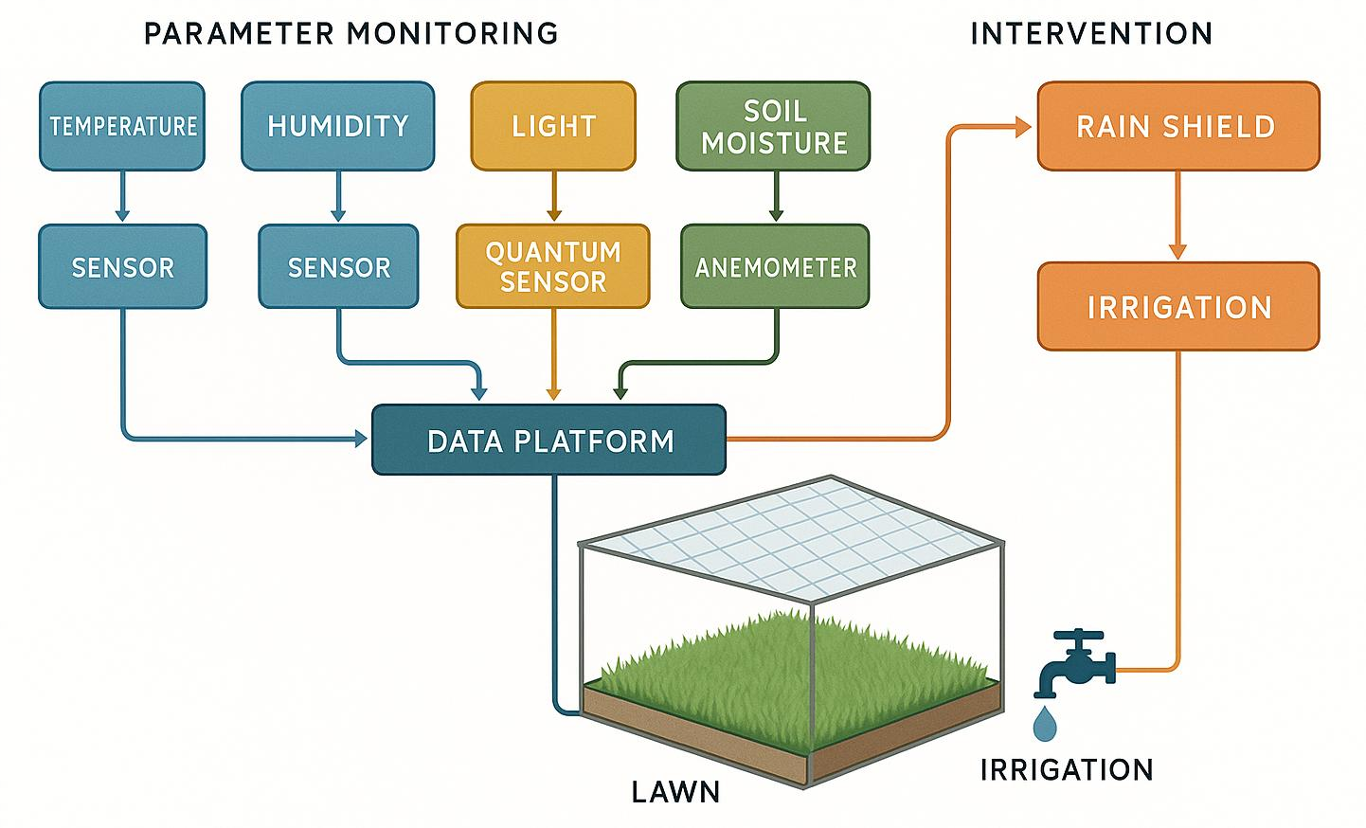
Figure 1: Experimental Environment Control Parameter Structure Diagram
3.4 Data Processing Methods
All raw experimental data were preliminarily entered into Excel 2019 for completeness screening, then imported into SPSS 26.0 and R environment (v4.2.2) for multidimensional statistical analysis. Data on turfgrass growth traits, pest and disease control, and ecological response indicators first underwent Shapiro–Wilk normality tests and Levene's tests for homogeneity of variance. Samples failing basic statistical assumptions were excluded, and missing values were imputed using partial weighted regression. To eliminate weighting distortions caused by dimensional differences across indicators, all data underwent range normalization using the following formula:
(2)
Where denotes the normalized value of the th indicator in the th sample, represents the minimum and maximum values of that indicator column, respectively, and is the original observed value. After obtaining standardized data, one-way ANOVA and LSD multiple comparisons were performed between the treatment and control groups, with a significance level set at α=0.05\alpha = 0.05α=0.05. For data not meeting normality assumptions, nonparametric analysis was performed using the Kruskal–Wallis H test. Additionally, to assess treatment-induced sensitivity differences across evaluation dimensions, a weighted composite scoring model was constructed incorporating fuzzy hierarchical weighting transformation:
(3)
where denotes the comprehensive benefit score for the th pesticide treatment, represents the weight of the th indicator, and is the membership function value of the th sample under the th indicator, defined as a linear growth function. The final treatment effect was identified through principal component analysis (PCA) to determine the dominant variable dimensions, followed by two-dimensional scatter plot visualization for sample clustering. To analyze the nonlinear coupling structure between pesticide type, dosage, and turf response, a multi-factor response surface model (RSM) is introduced:
(4)
where represents the response variable (e.g., comprehensive score), denotes different indicator variables, is the constant term, are the linear, quadratic, and interaction coefficients respectively, and is the residual term. All parameters were estimated via least squares fitting. Model significance was verified through F-tests, and goodness-of-fit was assessed using the R²R^2R2 metric. The final composite score results were visualized using Origin 2023 to generate response heatmaps and confidence ellipse plots. The anisotropic linear trend in these plots was employed to delineate stability boundaries for different reagent combinations. Figure 2 presents the complete data processing workflow diagram.
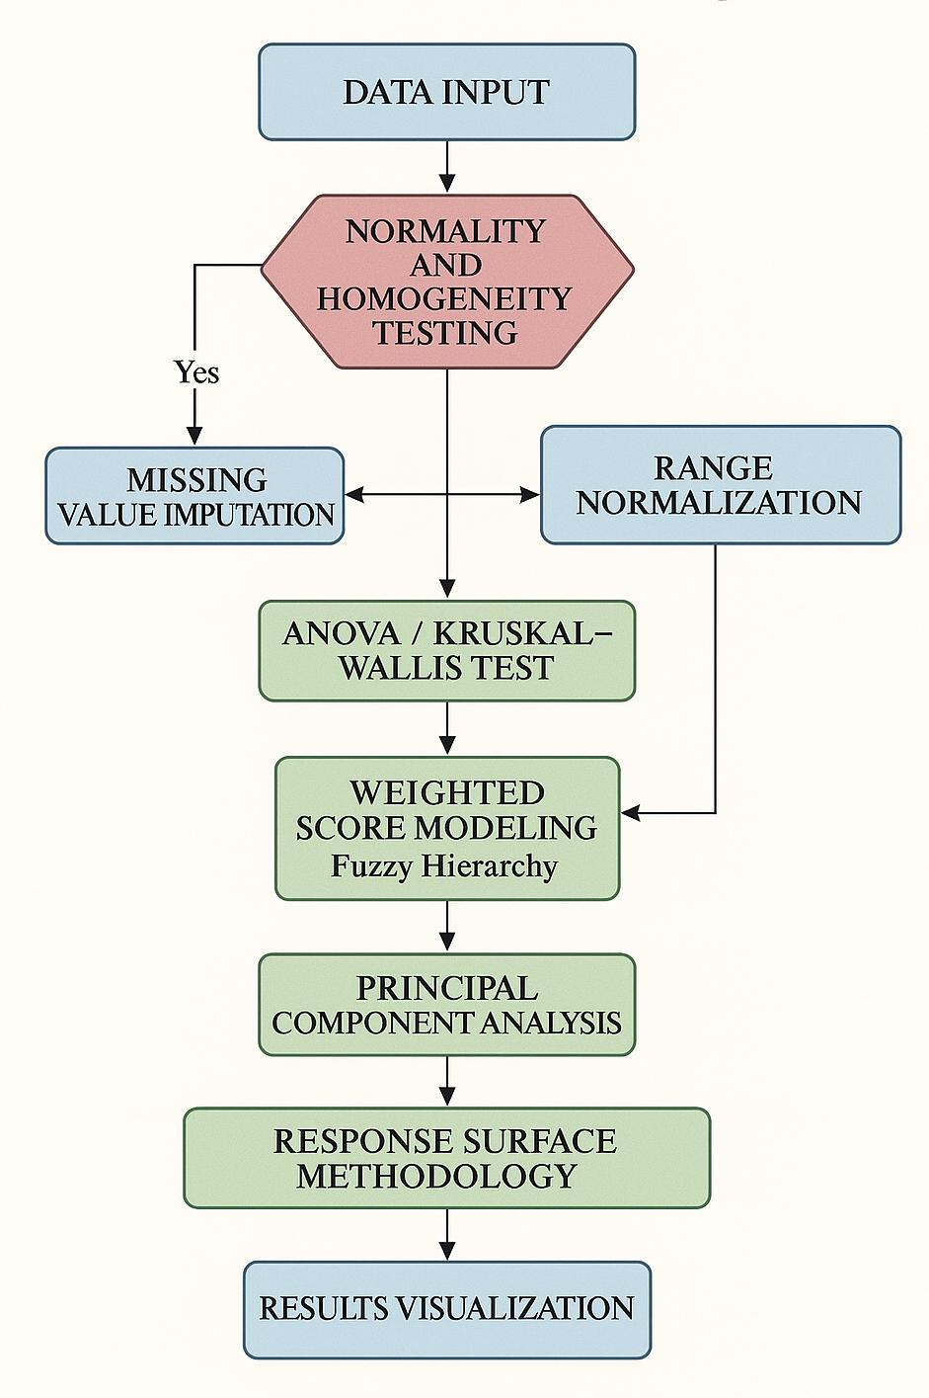
Figure 2: Data Processing Workflow Diagram
4. Pesticide Efficacy Experiment Results and Analysis
4.1 Effects of Different Pesticides on Turfgrass Growth
To evaluate the impact of different pesticide treatments on turfgrass growth performance, statistical analyses were conducted on the growth characteristics of Kentucky bluegrass and Bermuda grass under various treatments, focusing on turf coverage and average plant height. Results indicate that among synthetic pesticides, chlorantraniliprole treatment showed the most pronounced increase in turf coverage, with average coverage increases of 26.3% (Perennial ryegrass) and 22.7% (Bermuda grass) after 30 days. In the natural pesticide group, garlic oil treatment exhibited relatively stable performance, increasing coverage by 16.4% and 14.9%, respectively. The control group exhibited the smallest change in coverage, with some replicates even showing a slight decrease. Regarding plant height, synthetic insecticide and fungicide treatments also demonstrated significant promotion effects. Particularly in the American ryegrass treatment, the average plant height in the chlorothalonil group reached 17.6 cm, 4.2 cm taller than the control group. Although natural agents showed slower initial effects, they exhibited sustained growth between days 20 and 30, demonstrating potential for ecologically sustainable development. Table 5 lists changes in turf coverage for each treatment group before application and 30 days post-application.
Table 5: Statistical Table of Changes in Lawn Coverage
Turf Type | Treatment Group | Initial Coverage (%) | Coverage After 30 Days (%) | Increase (%)
Perennial ryegrass | Chlorantraniliprole | 48.6 | 74.9 | 26.3
 | Chlorothalonil | 49.1 | 70.8 | 21.7
 | Glyphosate | 47.3 | 66.5 | 19.2
 | Garlic Oil Extract | 46.5 | 62.9 | 16.4
 | Nicotine Solution | 47 | 61.3 | 14.3
 | Control group | 48.8 | 52.5 | 3.7
Cynodon dactylon | Chlorantraniliprole | 52.2 | 74.9 | 22.7
 | Chlorothalonil | 50.8 | 68.2 | 17.4
 | Glyphosate | 51.3 | 66.7 | 15.4
 | Garlic Oil Extract | 50.1 | 65 | 14.9
 | Nicotine Solution | 51.6 | 62.4 | 10.8
 | Control group | 52 | 53.1 | 1.1
Table 5 shows that all pesticide-treated groups significantly outperformed the control group (P&lt;0.05). The chlorantraniliprole group achieved the greatest increase in both turf types, indicating that it not only promotes uniform turf coverage and pest resistance but also rapidly enhances ground-level greenness. Although the nicotine treatment group showed slightly lower coverage than the synthetic group, the overall difference did not reach the highly significant level, demonstrating its growth stability under an ecologically friendly background.
Regarding plant height, as shown in Table 6, American ryegrass exhibited significant height increases under synthetic fungicide and insecticide treatments. The chlorothalonil group achieved an average height of 17.6 cm (31.3% increase), followed by the chlorantraniliprole group at 16.9 cm. Bermuda grass exhibited relatively similar growth rates in glyphosate and chlorothalonil treatments (27.5% and 25.9%, respectively), indicating synthetic agents possess strong comprehensive driving capabilities for promoting stem and leaf expansion. The natural agent treatment group exhibited slow growth in the early stage (first 10 days) but demonstrated a better sustained growth trend in the later stage. Notably, the garlic oil group achieved over 20% growth in both turfgrass varieties. The control group showed overall growth below 10%, with some replicates even exhibiting inhibited responses due to pest and disease damage.
Table 6: Statistical Summary of Average Plant Height Changes in Lawns
Lawn Type | Treatment Group | Initial Height (cm) | Height after 30 days (cm) | Increase (%)
American Ryegrass | Benomyl | 13.4 | 17.6 | 31.3
 | Chlorantraniliprole | 13.2 | 16.9 | 28
 | Glyphosate | 13.6 | 16.8 | 23.5
 | Garlic Oil Extract | 13.1 | 15.9 | 21.4
 | Nicotine solution | 13.3 | 15.4 | 15.8
 | Control group | 13.5 | 14.2 | 5.2
Cynodon dactylon | Glyphosate | 11.8 | 15.1 | 27.5
 | Chlorothalonil | 12.1 | 15.3 | 26.4
 | Chlorantraniliprole | 11.9 | 14.8 | 24.4
 | Garlic Oil Extract | 11.7 | 14.4 | 23.1
 | Nicotine solution | 12 | 13.7 | 14.2
 | Control group | 11.8 | 12.5 | 5.9
The above data confirms significant differences between pesticide types and turfgrass growth responses. While natural pesticides exhibit less pronounced growth-stimulating effects than synthetic ones, they remain viable sustainable alternatives for promotion under stable ecological conditions.
4.2 Comparative Analysis of Pesticide Efficacy
To comprehensively evaluate the practical efficacy of different pesticide types in controlling pests, diseases, and weeds in turfgrass, statistical analysis was conducted on two grass species—perennial ryegrass and Bermuda grass—to measure changes in disease lesion rates, pest density rates, and weed coverage reduction within 30 days post-application. Differences and efficacy response structures were compared and analyzed. Results indicate that synthetic pesticides exhibit higher short-term control efficiency, particularly in rapidly suppressing diseases and eliminating sucking pests. Natural pesticides demonstrate stronger sustainability advantages in weed control and ecological buffering dimensions, though their short-term efficacy is relatively slower. Tables 7, 8, and 9 present experimental data for three typical control indicators, followed by systematic analysis.
Table 7: Statistical Table of Turf Disease Spot Change Rate
Lawn Type | Treatment Group | Initial Disease Spot Count (spots/m²) | Number of Lesions After 30 Days (per m²) | Reduction Rate (%)
Perennial ryegrass | Chlorothalonil | 35.2 | 6.8 | 80.7
 | Chlorantraniliprole | 32.5 | 9.4 | 71.1
 | Garlic oil | 34 | 13.3 | 60.9
 | Nicotine | 33.8 | 15.1 | 55.3
 | Control group | 35.5 | 32.6 | 8.2
Bermuda grass | Chlorothalonil | 31.1 | 7.2 | 76.9
 | Chlorantraniliprole | 29.6 | 8.7 | 70.6
 | Garlic oil | 30.9 | 12.4 | 59.9
 | Nicotine | 31.3 | 14.2 | 54.7
 | Control group | 30.7 | 28.8 | 6.2
The data on lesion reduction rates indicate that chlorothalonil achieved the highest fungicidal efficacy on both turf types, with reduction rates of 80.7% and 76.9%, respectively. This performance was significantly superior to other treatments (P&lt;0.01), demonstrating that this contact fungicide exhibits excellent targeted activity in controlling fungal diseases. Among natural agents, garlic oil outperformed nicotine but remained inferior to synthetic fungicides overall. The control group showed almost no improvement in lesion counts, indicating that exogenous treatments play a decisive role in disease control.
Table 8: Statistical Table of Pest Density Change Rates
Lawn Type | Treatment Group | Initial Pest Density (individuals/m²) | Insect Density After 30 Days (Indiv./m²) | Reduction Rate (%)
Perennial ryegrass | Chlorantraniliprole | 78.3 | 14.5 | 81.5
 | Chlorothalonil | 76.5 | 19.6 | 74.4
 | Garlic oil | 77.1 | 28.2 | 63.4
 | Nicotine | 76.8 | 31.3 | 59.2
 | Control group | 77.5 | 72.6 | 6.3
Cynodon dactylon | Chlorantraniliprole | 73.6 | 15.8 | 78.5
 | Chlorothalonil | 72.4 | 20.3 | 72
 | Garlic oil | 71.9 | 27.4 | 61.9
 | Nicotine | 73.1 | 29.8 | 59.3
 | Control group | 72.6 | 68.5 | 5.6
In terms of pest density control efficacy, chlorantraniliprole achieved over 80% suppression of insect populations on both types of turf, demonstrating remarkably efficient and rapid killing power. Although chlorothalonil is not a dedicated insecticide, its mixed infection control mechanism still performed well in plots with heavier infestations. Natural pesticides generally achieved control rates around 60%. While less pronounced than synthetic insecticides, they possess repellent and ecological suppression effects, making them suitable for low-intensity intervention scenarios.
Table 9: Weed Coverage Reduction Statistics
Lawn Type | Treatment Group | Initial Weed Coverage (%) | Coverage After 30 Days (%) | Reduction Rate (%)
Perennial Ryegrass | Glyphosate | 26.3 | 5.1 | 80.6
 | Garlic Oil | 25.6 | 9.2 | 64.1
 | Nicotine | 24.9 | 11.5 | 53.8
 | Control group | 25.8 | 23.7 | 8.1
Cynodon dactylon | Glyphosate | 28.2 | 5.8 | 79.4
 | Garlic oil | 27.6 | 10.2 | 63
 | Nicotine | 26.7 | 12.6 | 52.8
 | Control group | 27.1 | 25.9 | 4.4
In weed control, glyphosate demonstrated significant suppression of common broadleaf weeds in turf areas due to its non-selective nature, reducing weed coverage by over 80% within 30 days. Among natural agents, garlic oil extract demonstrated strong repellent properties with over 60% control efficacy, making it particularly suitable as a herbicide alternative in ecological restoration areas. Nicotine showed slightly weaker control, primarily due to insufficient inhibition of weed root regrowth. Weed growth in the control group remained unchecked, highlighting the foundational impact of weed removal on overall aesthetics and maintenance costs in turf areas.
4.3 Influence of Environmental Factors on Pesticide Efficacy
To clarify how different environmental factors regulate pesticide efficacy on turfgrass, three key environmental variables—temperature, air humidity, and light intensity—were systematically monitored for dynamic changes within 30 days post-application. Concurrent fluctuations in disease lesion reduction rates were recorded to reveal the degree of interference from climatic conditions in actual pesticide control. Results indicate that temperature fluctuations significantly affect pesticide metabolic stability and volatilization rates. Synthetic pesticides degrade faster under high temperatures, shortening their active period. Humidity influences actual coverage on leaf surfaces by regulating pesticide adhesion and penetration properties. Light intensity indirectly affects pesticide bioavailability by inducing stomatal opening and transpiration regulation in plants. Table 10 presents the efficacy variation rates of three typical pesticide classes under varying environmental conditions.
Table 10: Impact of Environmental Factors on Efficacy of Typical Pesticides
Pesticide Type | Temperature Level (°C) | Humidity Level (%) | Light Intensity (lx) | Disease Spot Reduction Rate (Perennial Ryegrass) | Disease Spot Reduction Rate (Bermuda Grass)
Chlorothalonil | 18–22 | 60–70 | 15,000 | 82.3 | 77.5
 | 26–30 | 75–85 | 30,000 | 74.1 | 70.2
Chlorantraniliprole | 18–22 | 60–70 | 15,000 | 76.5 | 72.8
 | 26–30 | 75–85 | 30,000 | 67.4 | 65.1
Garlic Oil | 18–22 | 60–70 | 15,000 | 62.7 | 59.6
 | 26–30 | 75–85 | 30,000 | 58.2 | 55.9
Analysis data indicates that under elevated temperatures of 26–30°C, the disease reduction rates of chlorothalonil and chlorantraniliprole decreased by 8.2 and 9.1 percentage points respectively. This demonstrates that high temperatures accelerate the volatilization and decomposition of active ingredients, thereby weakening their sustained fungicidal and insecticidal effects. Although garlic oil releases its volatile natural components more rapidly at high temperatures, its efficacy declines relatively less due to its primary mode of action involving evaporation to form a vapor-phase repellent layer. Humidity increases to 75–85% slightly enhanced the efficacy of all three agents, particularly in chlorothalonil-treated areas. The moist environment improved the adhesion and spreadability of the spray solution on leaf surfaces, thereby increasing its penetration efficiency. Under high light intensity (30,000 lx), disease reduction rates generally decreased, most notably on Bermuda grass. This may result from its stronger light adaptation and higher transpiration rate, leading to reduced pesticide uptake. Comprehensive analysis indicates that environmental factors significantly modulate pesticide efficacy. Therefore, simultaneous monitoring of temperature, humidity, and light conditions is essential in turfgrass maintenance management. Implementing differentiated pesticide formulation strategies is crucial to enhance overall application effectiveness.
5 Conclusion
In summary, synthetic pesticides demonstrate significant advantages in rapidly controlling pests, diseases, and weeds while promoting turf growth, as evidenced by markedly improved coverage and plant height, along with highly effective suppression of lesion counts and pest densities. However, natural pesticides exhibit unique value in ecological friendliness and sustainability, particularly standing out in weed control and ecological buffer dimensions, though their short-term efficacy shows some lag. The experimental design enabled systematic comparisons of different pesticide treatments under uniform environmental conditions, highlighting the critical role of interactions between pesticide type, dosage, and environmental factors in maintaining turf health. Innovation lies in quantifying the differential effects of synthetic and natural pesticides using a comprehensive evaluation index system and a multi-factor response model, providing systematic comparative references for turfgrass management. Limitations primarily stem from the short experimental period, which hindered the full presentation of long-term residual effects and resistance accumulation trends.
Future research should extend the temporal scale, incorporate multi-regional field trials, and integrate multi-source data to further validate the long-term replacement potential of natural pesticides in turfgrass management. Exploring differentiated management strategies based on precision application and intelligent monitoring will help establish a greener, more efficient turfgrass maintenance system.
References
- Alarcon-Segura V, Grass I, Feuerbacher A, et al. Semi-natural habitats and their contribution to crop productivity through pollination and pest control: a systematic review[J]. Landscape Ecology, 2025, 40(7): 137.
- Appleby A B, Reganold J P, Carpenter‐Boggs L A. Efficacy and cost of four plant‐derived, natural herbicides for certified organic agriculture[J]. Pest Management Science, 2025, 81(6): 3391-3402.
- Zhang D, Guo X, Rao W, et al. A multi-stimuli–response metal–organic framework nanopesticide for smart weed control in agriculture[J]. Environmental Science: Nano, 2025, 12(1): 608-622.
- Pattanaik K P, Jena S, Mahanty A, et al. Exploitation of volatile organic compounds for rice field insect‐pest management: current status and future prospects[J]. Physiologia Plantarum, 2025, 177(3): e70240.
- Zhang L J, Ma Y S, Liu Y, et al. Ecological Pest Control in Alpine Ecosystems: Monitoring Asteraceae Phytophages and Developing Integrated Management Protocols in the Three River Source Region[J]. Insects, 2025, 16(8): 861.
- Reuter T, Nahrstedt K, Jarmer T, et al. Delineation of management zones in clover-grass for site-specific management of subsequent crops[J]. Precision Agriculture, 2025, 26(4): 61.
- Neal J C. Biological control of weeds in turfgrass: opportunities and misconceptions[J]. Pest Management Science, 2024, 80(1): 40-48.
- Meryani L M, Janaki P, Suganthy M, et al. Potential of essential oils as natural herbicides: a comprehensive review of current developments[J]. Plant Growth Regulation, 2024, 104(3): 1307-1328.
- Pattanaik K P, Jena S, Mahanty A, et al. Exploitation of volatile organic compounds for rice field insect‐pest management: current status and future prospects[J]. Physiologia Plantarum, 2025, 177(3): e70240.
- Chowdhury S K, Banerjee M, Basnett D, et al. Natural pesticides for pest control in agricultural crops: an alternative and eco-friendly method[J]. Plant Science Today, 2024, 11(1): 433-450.

